Installation of EBER

# 1). Purchasing Server On AWS

Create an account on AWS and complete basic registration steps that are required to get done before we can access AWS benefits.

After registration now we need to purchase an instance(server) where we can install our code.

So for that, we need to purchase instances

steps to purchase instance

## 1.1 Selecting region for instance

* + We need to select the region (from the top right corner) wisely so that we get the best latency and API responses in less time. Select the region where this application is going to be used most of the time.
  + If a region is not available in a particular country or state, then use the region which is nearest.

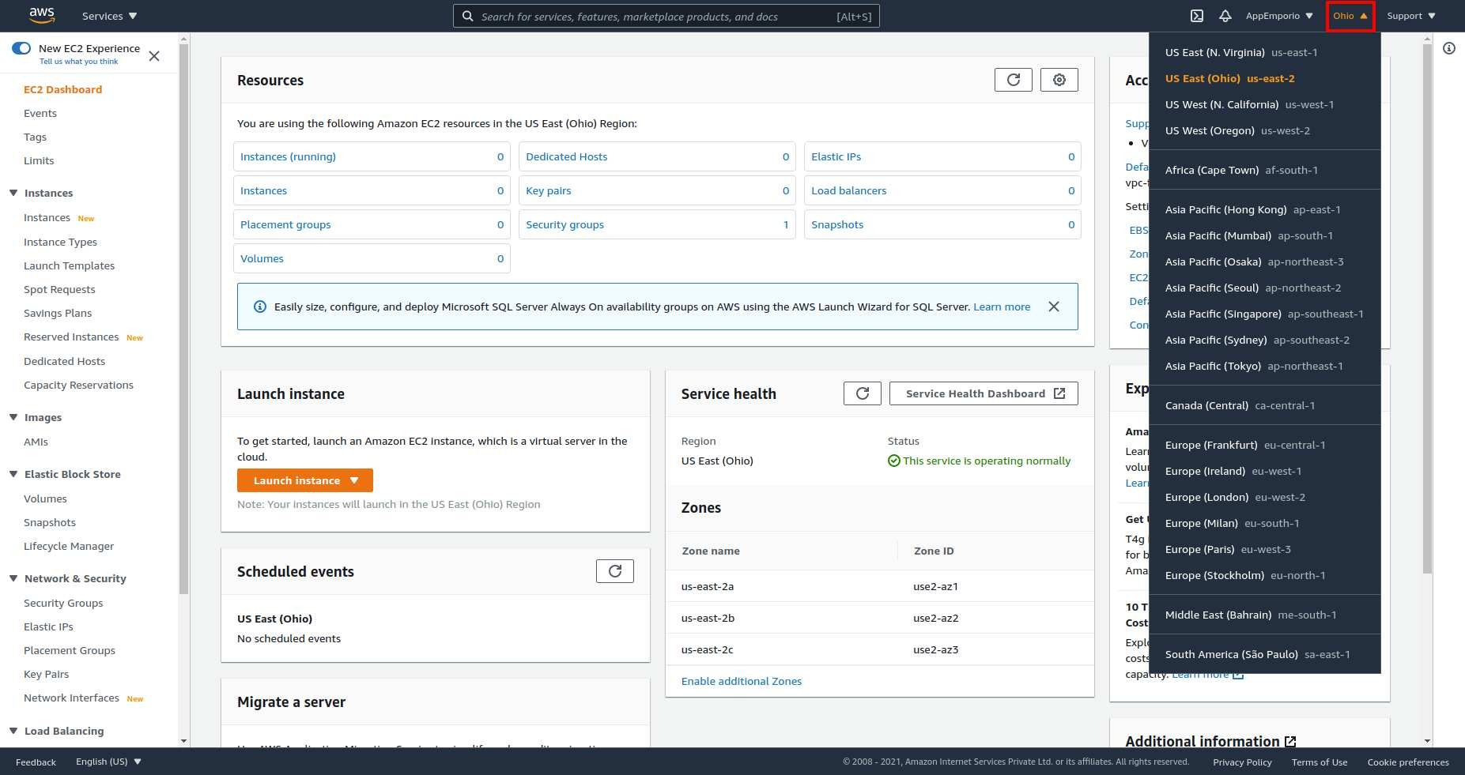

## 1.2 Purchasing Instance

#### 1.2.1: From AWS services select EC2.

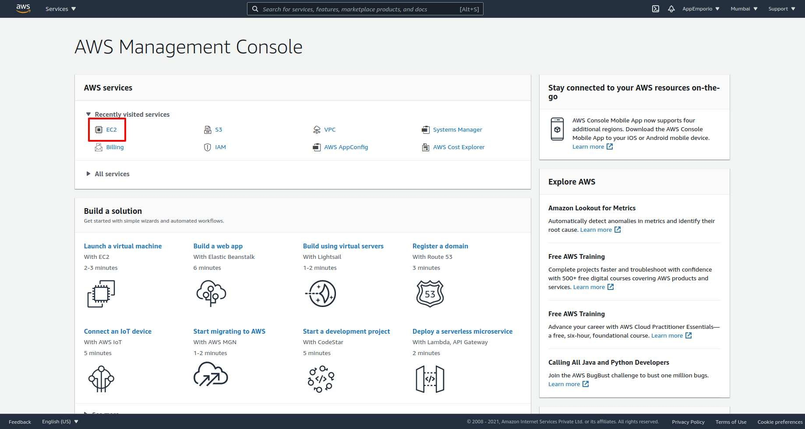

#### 1.2.2: Now, from the side navigation bar select instances.

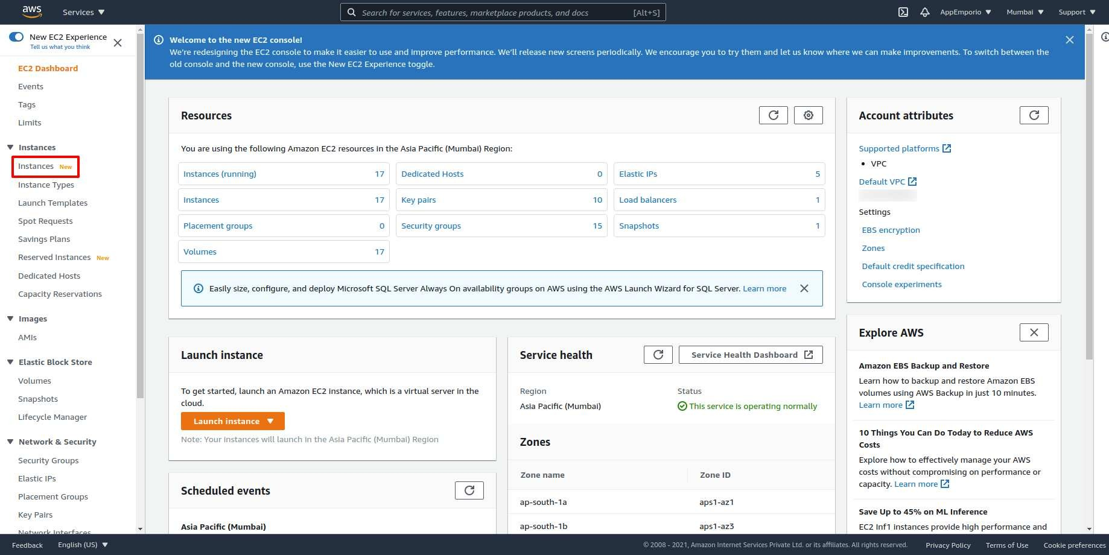

#### 1.2.3: Select Launch from the top right corner.

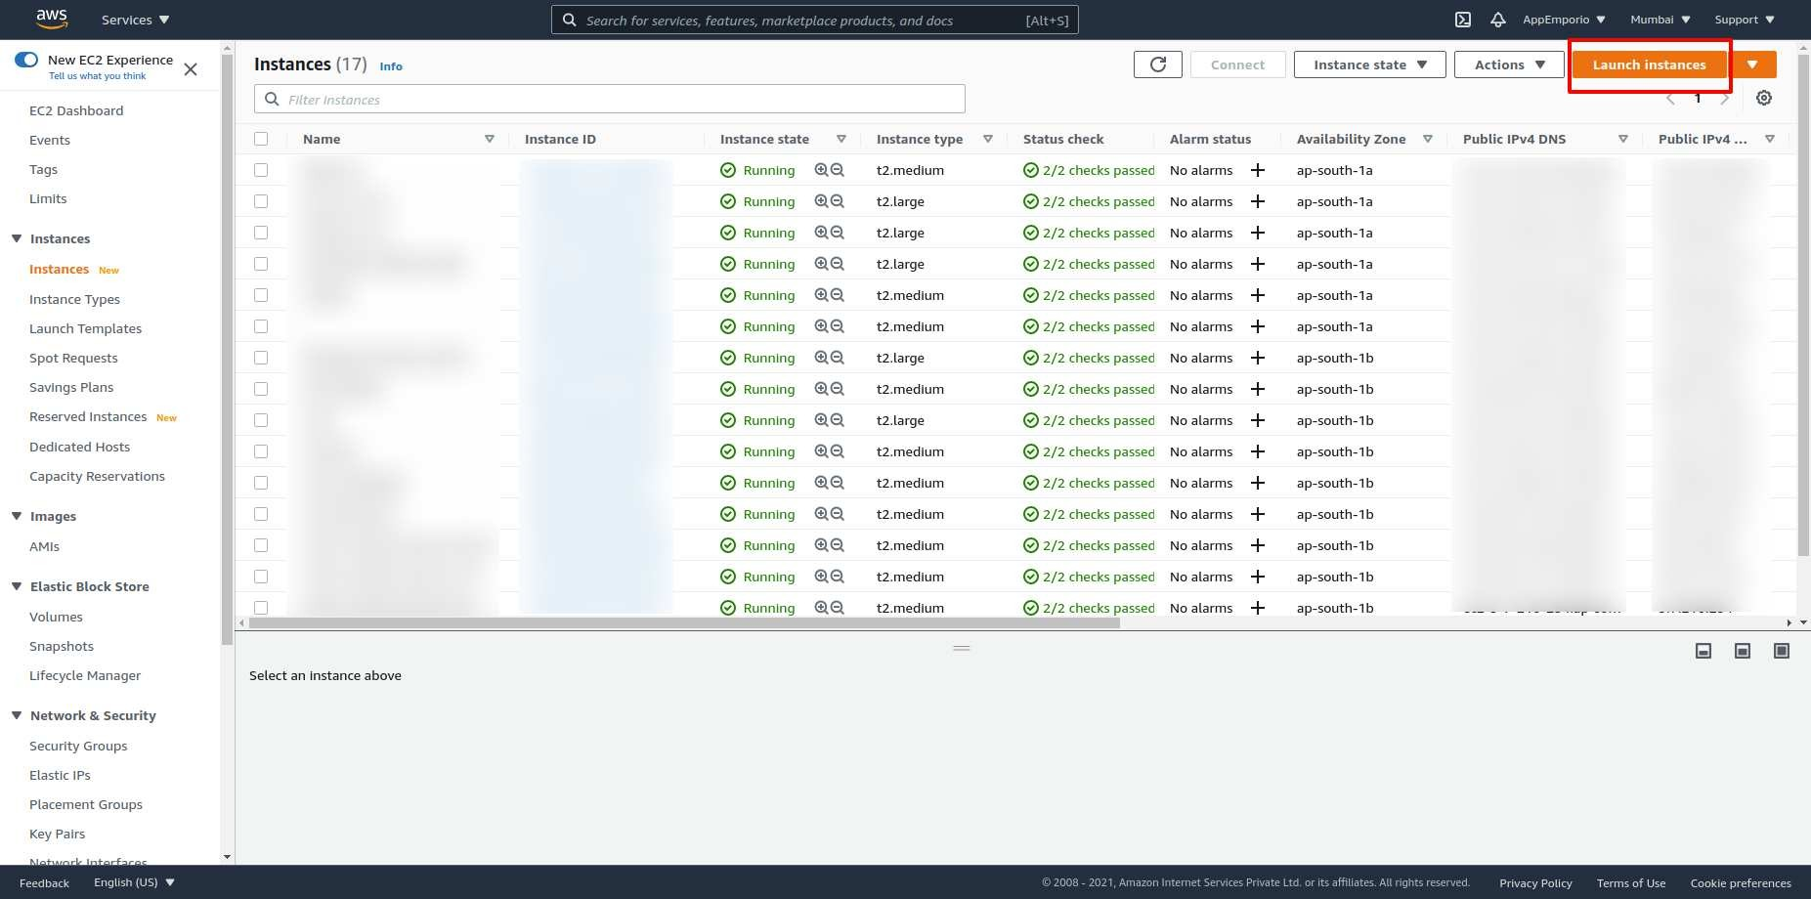

#### 1.2.4: Now we few steps to follow for launching our instance

#### ***1.2.4(i) Choose an AMI***

* + - * AMI is a bunch of basic preloaded software configurations like Operating Systems.
      * Select Ubuntu which is most preferable according to our use case.

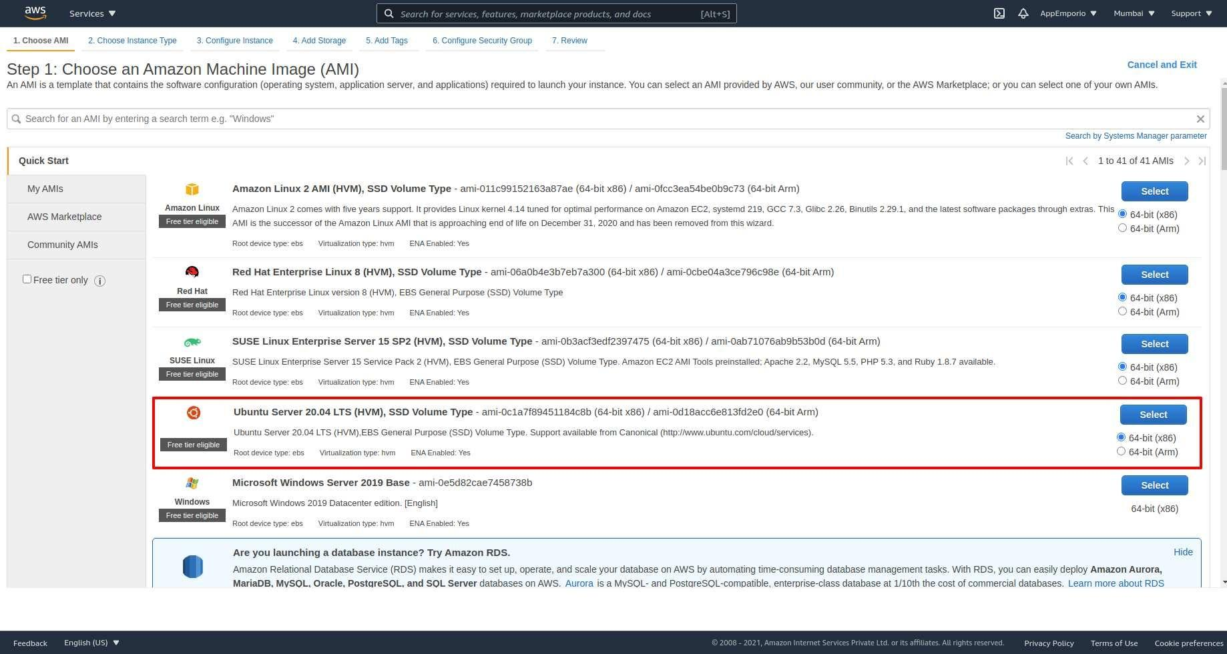

##### ***1.2.4(ii) Choose instance type***

* + - * Amazon EC2 provides a wide selection of instance types optimized to fit different use cases. They have varying combinations of CPU, memory, storage, and networking capacity, and give you the flexibility to choose the appropriate mix of resources for your applications.
      * Preferable selection c5.large for backend

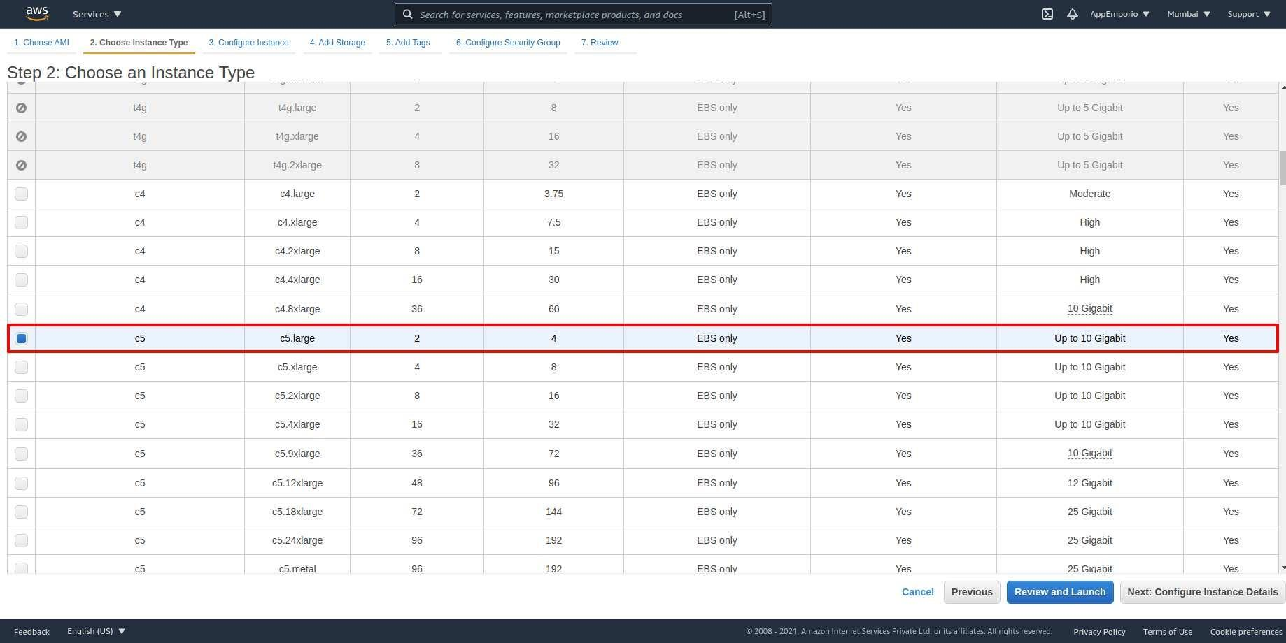

##### ***1.2.4(iii) Configure instance details***

* + - * Configure the instance to suit your requirements. You can launch multiple instances from the same AMI, request Spot instances to take advantage of the lower pricing, assign an access management role to the instance, and more.
      * Configure your server according to your requirements. Let's head to the next step.

##### ***1.2.4(iv) Add storage***

* + - * Your instance will be launched with the following storage device settings. You can attach additional EBS volumes and instance store volumes to your instance, or edit the settings of the root volume. You can also attach additional EBS volumes after launching an instance, but not instance store volumes.
      * Select 30 GiB.

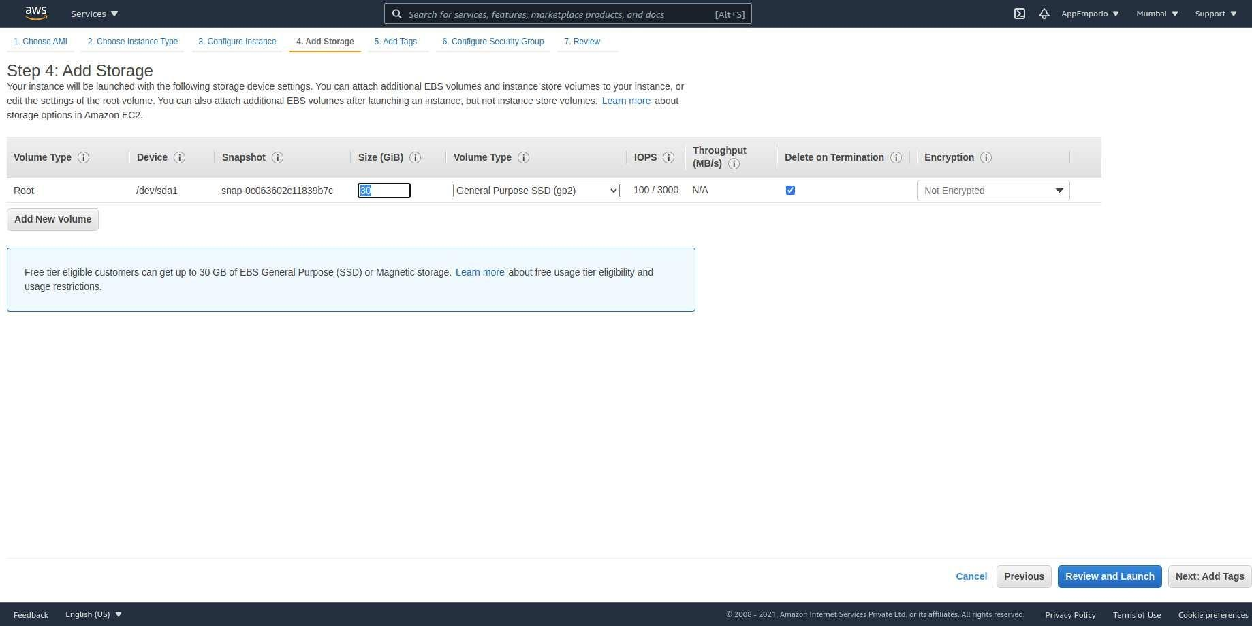

##### ***1.2.4(v) Add Tags(Optional)***

* + - * A tag consists of a case-sensitive key-value pair. For example, you could define a tag with key = Name and value = Web Server. A copy of a tag can be applied to volumes, instances or both.
      * This step is optional for us.

##### ***1.2.4(vi) Configure security group***

* + - * A security group is a set of firewall rules that control the traffic for your instance. On this page, you can add rules to allow specific traffic to reach your instance.
      * We will require SSH, HTTP, and HTTPS security groups to have ssh connection and http and https connections from web browsers.

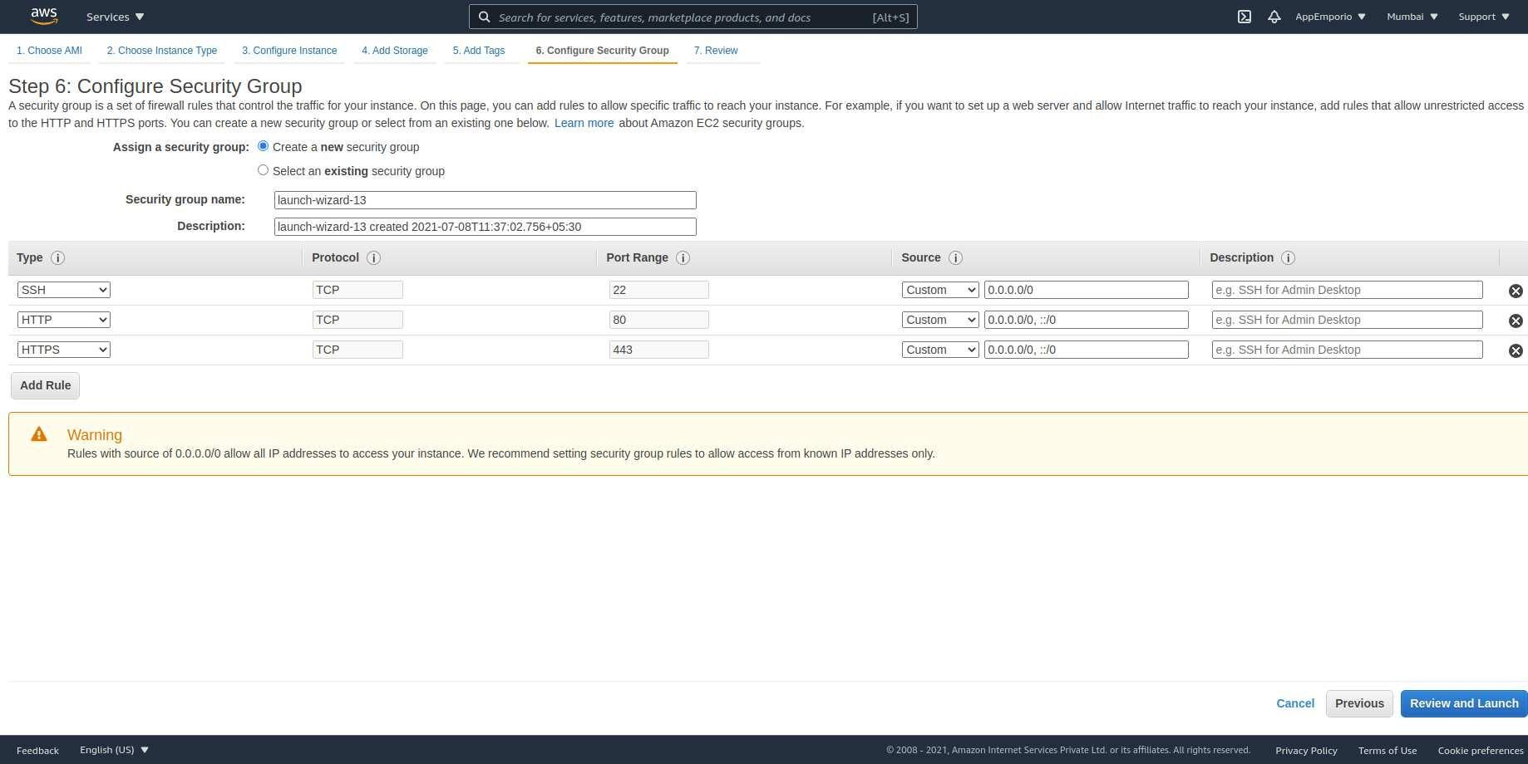

##### ***1.2.4(vii) Review***

* + - * Please review your instance launch details. You can go back to edit changes for each section.
      * Click Launch to assign a key pair to your instance and complete the launch process.

##### ***1.2.4(viii) Security Keys***

* + - * As shown in the image below while reviewing we can see a popup for security. If you have any security keys then select that or generate a new one for our server.
      * For creating new security keys we need to select Create a new key pair and enter the appropriate name for your key and press download key pair.

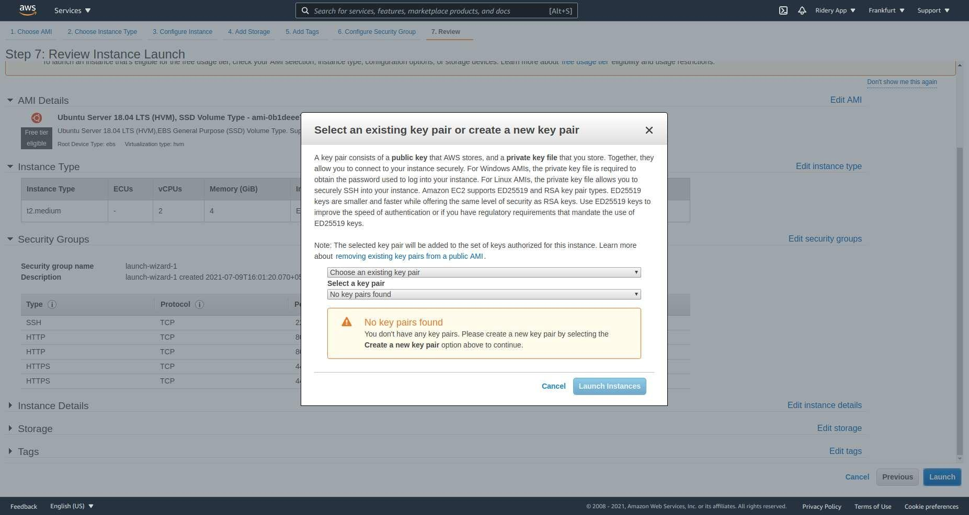

# 

# 

# Or Purchasing Server On Digitalocean

1.1) choose organization, go to droplet, if there is no droplet. Create a new droplet with a create button. Choose your nearest region. Most case we go through new york region.

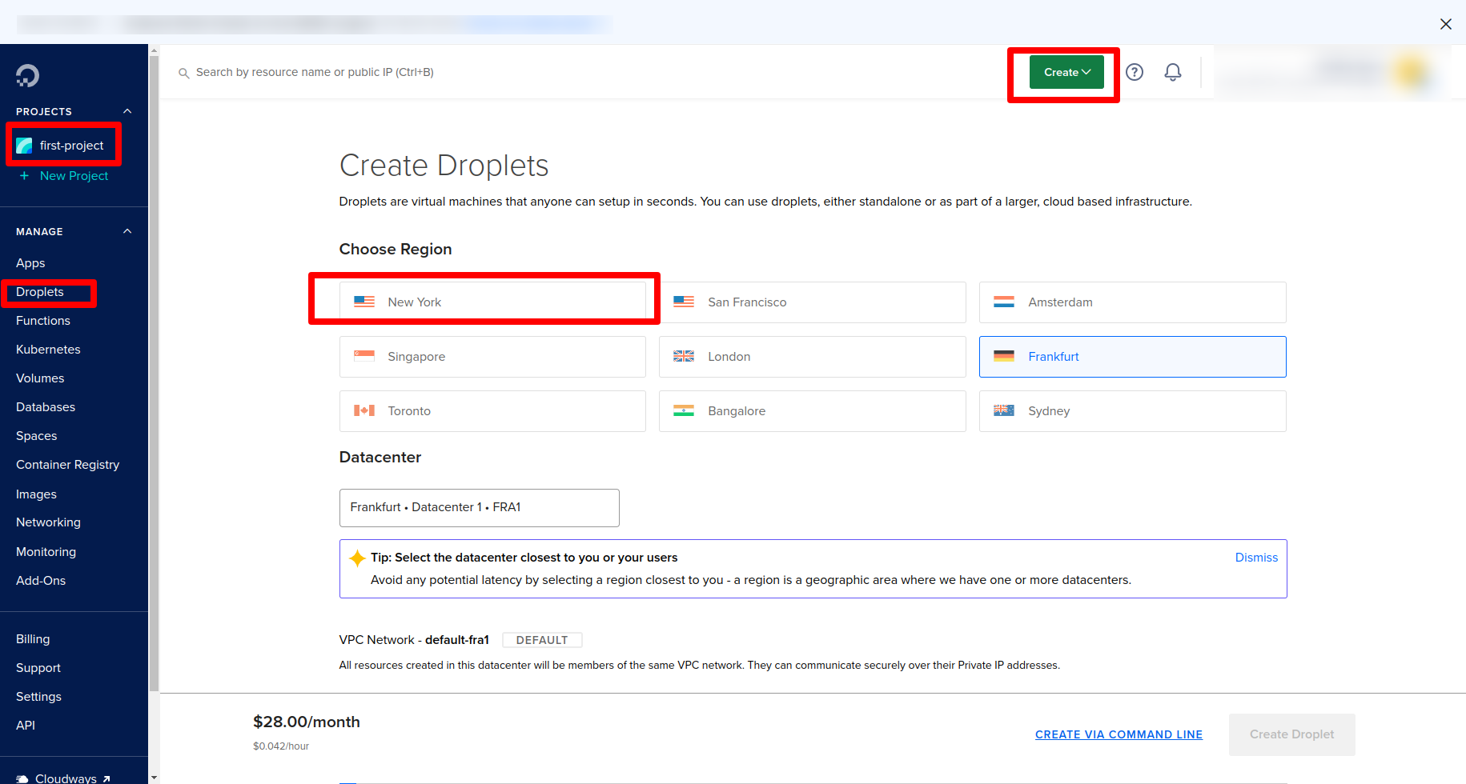

1.2) choose os ubuntu 20.04 LTS

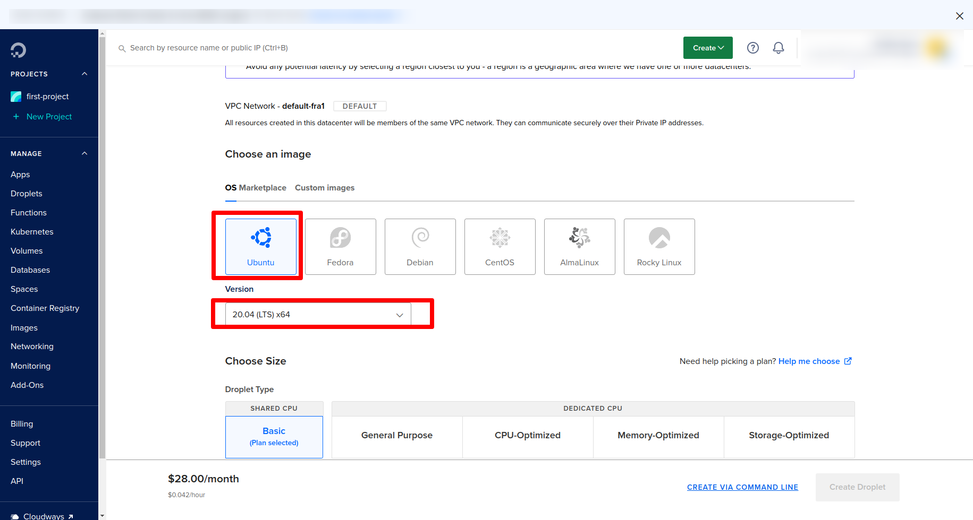

1.3) Choose size for droplet. Go for a basic plan. Select premium intel CPU. choose 28$/month plan

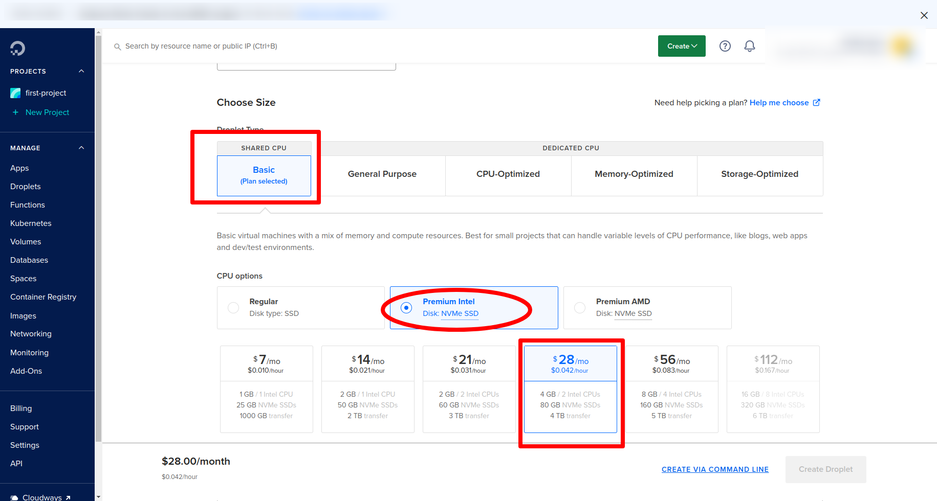

1.4) choose an authentication method. Go to the password method. Use root password. You can create your own or you can create a password with the help of password generator. It will give you a strong password.

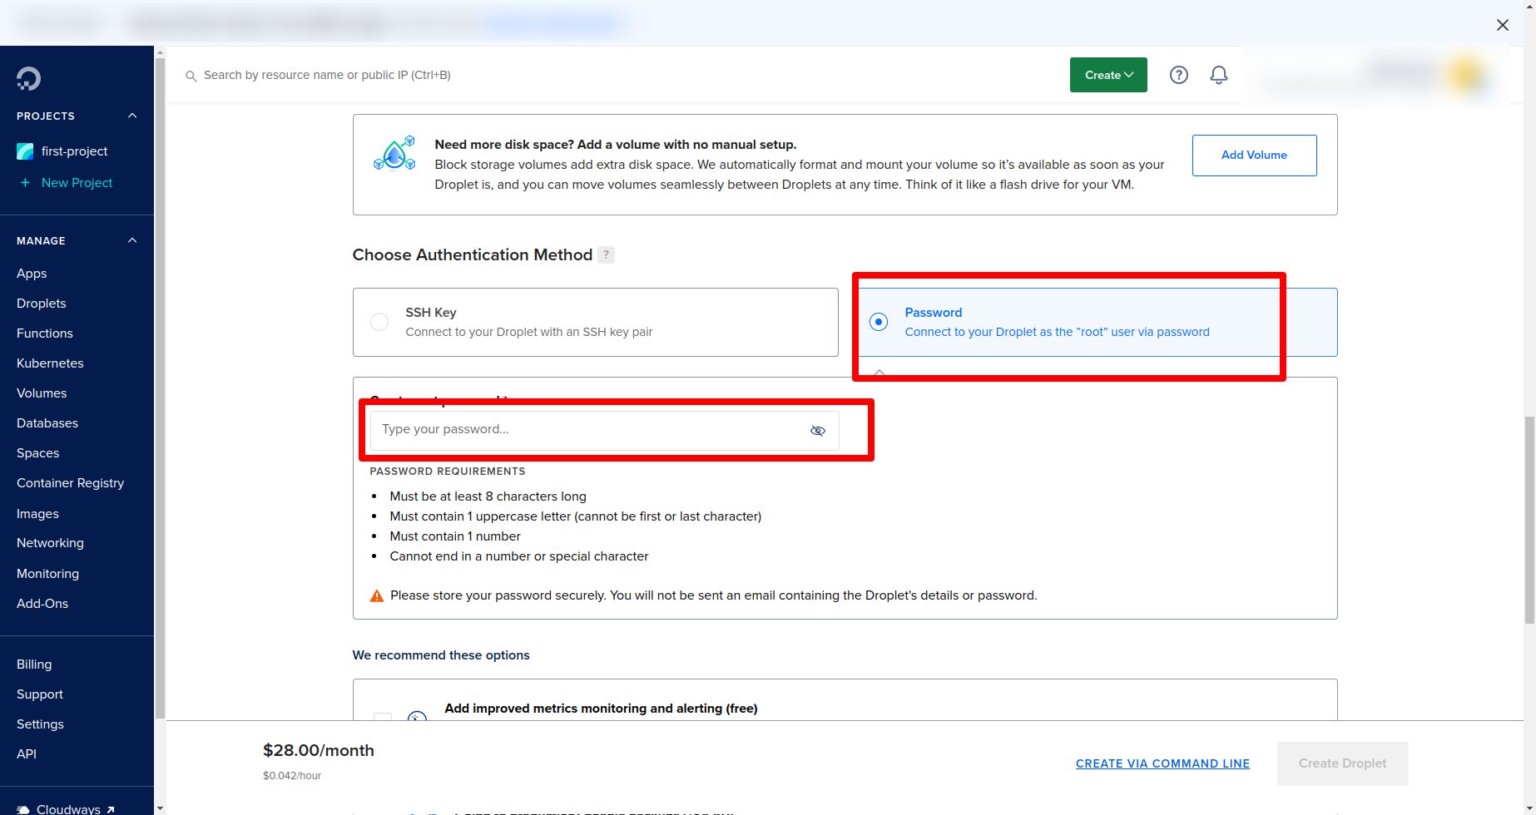

1.5) after creating password check first free recommendation option. The 2nd option is backup of the server. If want this will charge 5$

Quantity 1 droplet and auto create hostname

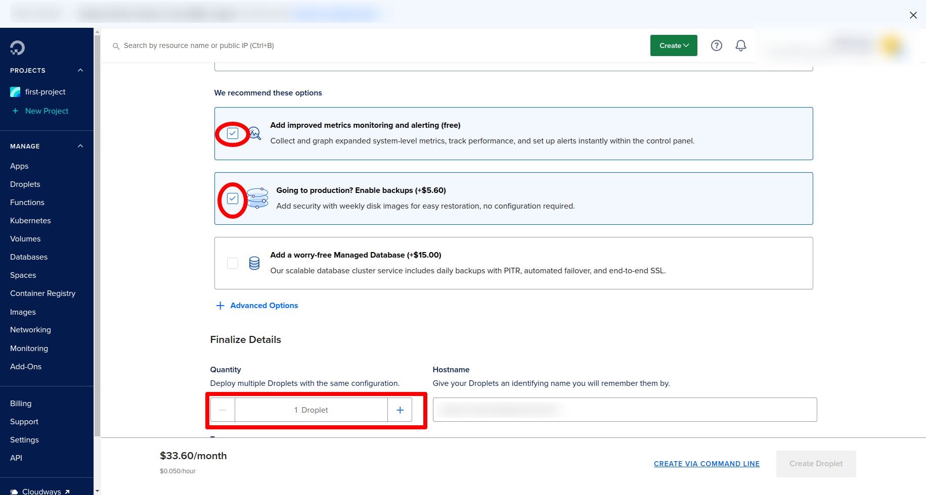

1.6) optional add tags. If you go through this it approximately charges 33$. Hit create droplet button

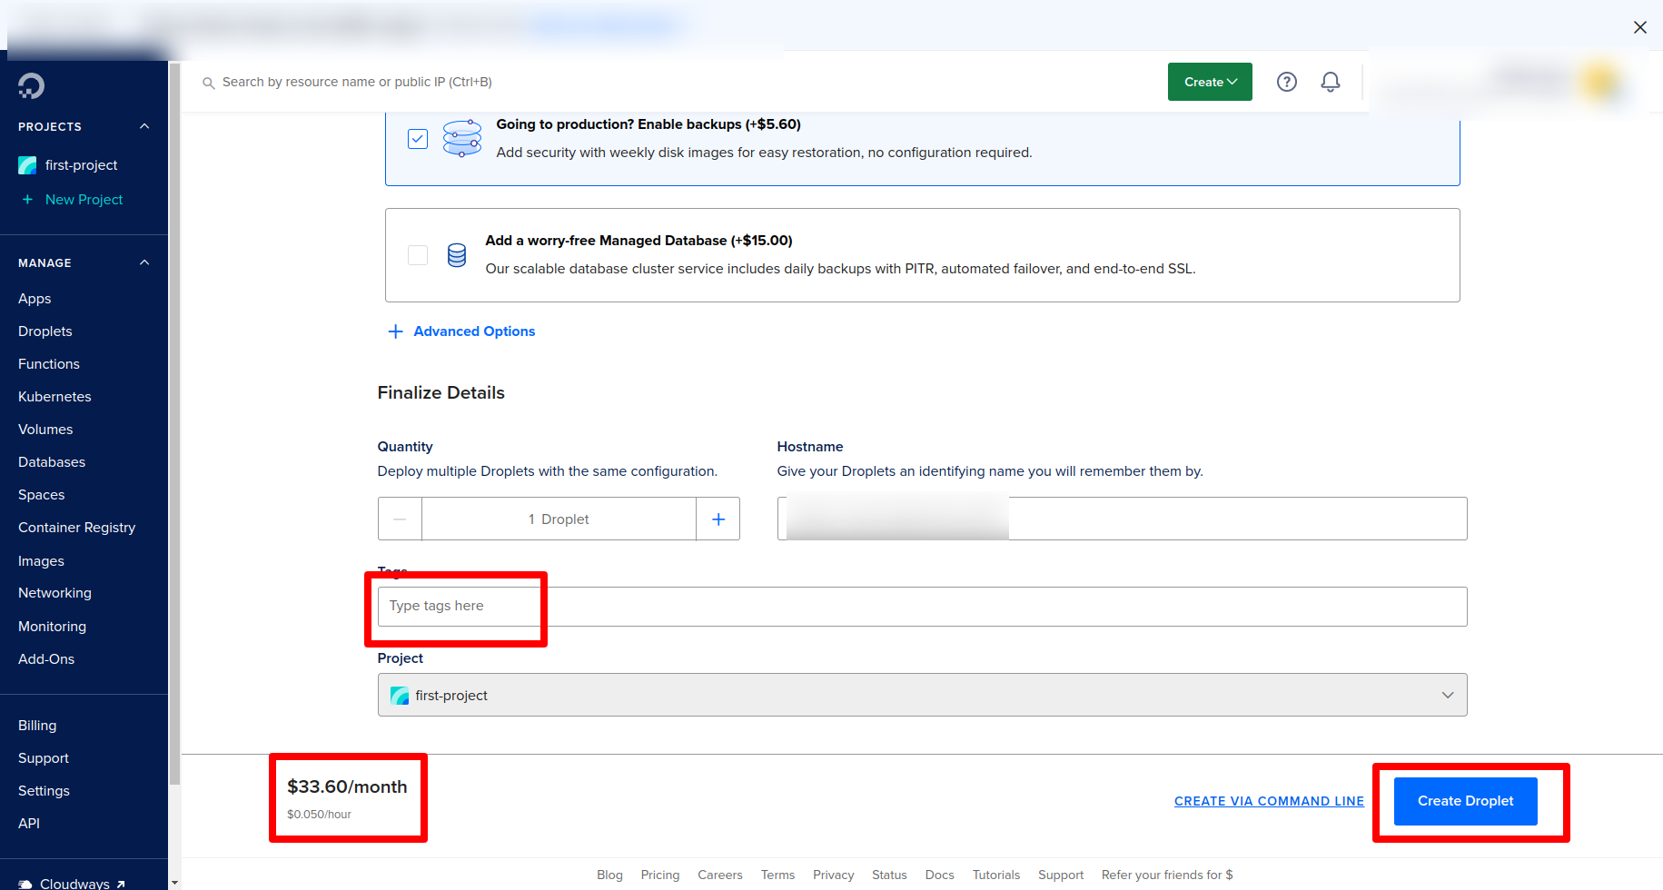

On success creation of droplet you will redirect the droplet section where you get ip and password(which you created before while creating droplet). This credential will help

you to connect with server

# 

# Or Purchasing Server On Vultr:

1.1) Create instance on Vultr dashboard

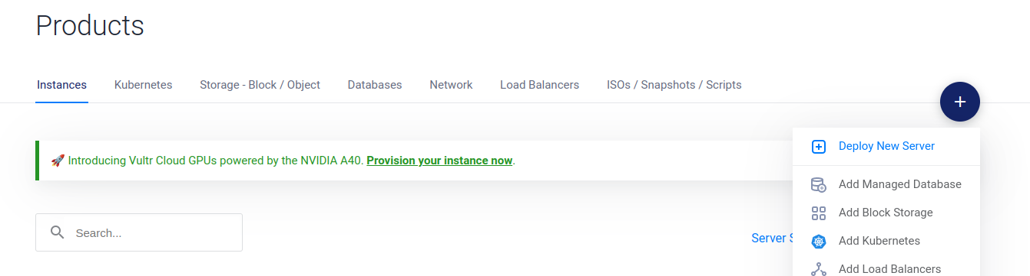

1.2) Select the Server and CPU

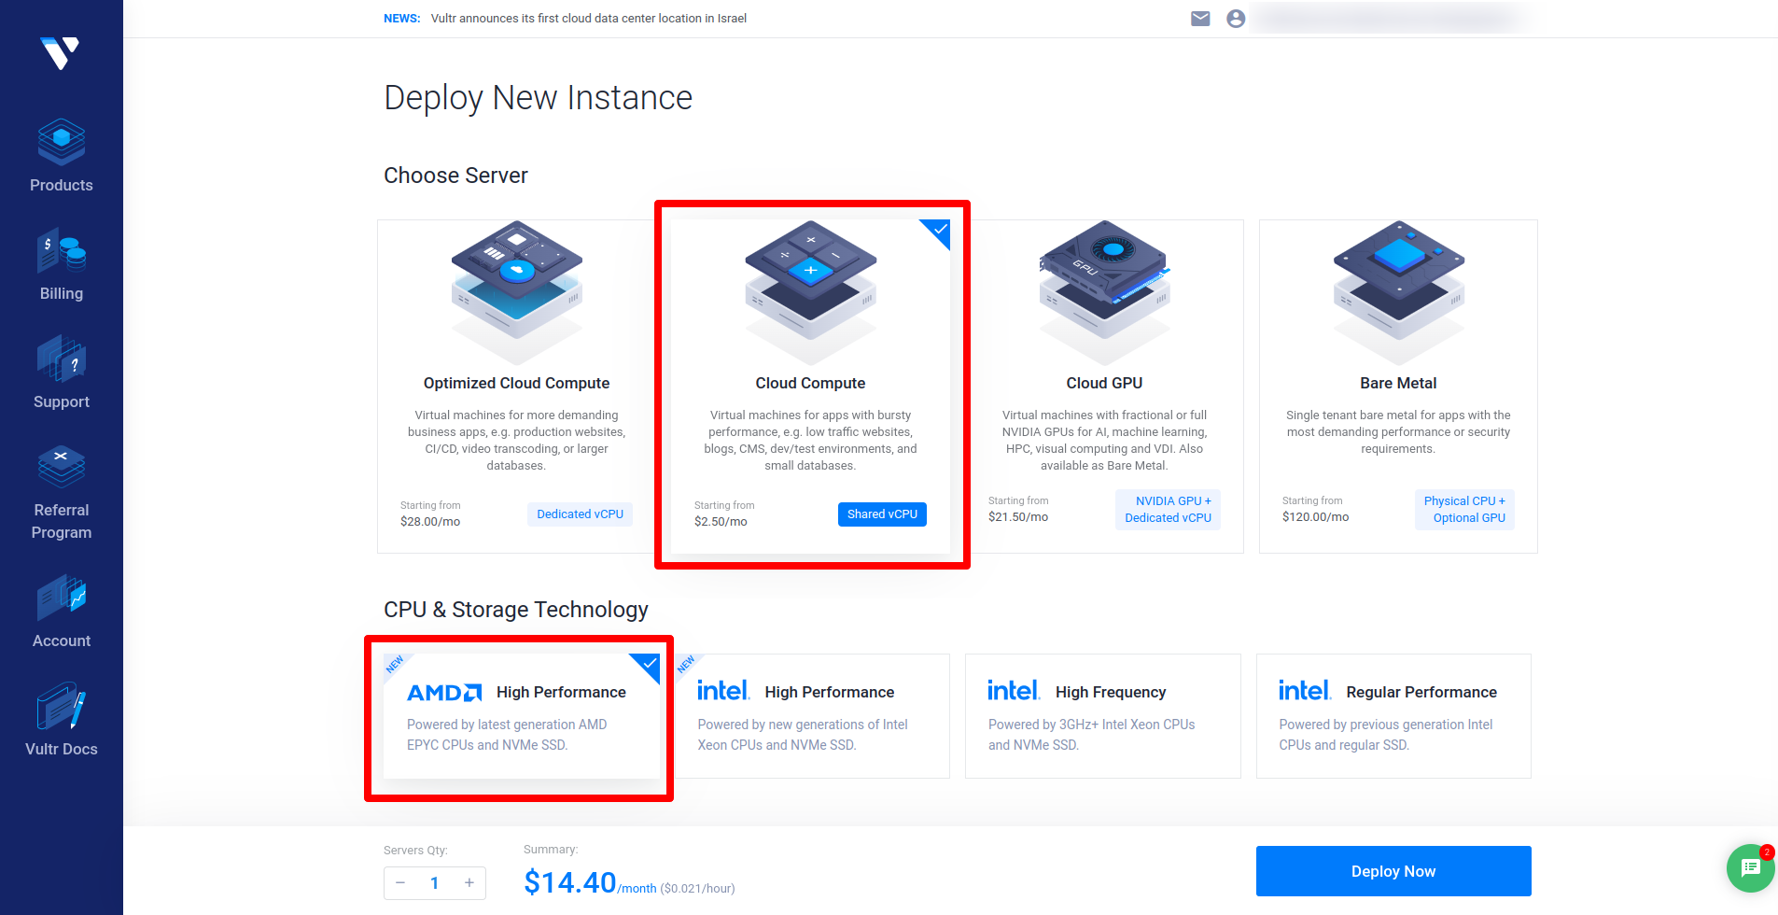

1.3) Select the server’s nearest Location as your country:

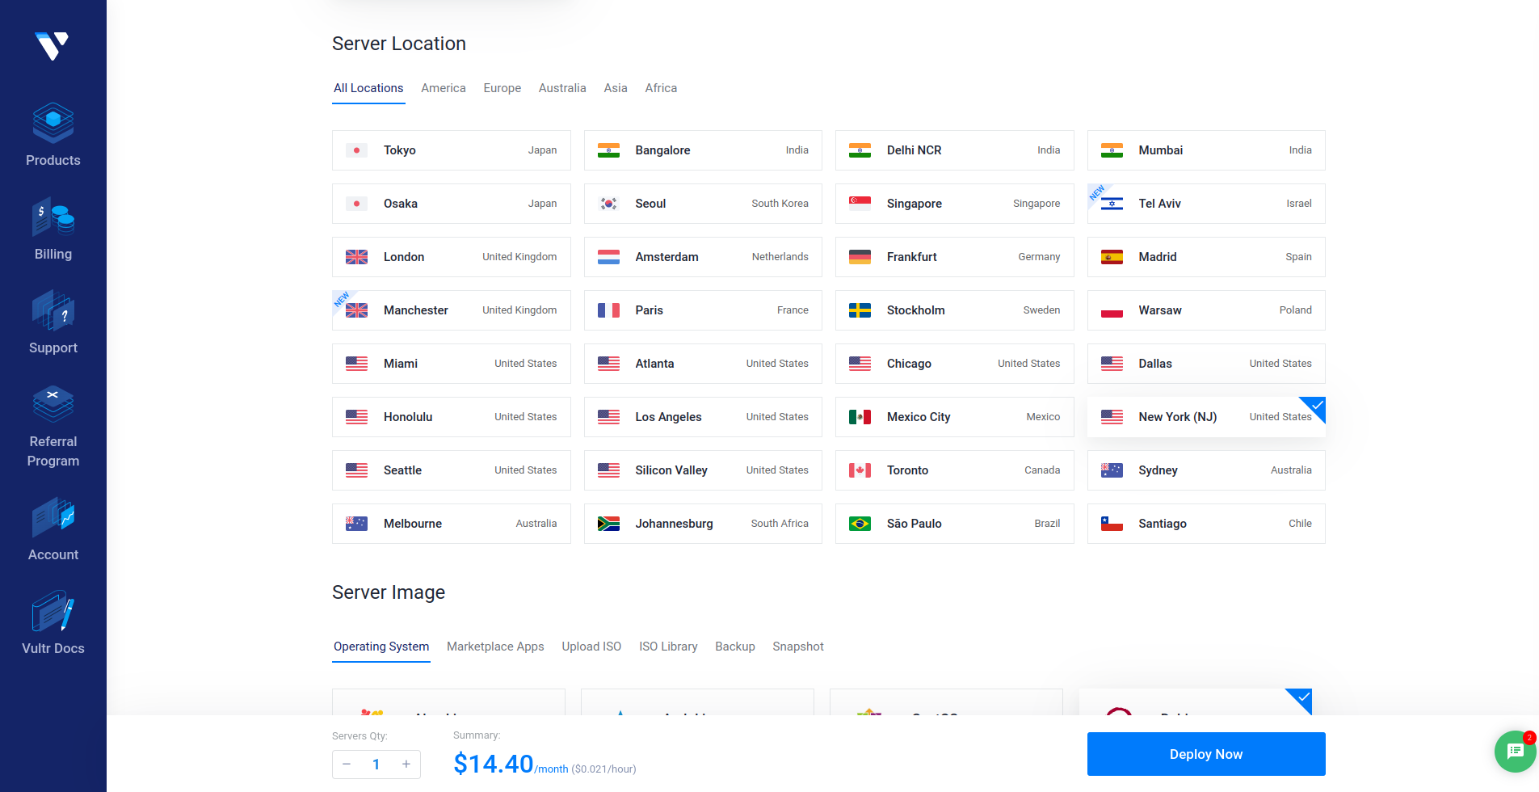

1.4) Select the server image on which you want to deploy.

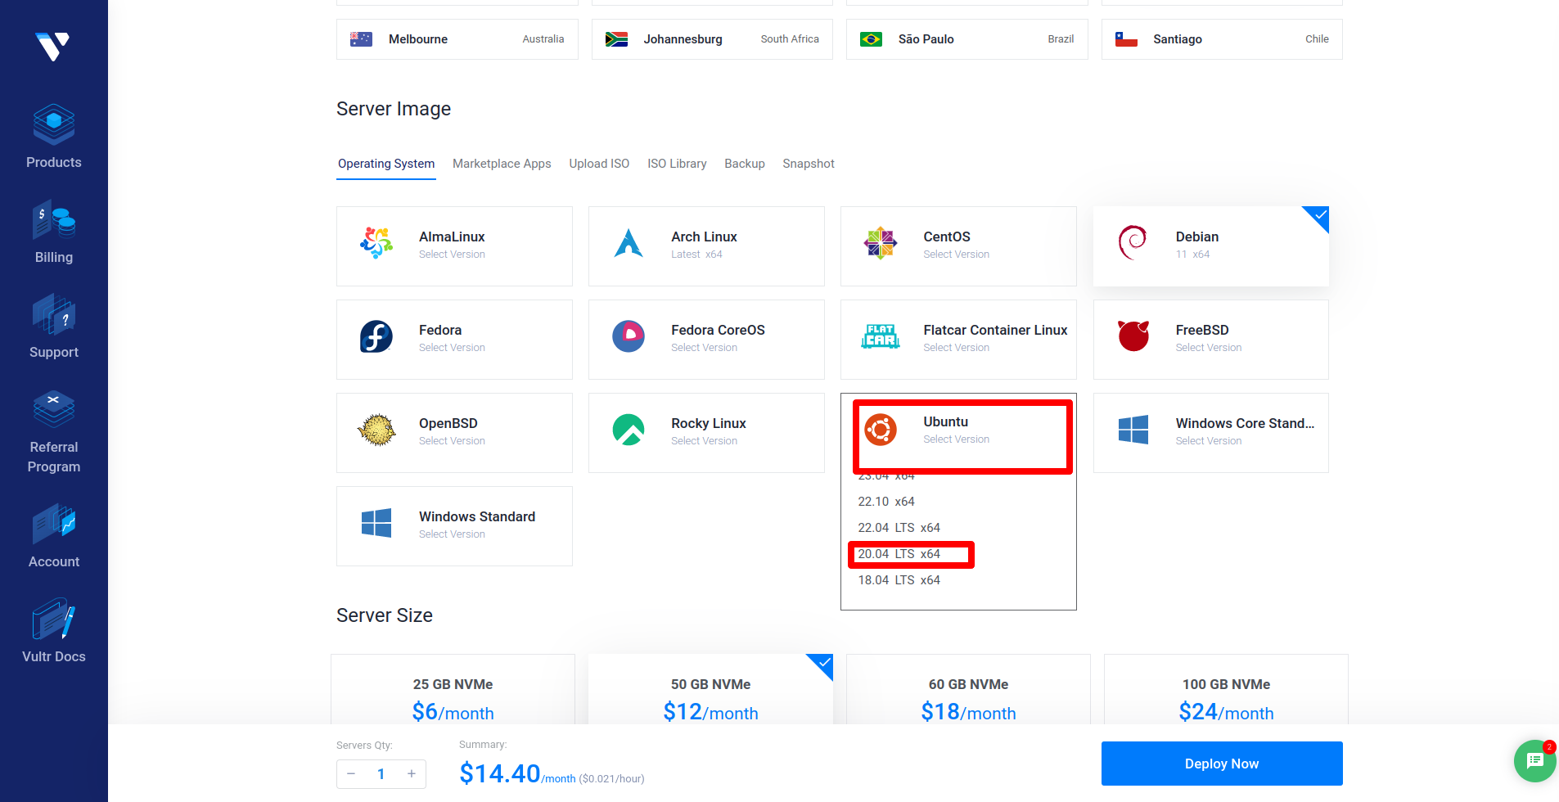

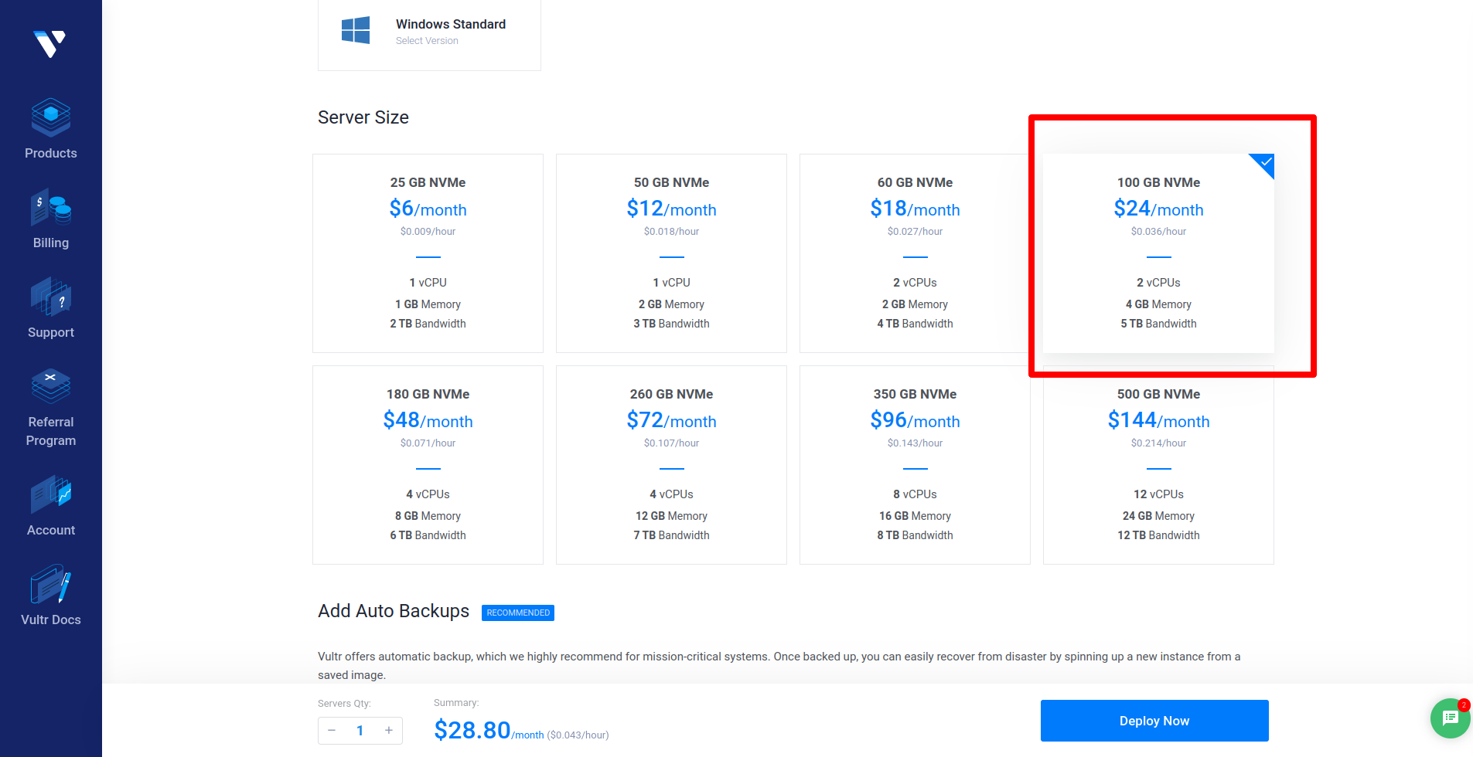

1.4) Keep these settings as default.

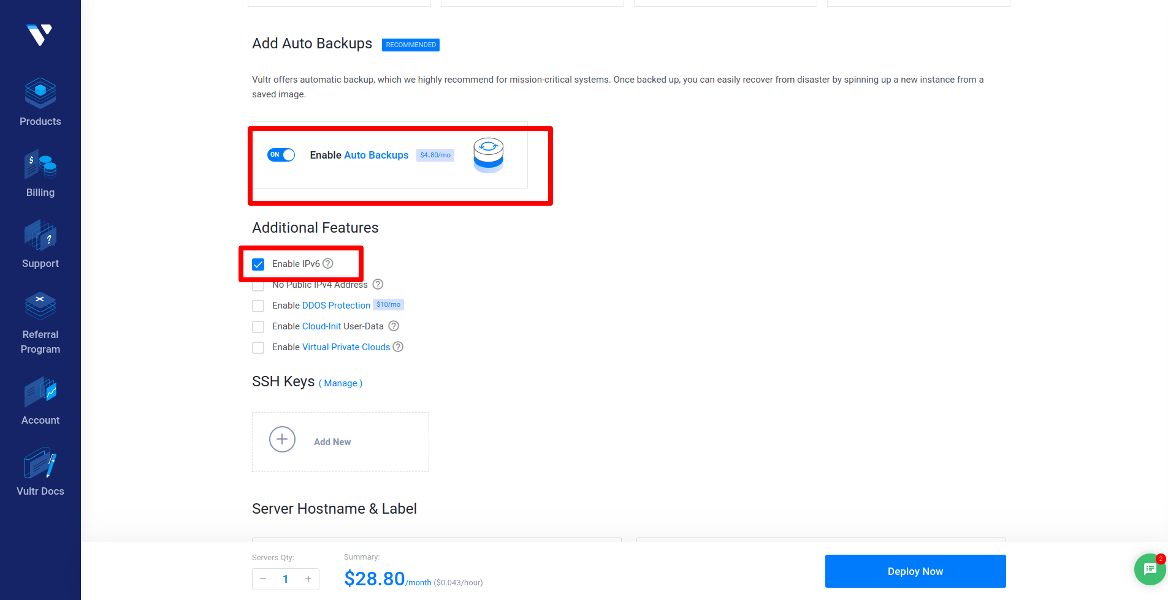

1.5) server hostname you want as tag. In the footer you can show estimation. Everything is ok then click deploy now. Check review at last before you deploy

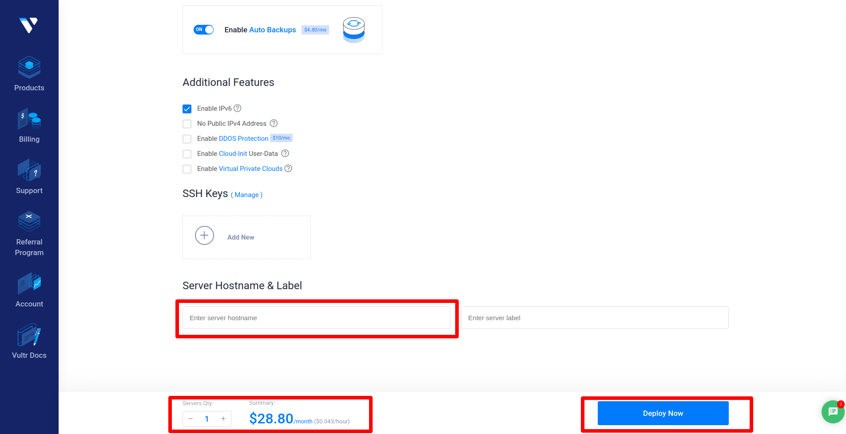

1.6) Click on server detail to see IP, passwords and other server details

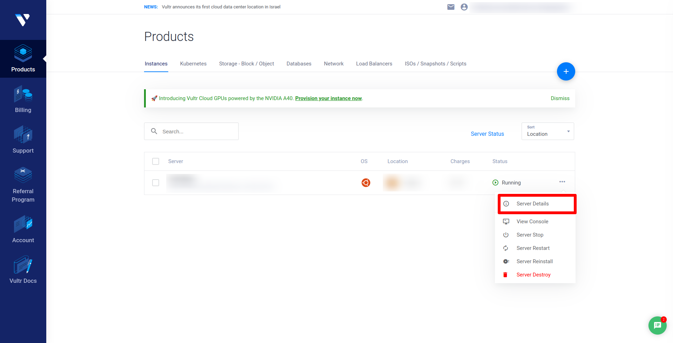

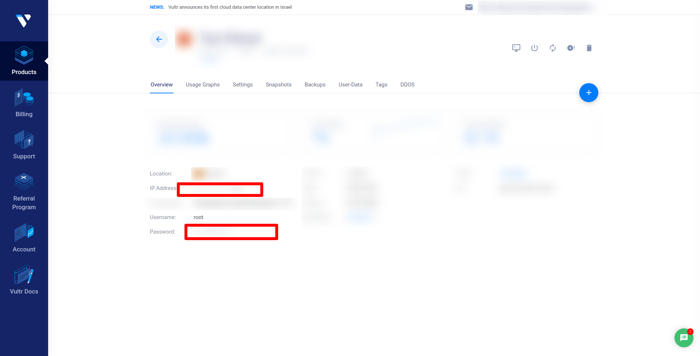

# 2). Security Groups in AWS.

### 1) Why are security groups used in AWS?

A security group acts as a virtual firewall for your EC2 instances to control incoming and outgoing traffic. Inbound rules control the incoming traffic to your instance, and outbound rules control the outgoing traffic from your instance. If you don't specify a security group, Amazon EC2 uses the default security group.

### 2) In the navigation pane, choose Security Groups.

### 3) Choose your instance and create a security group.

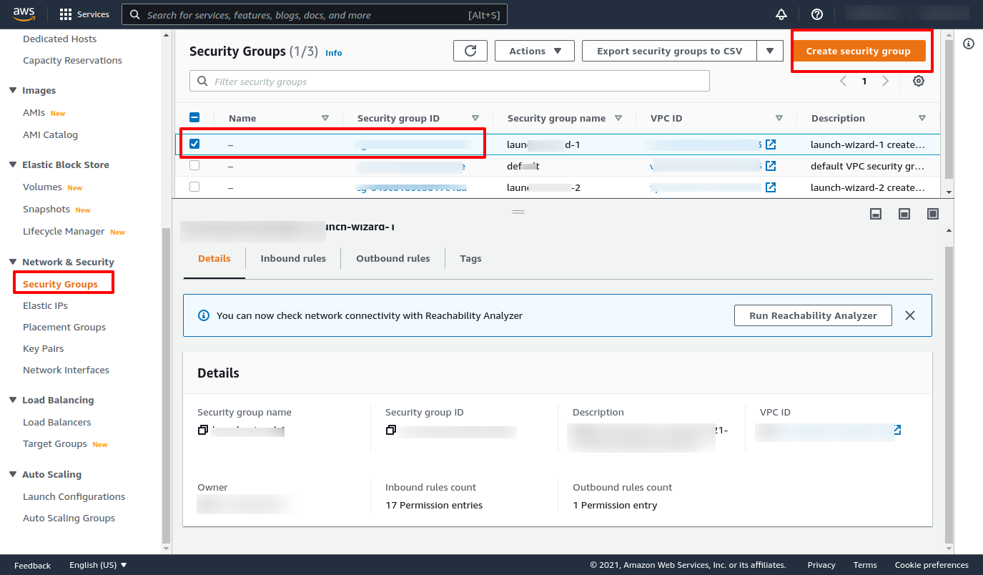

### 4) First click on the add rule and then click on the custom button and select the type HTTPS.

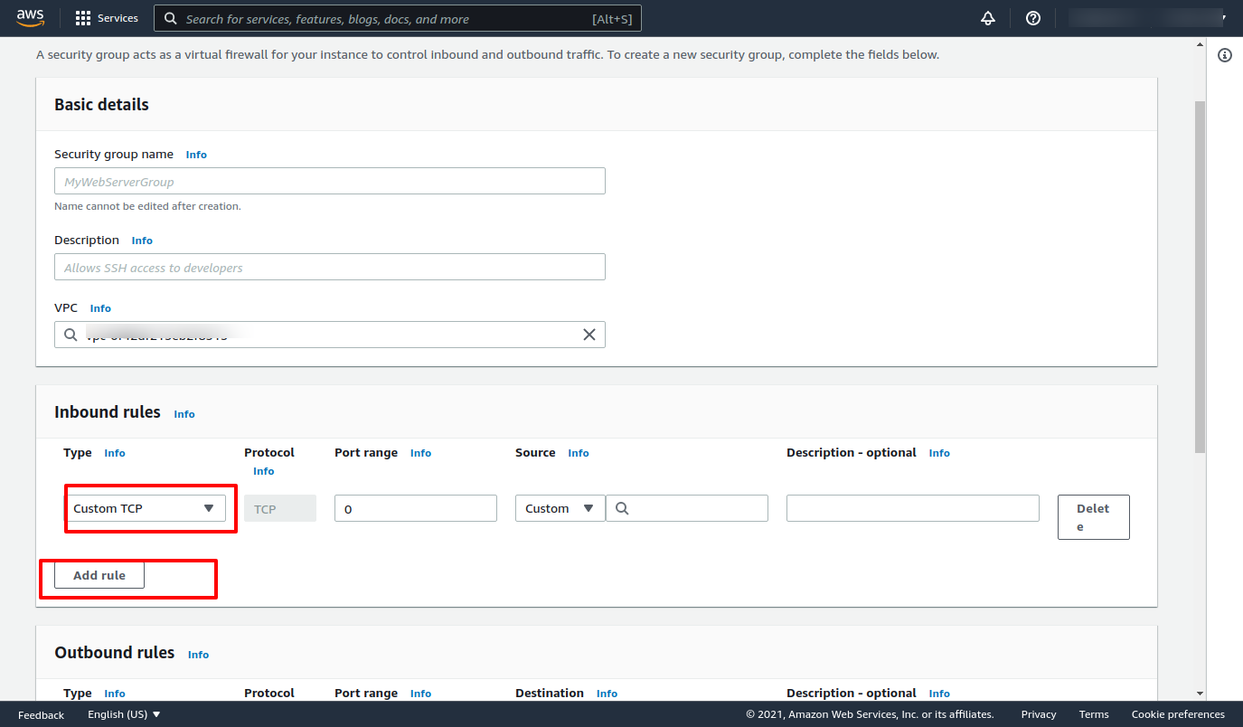

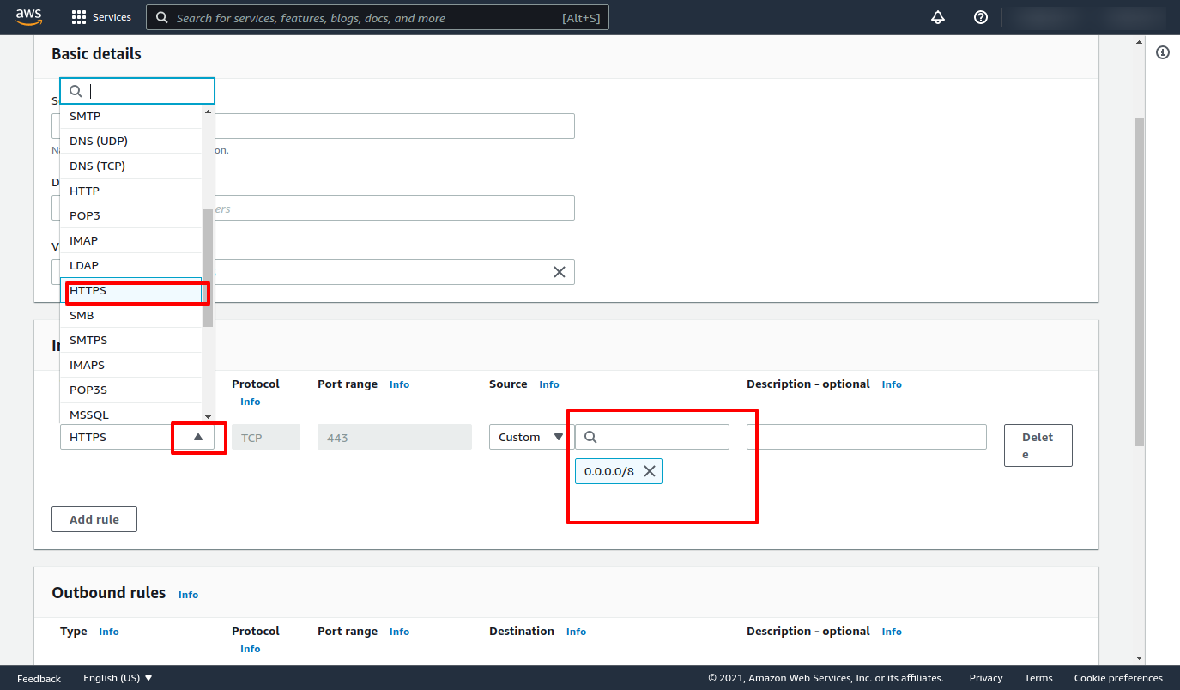

### 5) Add all custom IPv4 addresses with HTTPS, which are given in this link <https://www.cloudflare.com/en-gb/ips/> ,and Save Rules.

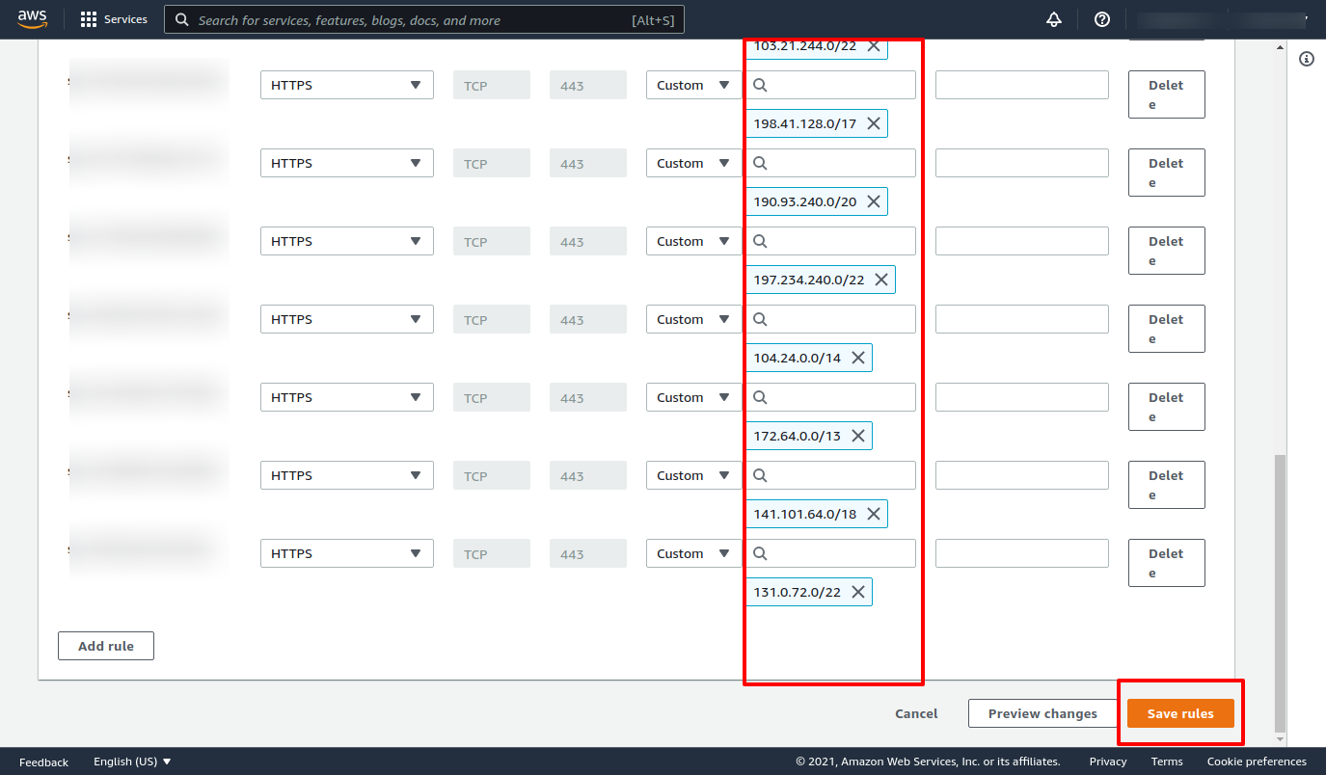

# 3). Add Elastic IP address in AWS

### 3.1) What is Elastic Ip and why is it useful?

The Elastic IP address is a public **static IPv4 address** that is reachable from the Internet. Basically, Elastic IP addresses are used by AWS to manage its dynamic cloud computing services. Within the AWS infrastructure, customers have virtual private clouds (VPC), within the VPCs, users have instances. So when you launch an EC2 instance, you receive a Public IP address by which that instance is reachable from the internet. Once you stop that instance and restart the instance you get a new Public IP for the same instance. So it's basically a problem to connect your instance from the internet for not having a static IP. To overcome this problem, we attach an Elastic IP to an Instance that doesn't change after you stop/start the instance.

### 3.2) Open the Amazon EC2 console at<https://console.aws.amazon.com/ec2/>

In the navigation pane, choose Network & Security, Elastic IPs.

### 3.3) Choose Allocate Elastic IP address.

### 

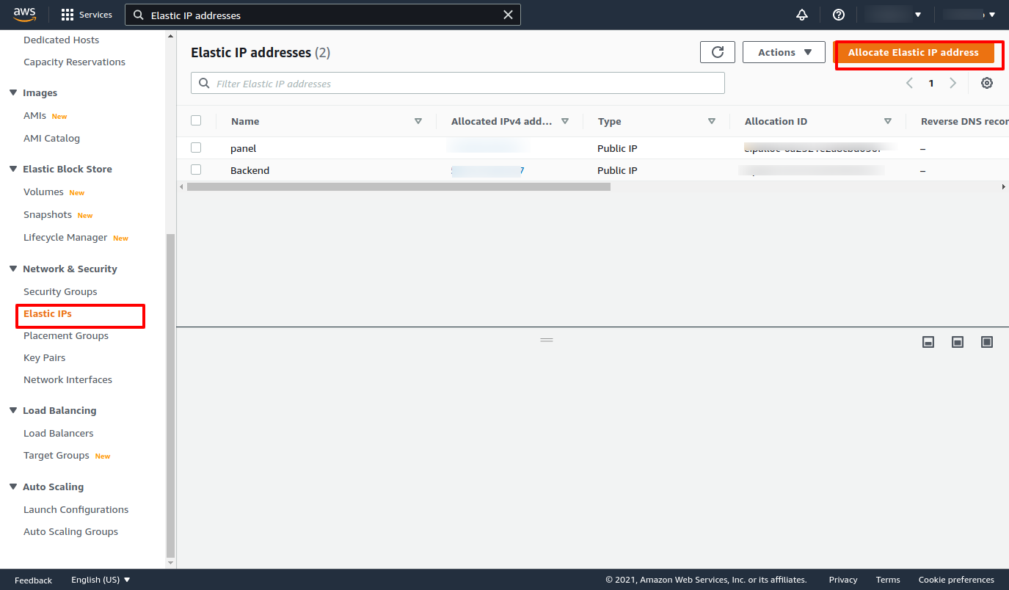

### 3.4) For the Public IPv4 address pool, choose one of the following and then allocate

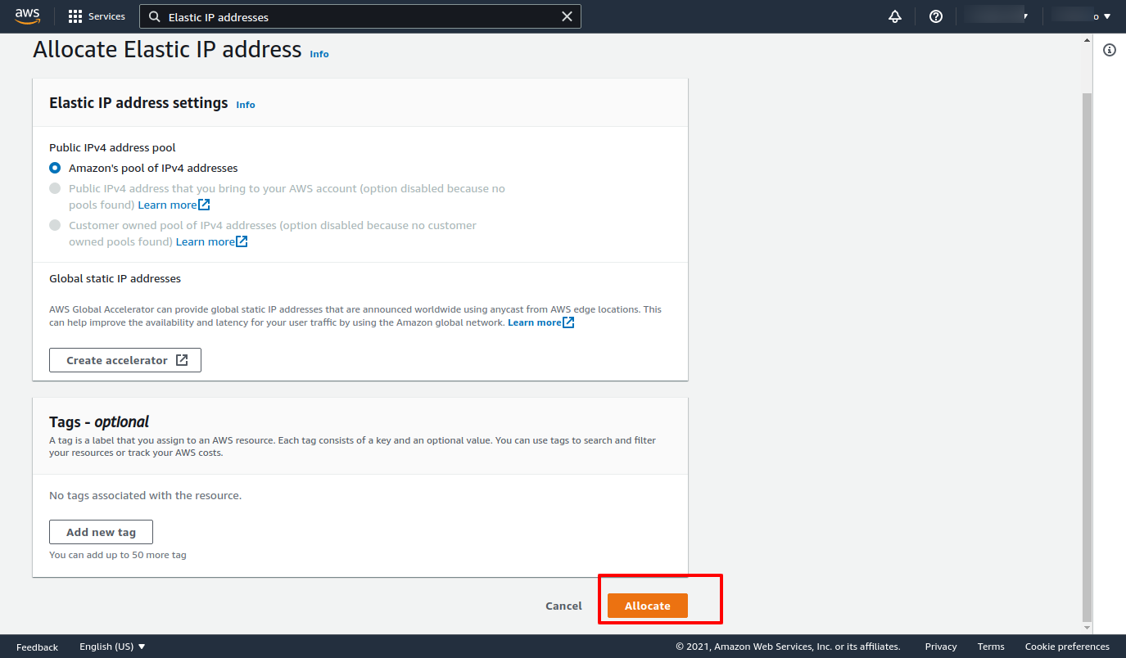

### 3.5) Now Select IP and click on allocate an elastic IP address.

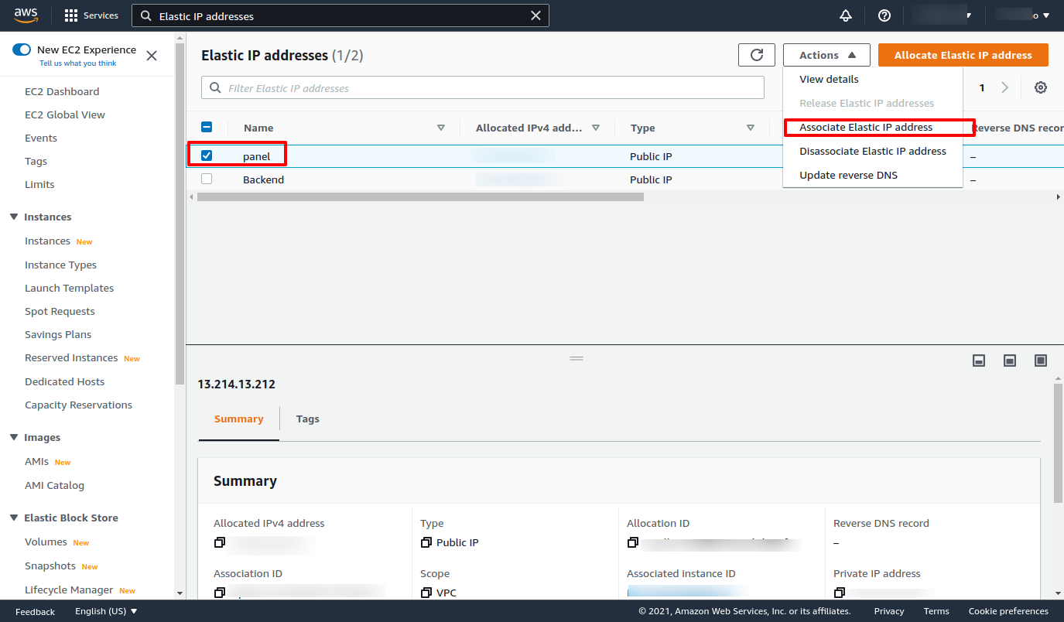

### 3.6) Select your project Instance and allocate.

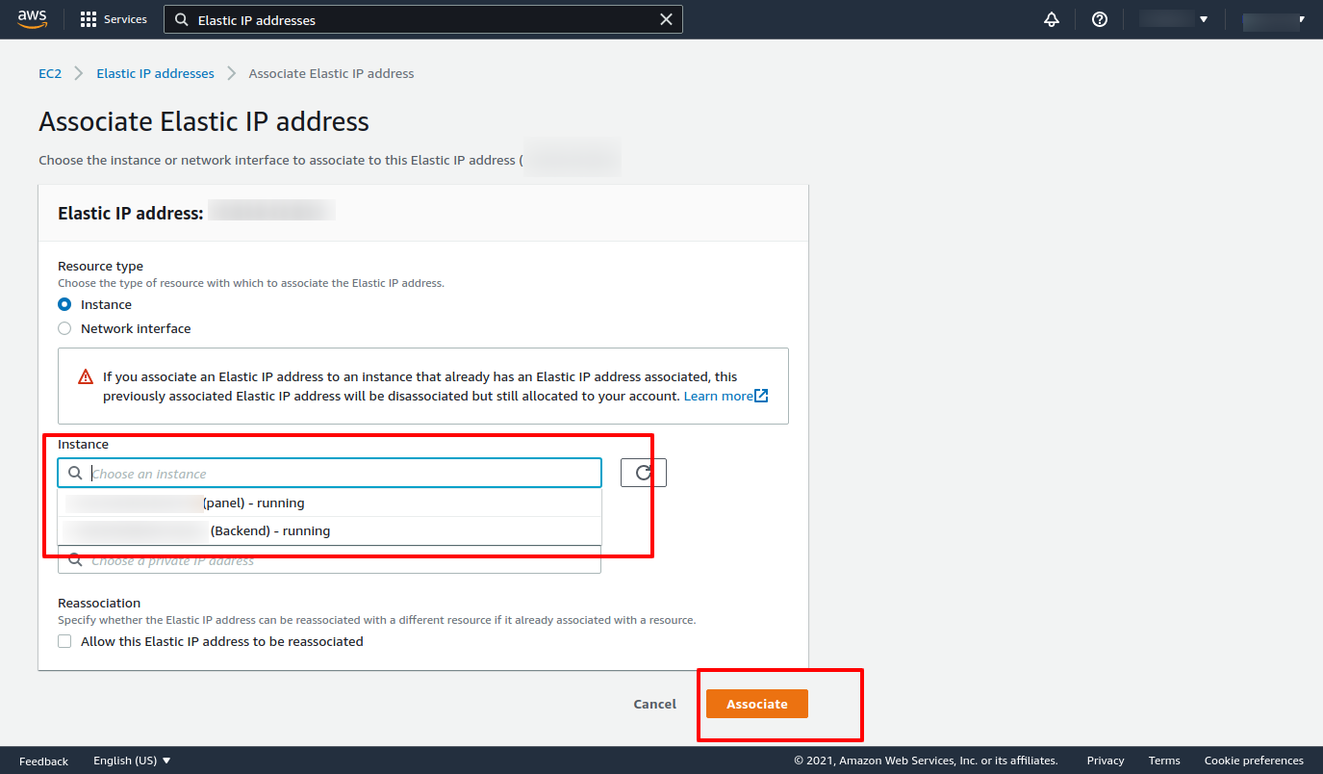

# 4). Create s3 Bucket in AWS.

### 4.1) What is S3 Bucket and why do we use it?

An Amazon S3 bucket is a public cloud storage resource available in Amazon Web

Services' (AWS) Simple Storage Service (S3), an object storage offering. Amazon S3

buckets, which are similar to file folders, store objects, which consist of data and its

descriptive metadata.

Amazon S3 is a program that's built to store, protect, and retrieve data from “buckets” at

anytime from anywhere on any device. ... Use cases include websites, mobile apps,

archiving, data backups and restorations, IoT devices, enterprise application storage, and

providing the underlying storage layer for your data lake.

### 4.2) Click on s3 from all services

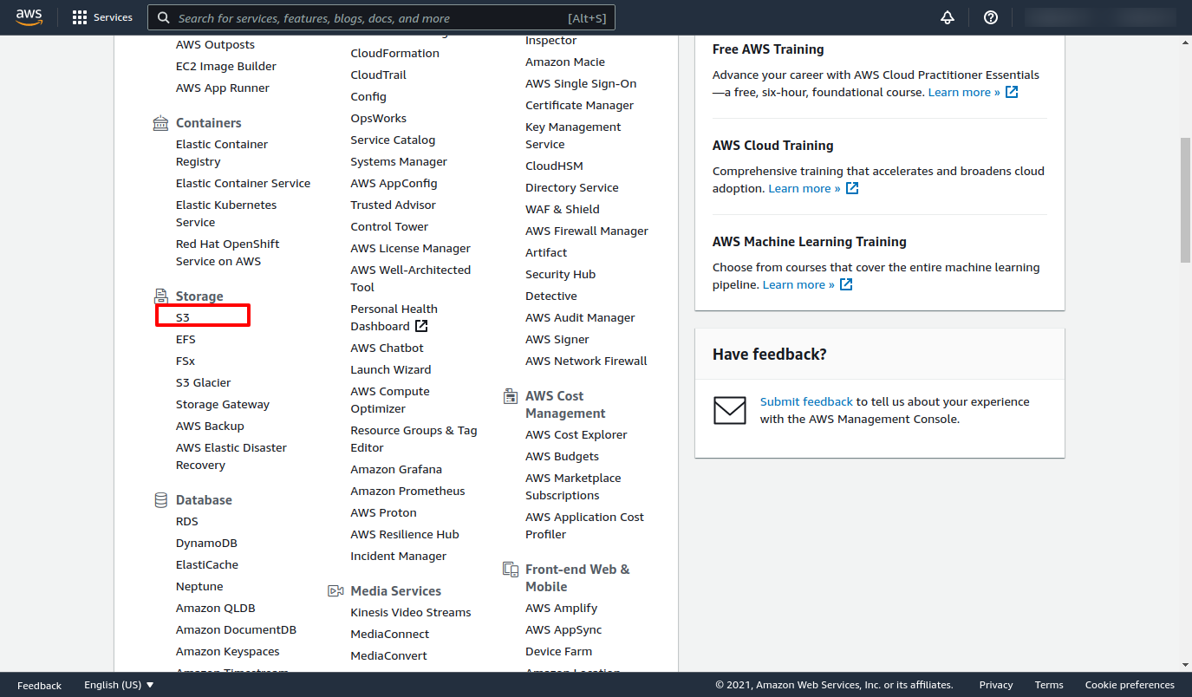

### 4.3) Click on create a bucket

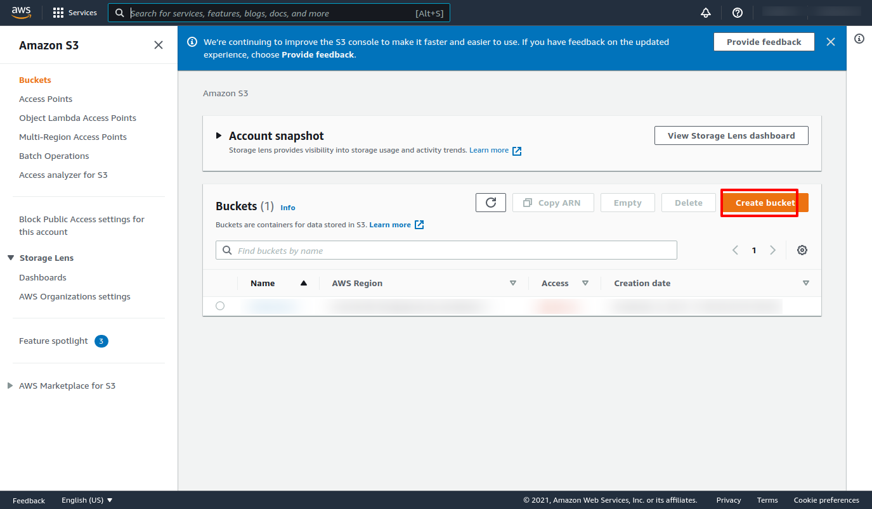

### 4.4) Add bucket name and select region according to country.

● In Bucket name, enter a unique name for your bucket.

● Choose a Region close to you to minimize latency and costs and address regulatory

requirements. Objects stored in a Region never leave that Region unless you explicitly

transfer them to another Region.

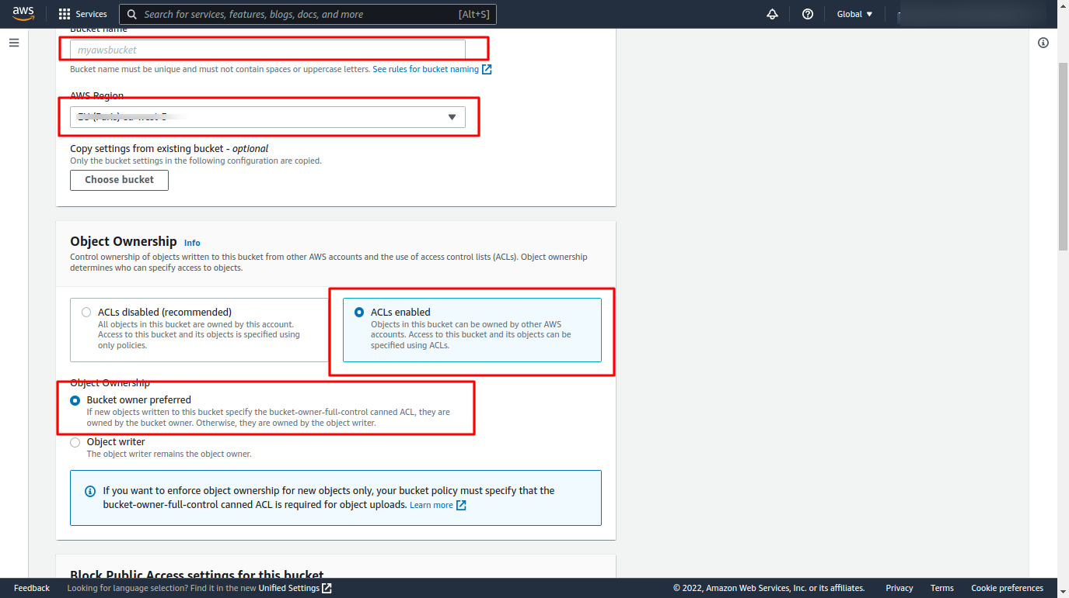

### 4.5) Unblock public access.

● We need to disable the block off public access

● Accept the Acknowledge because our bucket gives the public access.

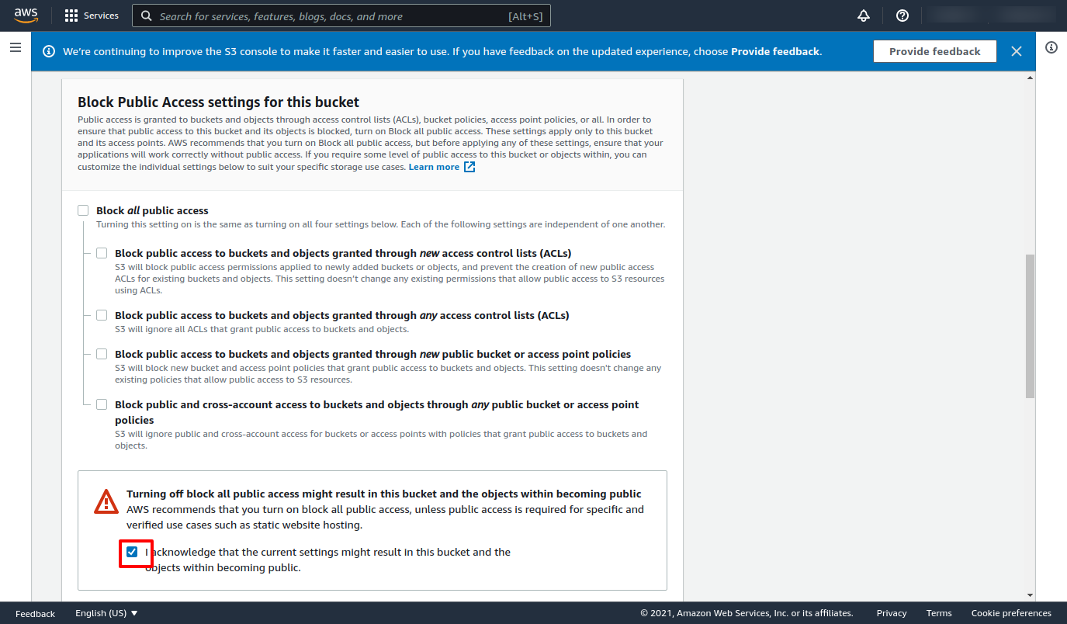

### 4.6) Now Click on Create Bucket.

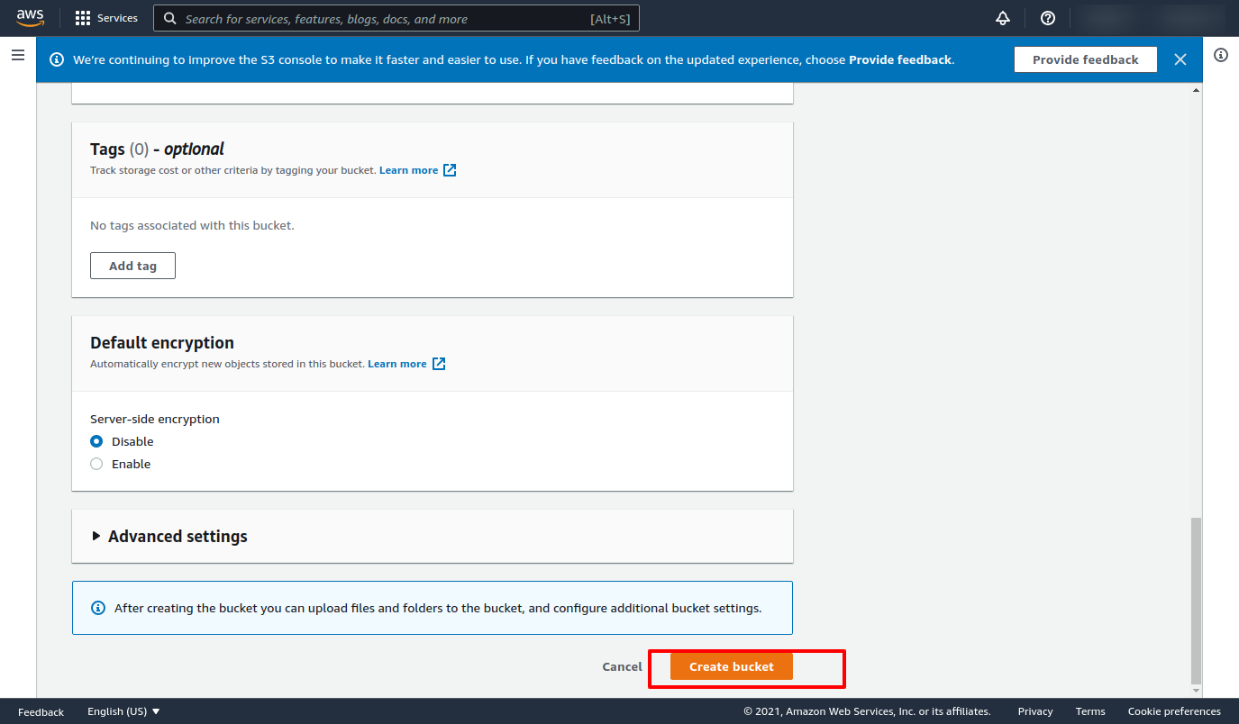

### 4.7) how to get an S3 bucket image URL

1) Upload image in s3 bucket and select that image and open properties.

2) In object overview copy that Object URl .

3) It will look something like - “http://your-bucket.s3-website-us-east-1.amazonaws.com”

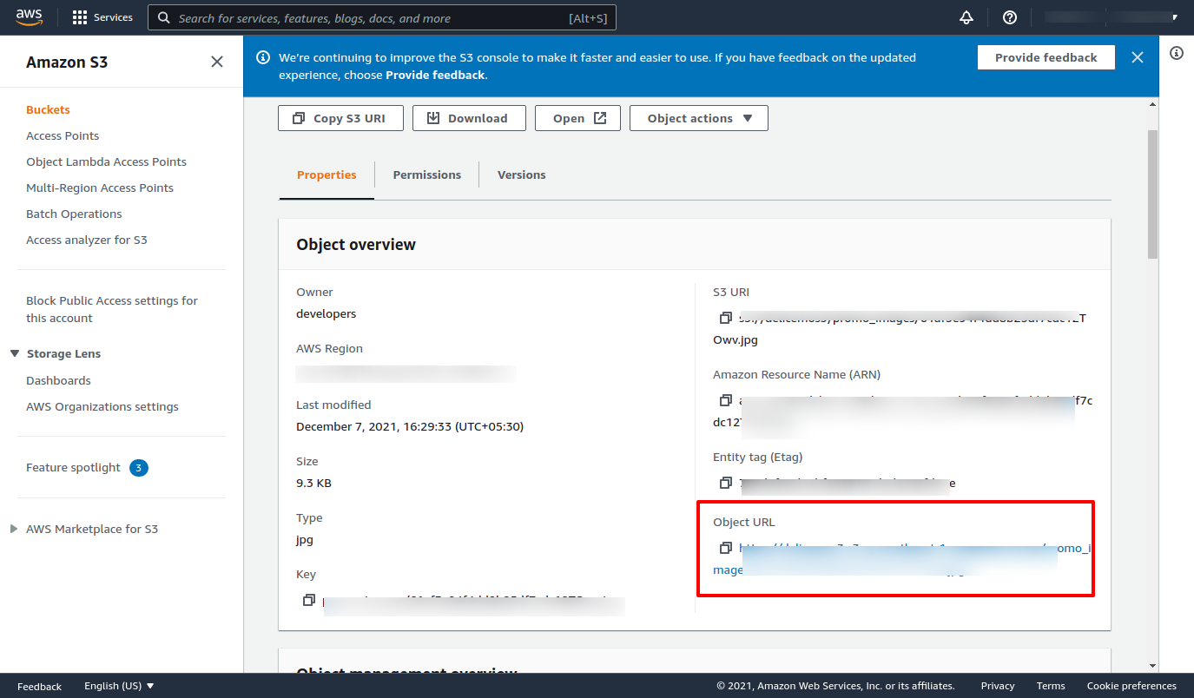

### 4.8) S3 bucket Access key and secret key download and save it.

1. Save this key & Add this Access key & Secret key in the Database..
2. Add bucket name in Database.

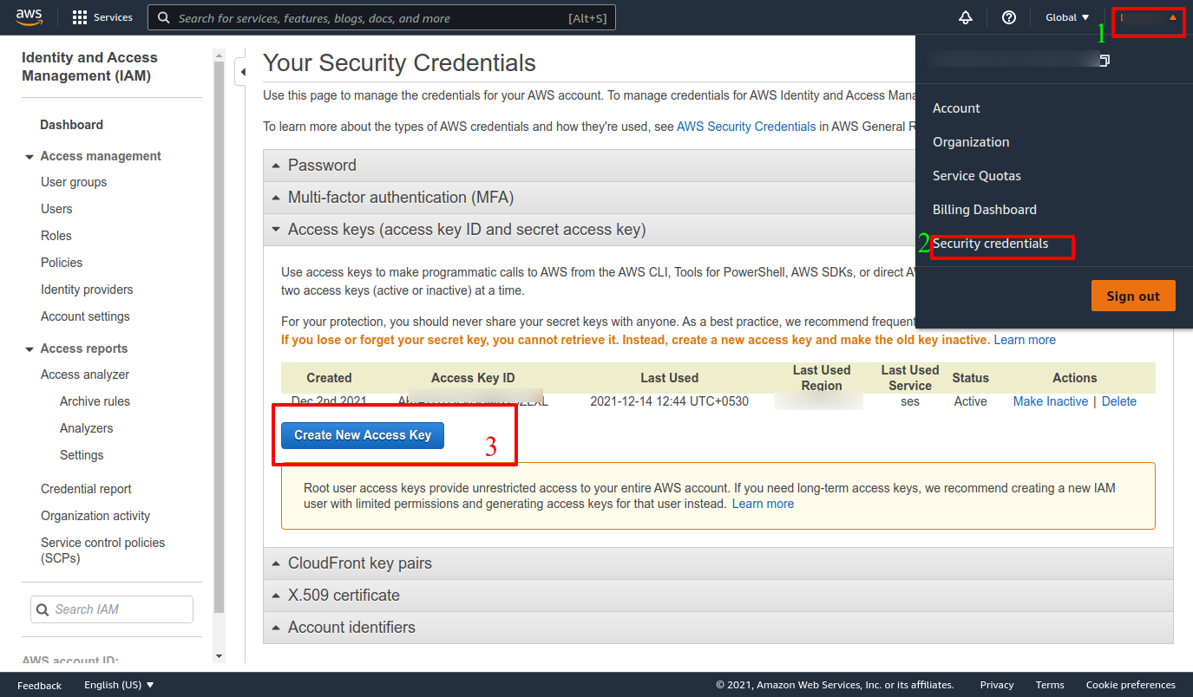

# 5). Pointing Domain name, and SSL certificate

Now as our code is now running on the server, we can't open our application from search engines or web browsers using domain names.

For that, we need to setup a few things and that are:

1. Domain Name

2. SSL certificate

### 5.1 Domain Name(DNS)

For Domain configuration we are using Cloudflare (https://www.cloudflare.com). Register your account and go to the DNS section and click Add Record. On the given input field in the type section select A (A records) and in name enter @ and in IPv4 enter the IP address of our server, then click Save. For subdomains click add new record again and in the type section select CNAME and in the name section enter admin and in IPv4 enter @ (it indirectly points to our server IP address). Add 9 more subdomains for api, history, payment, notification, admin, driver, corporate, dispatcher, partner.

Generally, for our user panels, we use our domain name instead of sud domains, And now we are done with our Domain pointing.

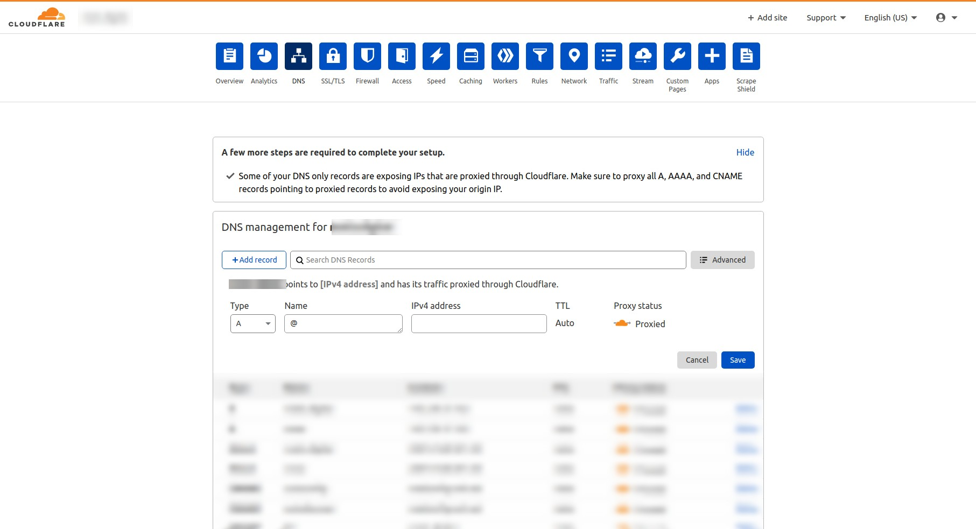

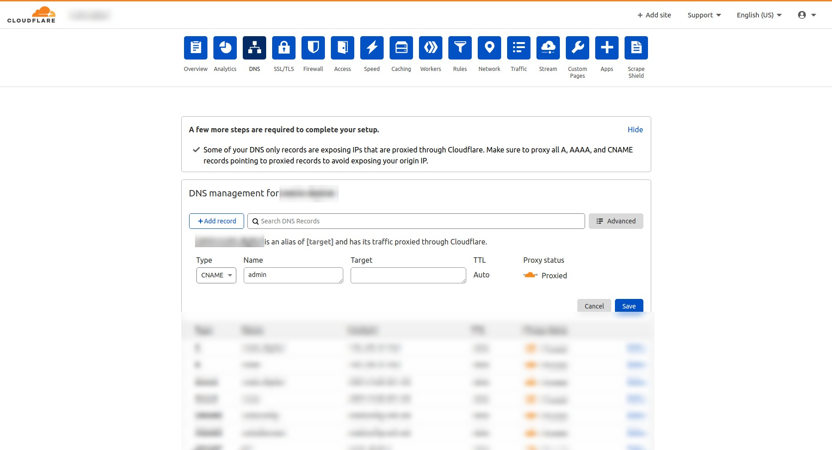

### 5.2 SSL certificate

Now we have a domain pointed to our IP address, let’s create an SSL certificate to secure our domain. Let’s head towards Cloudflare for SSL certificates (https://www.cloudflare.com). Head towards the SSL/TLS section(SSL\TLS > Overview) and select your plan(prefered full strict). For certificates go to SSL/TLS > Origin Server to generate certificates. Please check screenshots for References.

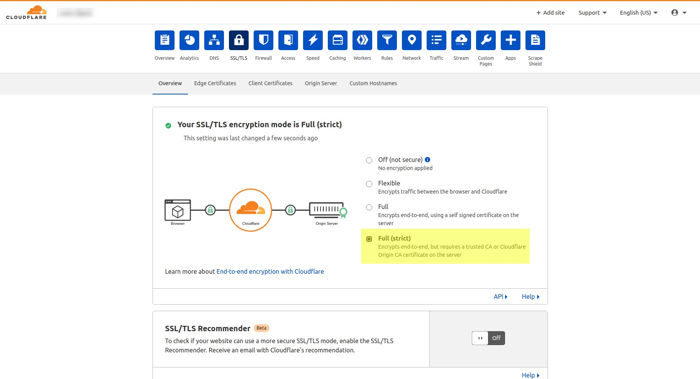

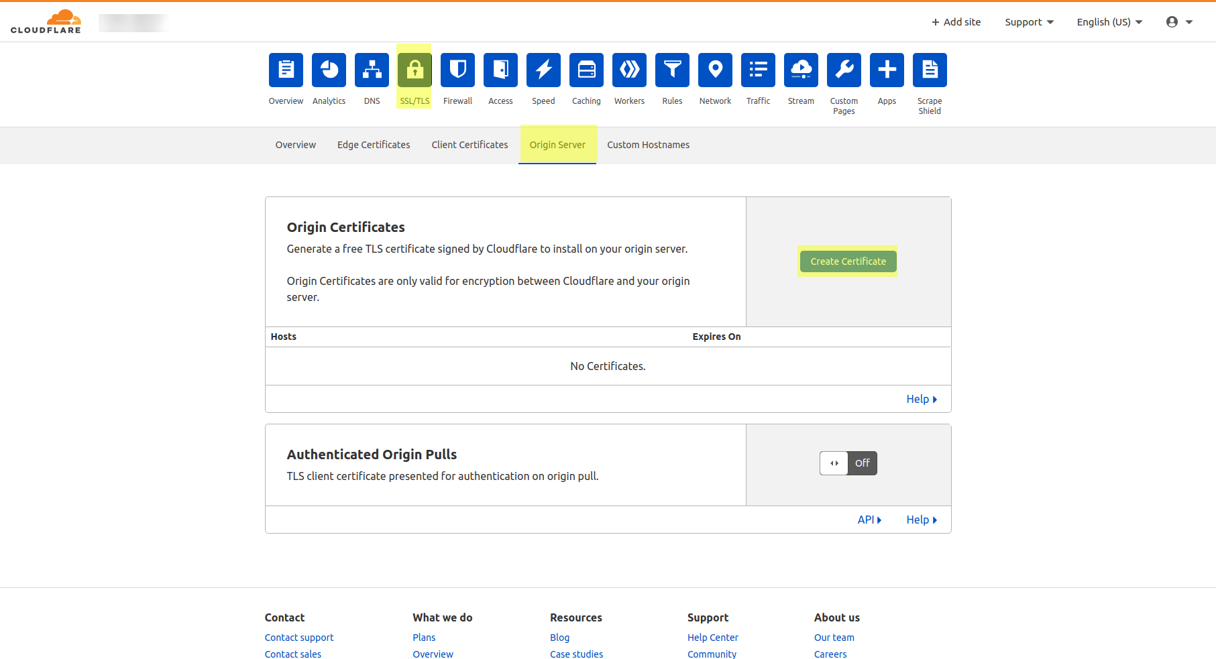

# 6) Establishing SSH connection to connect server and installing environment for our code to run.

We will be Using putty for establishing SSH connection between our system and server.

What is PuTTY ?

PuTTY is a free and open-source terminal emulator, serial console, and network file transfer application. It supports several network protocols, including SCP, SSH, Telnet, rlogin, and raw socket connection. It can also connect to a serial port. The name "PuTTY" has no official meaning.in short, it is used for connecting the ubuntu server in any operating system for application installation on the domain server.

### 6.1 Open PuTTY using ip

### 6.2 Enter username and password in the PuTTy console :

(if you connect with the key and ip then no need to provide a username

and password at that time hostname be like : username@ip

for ex : ubuntu@91.233.33.191 or root@91.233.33.191)

→ want to connect with ssh

Root : ssh root@ip

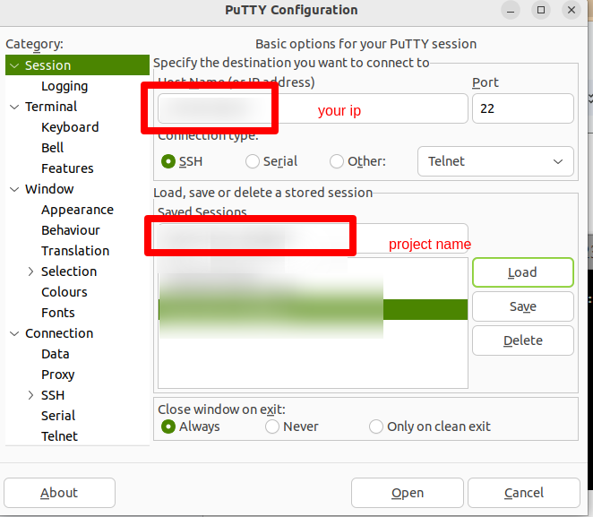

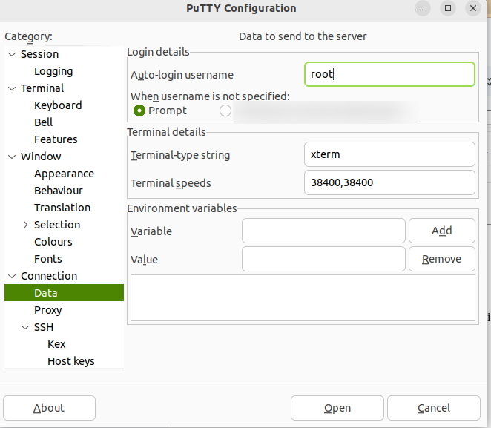

After this go to session page and save the detail try to connect with open button

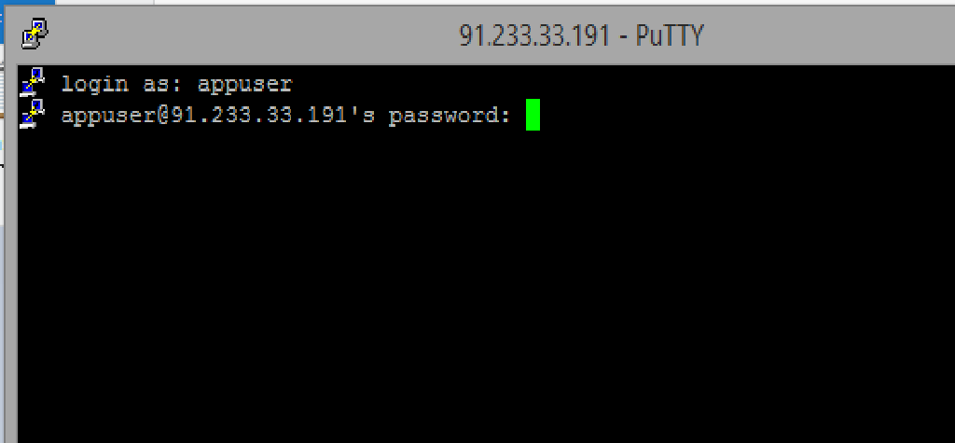

This will ask you password of root and you will get connected

## 

## 

### 6.3 Connect with PEM File

## ubuntu : ssh ubuntu@ip -i /path/to/pem/file



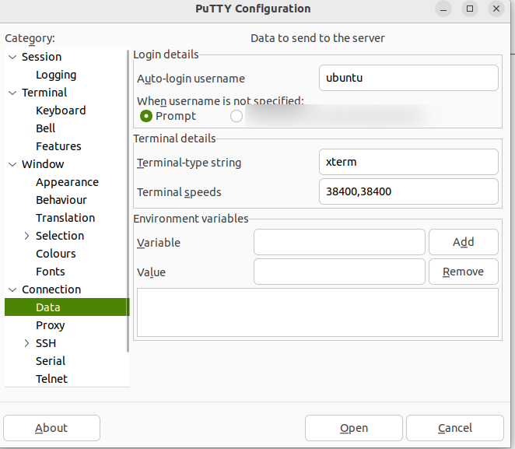

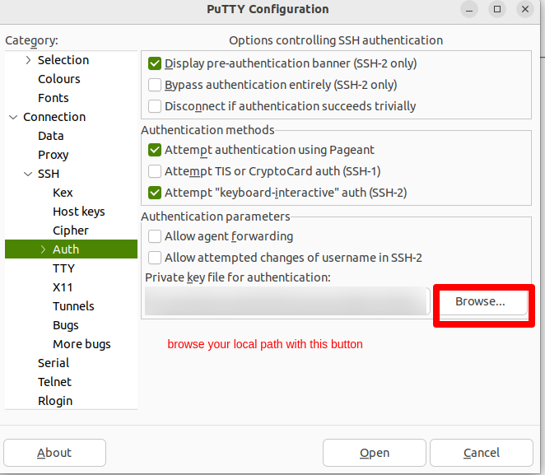

After this go to session page and save the detail try to connect

### 6.4 Perform the below steps to install all dependencies or important server domain:

**Command to change permission from root (Used in AWS) :**

sudo chown <hostname>

hostname = root(for digitalocean/vultr domain) /

ubuntu(for AWS domain) /

**installing environment for our code to run**

○ Place installation bash script file in the instance where you want to perform installation.

○ Run this file with the use of following command:

bash BASH_FILE_PATH

○ It will ask you to enter choice,

press 1 if you want full Installation

press 2 if you want custom Installation

1) For Full Installation , you have to do following steps

○ This process will install all required dependencies, packages and applications automatically.

○ This installer file has appropriate description at each stage.

○ It will ask for version selection for Nodejs and MongoDB.

○ In the "default file" configuration stage it will ask to input total number of domains along

with the port number on which associate server is running.

2) For Custom Installation, you will get following list

0) Exit

1) Update Packages

2) NodeJS

3) Angular

4) Nginx

5) MongoDB

6) Redis

7) Nodemon

8) PM2

9) Install Git

10) Setup Your Project

11) PM2 startup

12) Setup Nginx Default File

13) Install Letsencrypt

○ You can choose from the above list.

**Note**:

If you select default nginx file config so you have to select 10 number of domain here.

user panel - port - 4000 - domain - <domain name>

admin panel - port - 9000 - domain - admin.<domain name>

driver panel - port - 6000 - domain - driver.<domain name>

partner panel - port - 8000 - domain - partner.<domain name>

corporate panel - port - 7500 - domain - corporate.<domain name>

dispatcher panel - port - 7000 - domain - dispatcher.<domain name>

backend server port - 5000 - domain - api.<domain name>

backend payment port - 5002 - domain - payment.<domain name>

backend history port- 5007 - domain - history.<domain name>

Backend notification port - 5003 - domain - notification.<domain name>

### 6.5 Connection to the DB

go to the robo 3t .

Use your mongodb string url from atlas.

# 7). Firebase Configuration

→ Open firebase console

### 7.1 Go to the console.

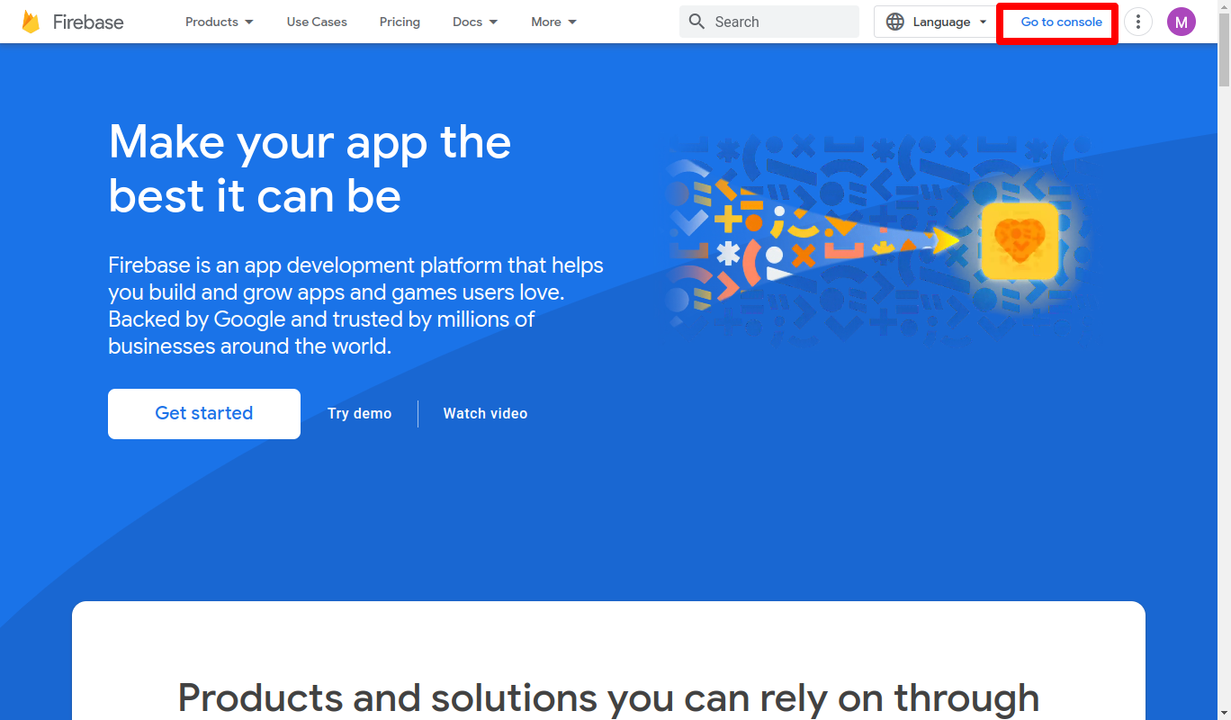

### 7.2 create a project,and complete that 4 step with continue in given image below OR you have to use existing one if project already created.

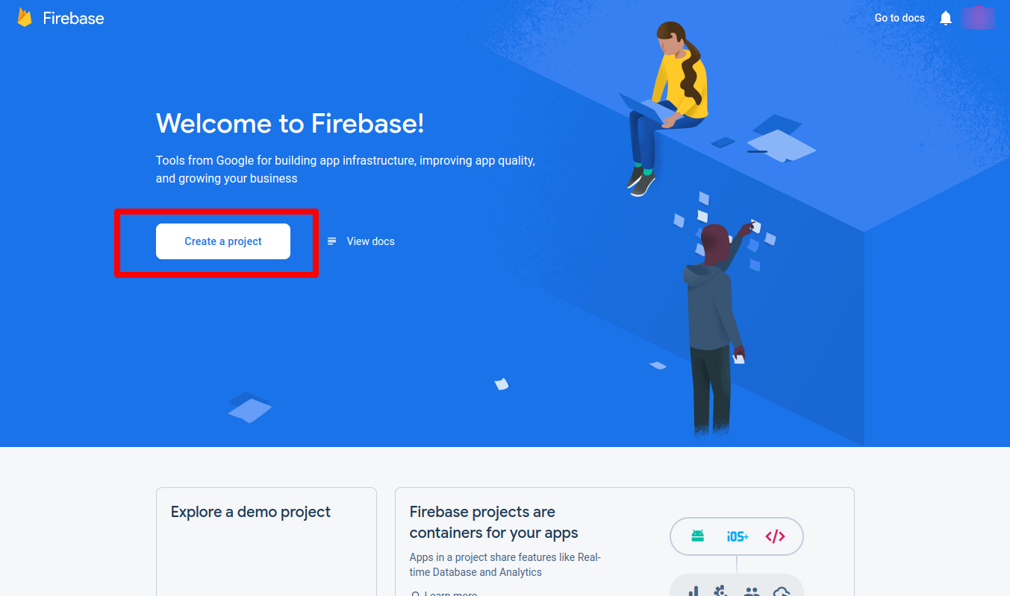

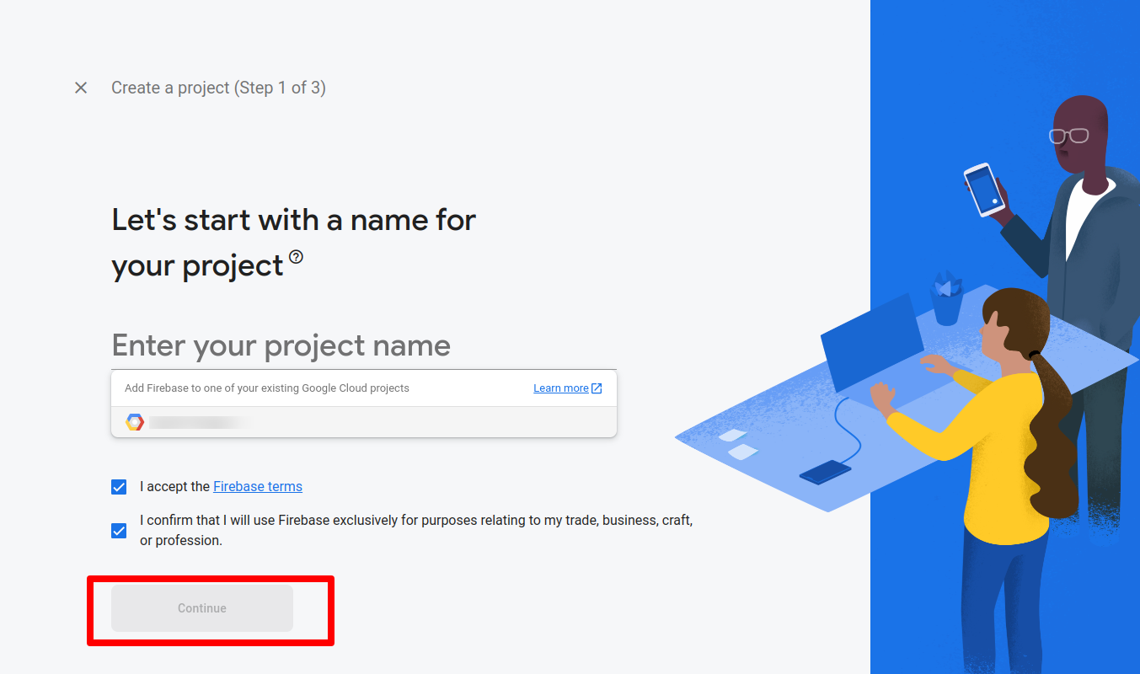

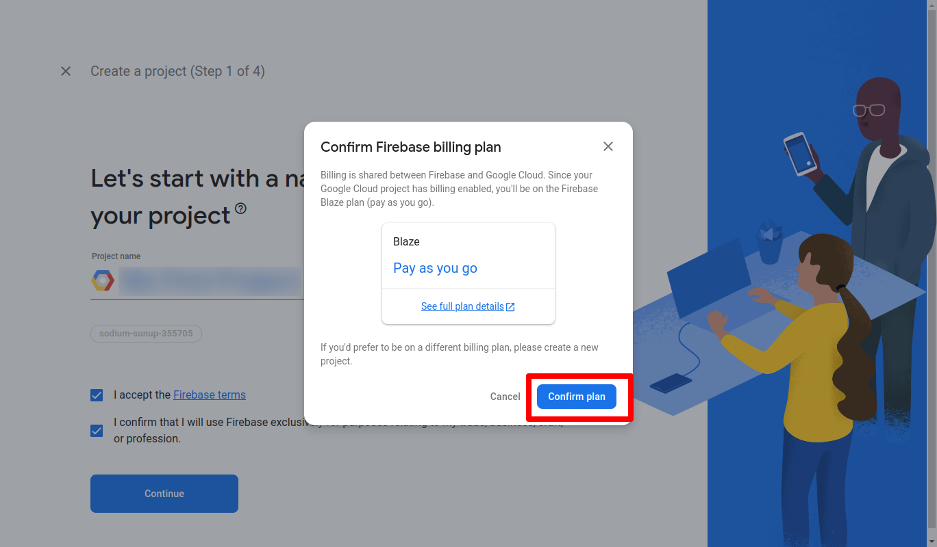

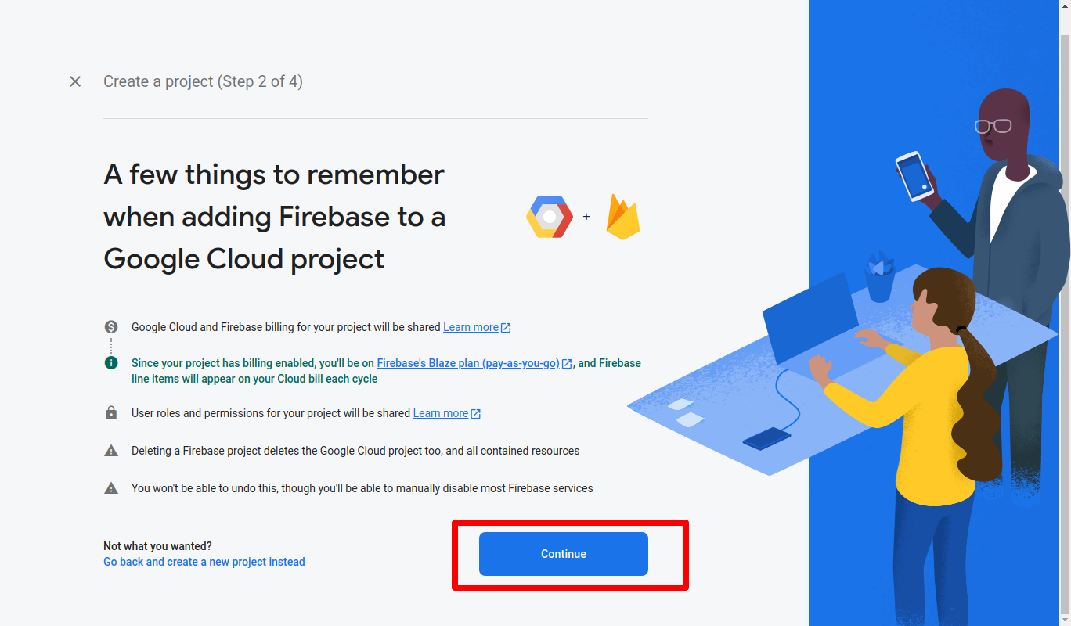

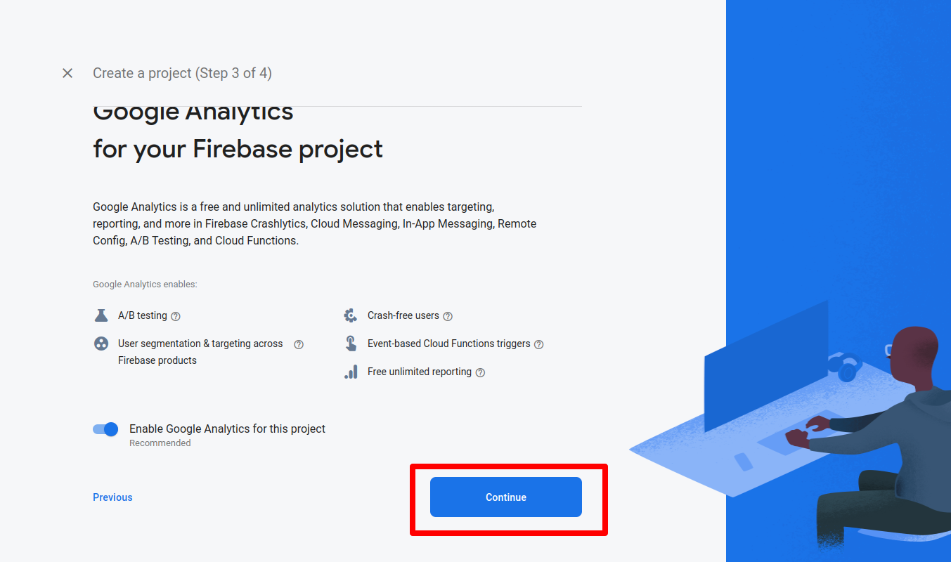

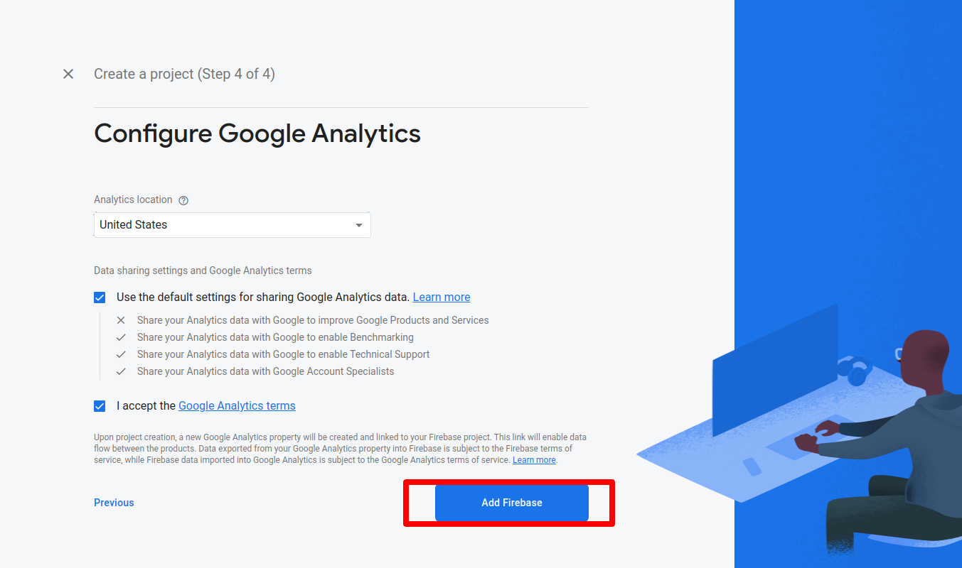

### 7.3 Create a web app in firebase General project settings.

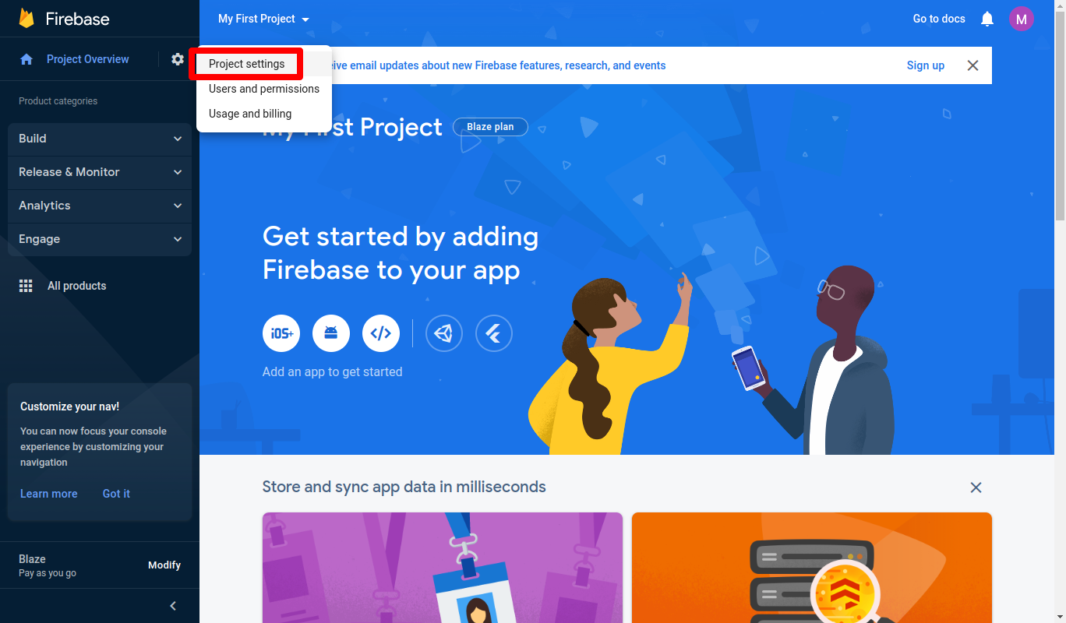

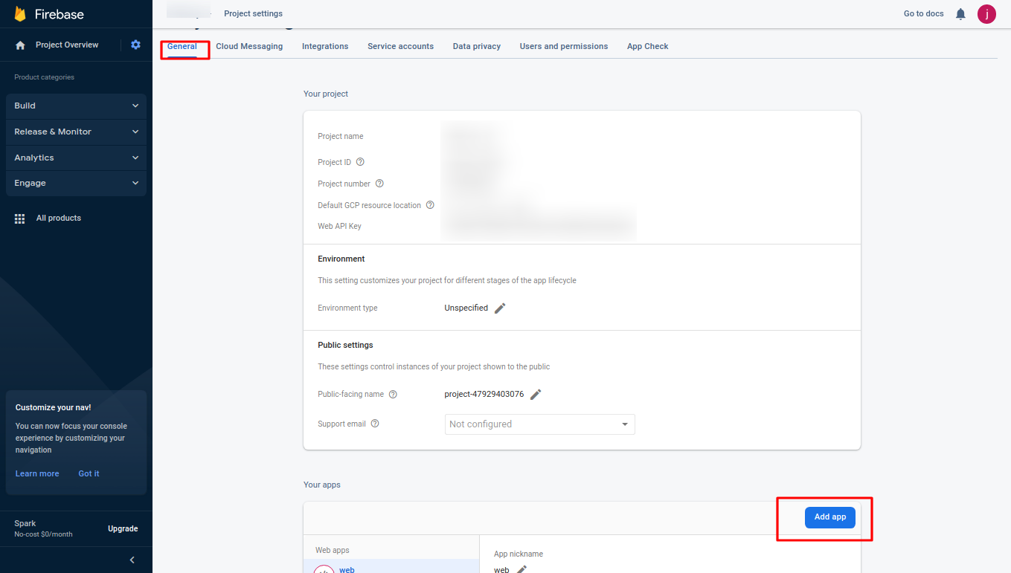

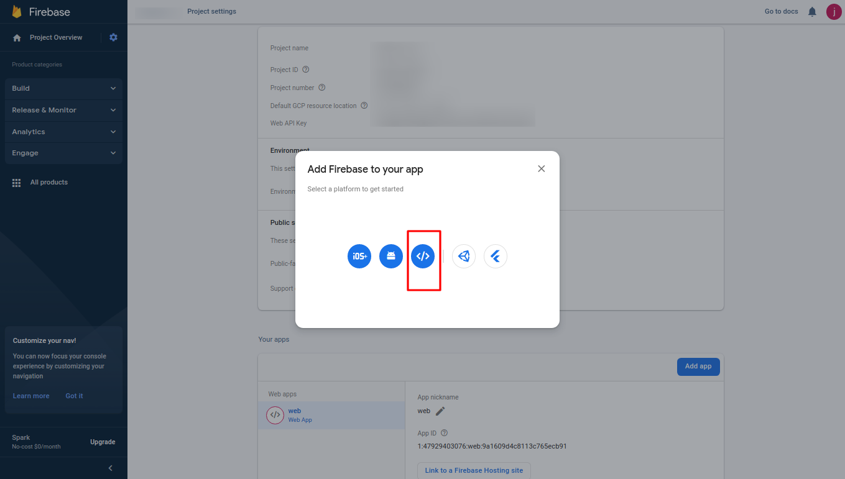

### 7.4 Create a Service account and download, generate a new private key and add in setting database.

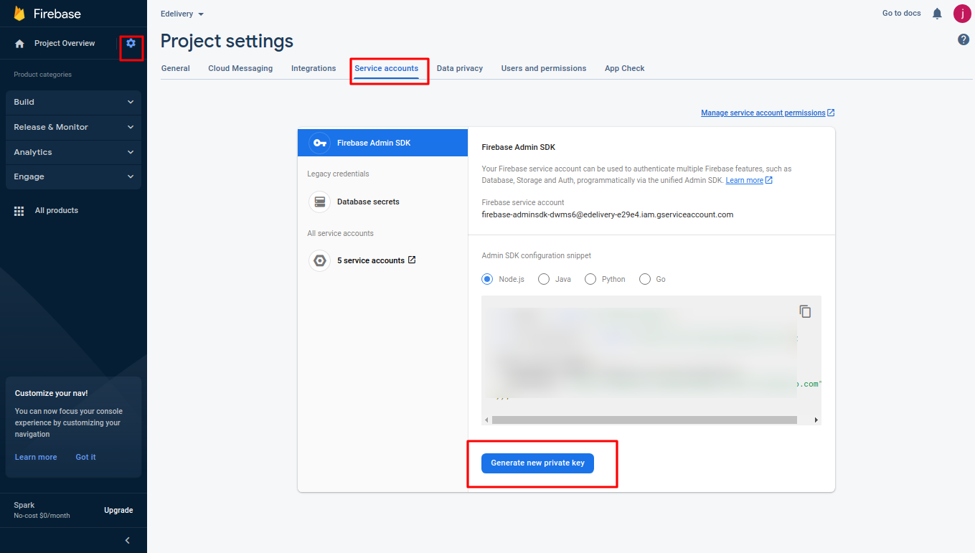

### 7.5 Create a Realtime Database.

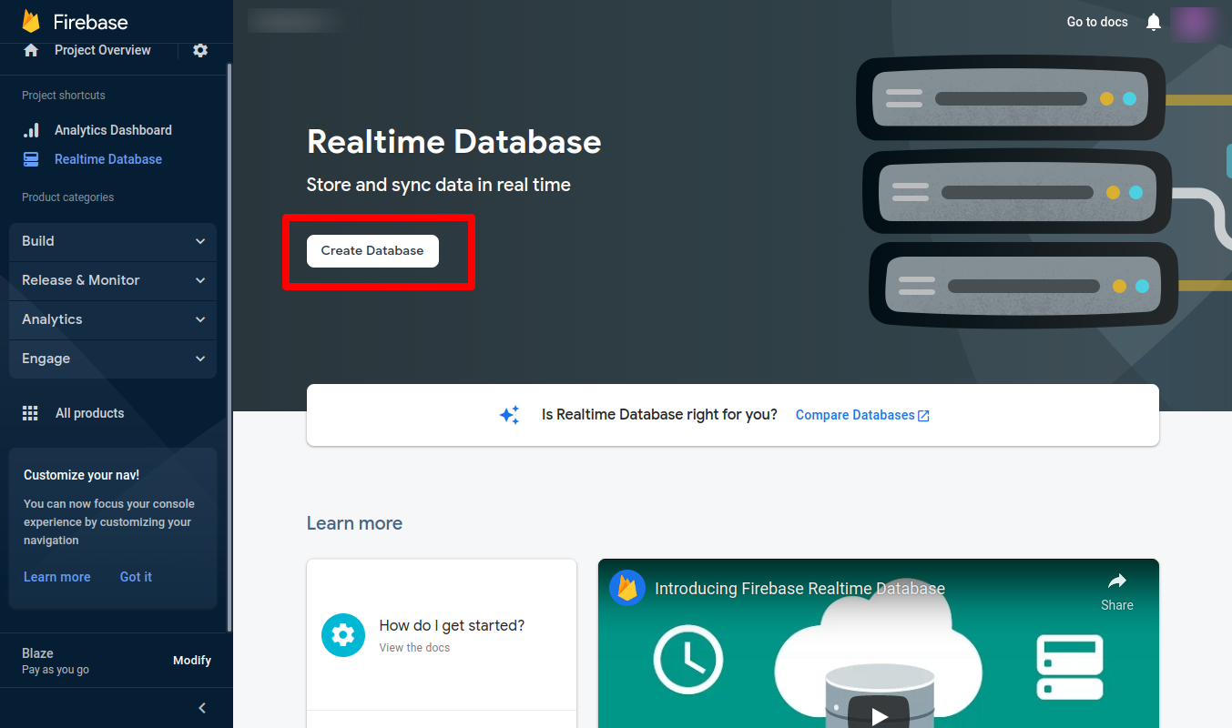

**NOTE**: Always select the US region like this.

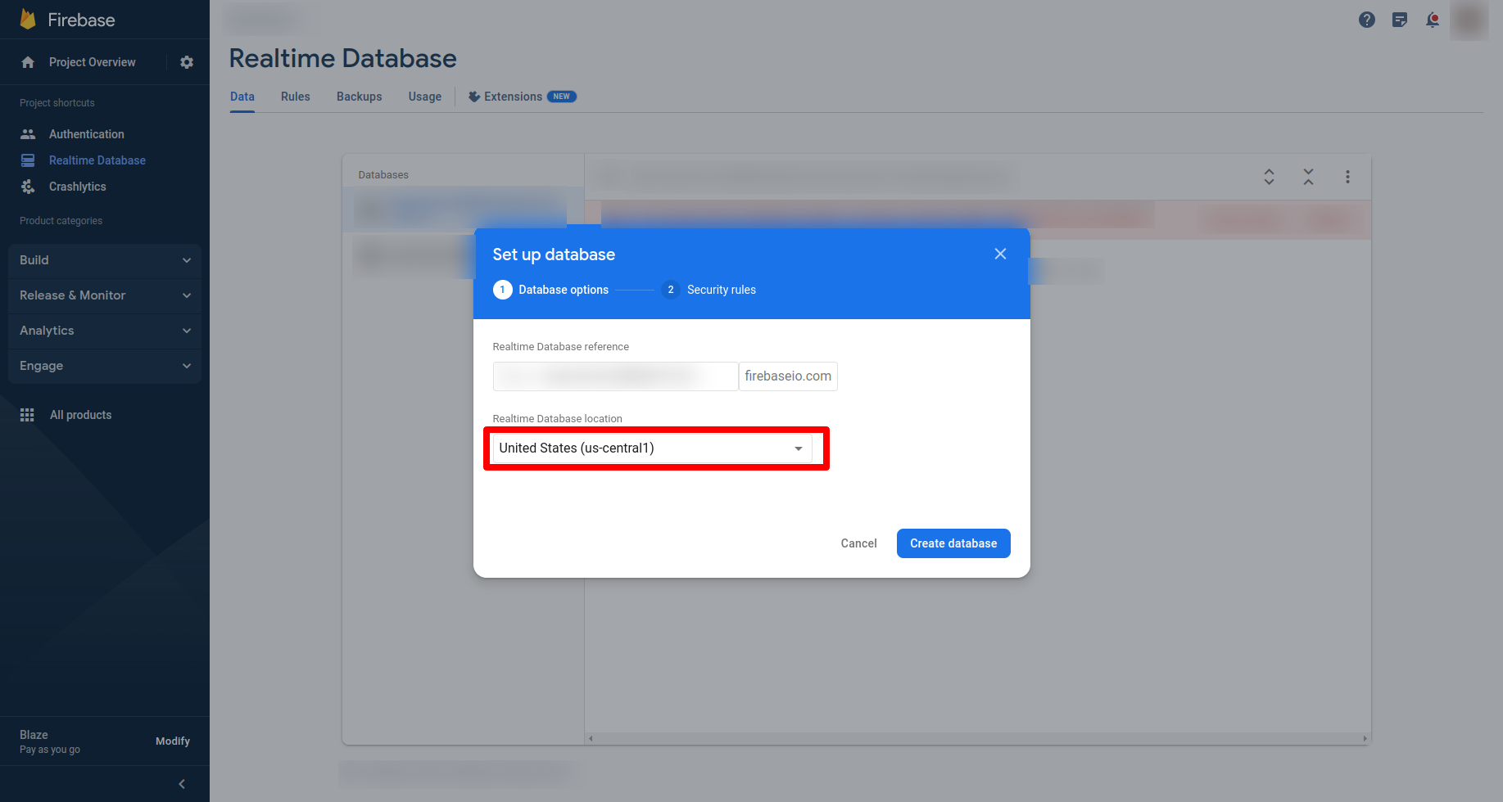

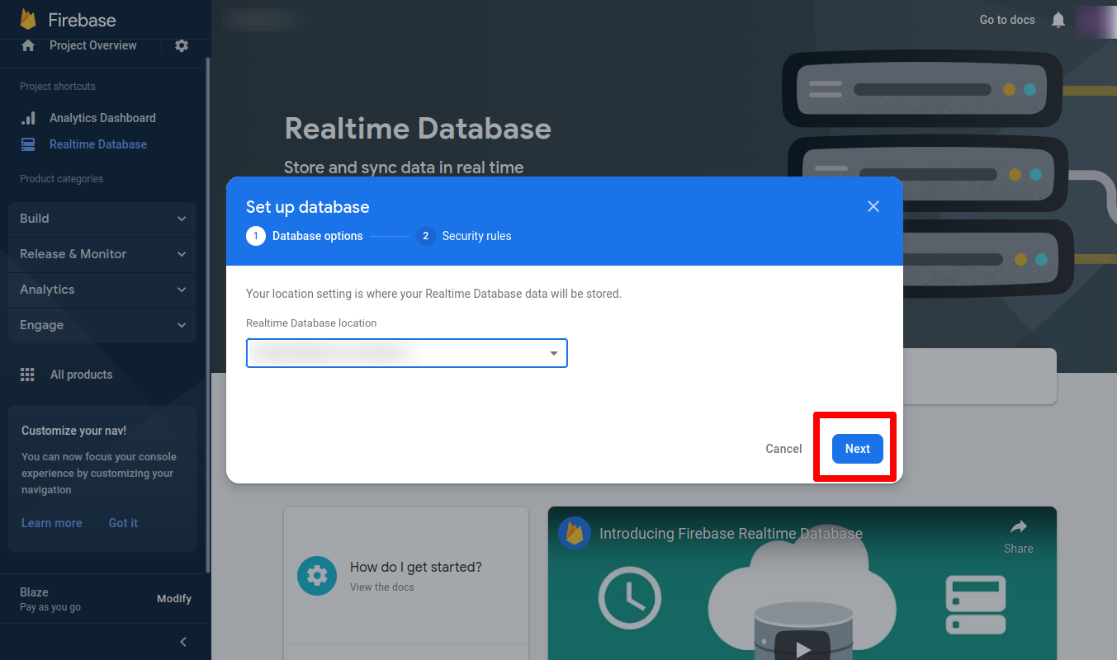

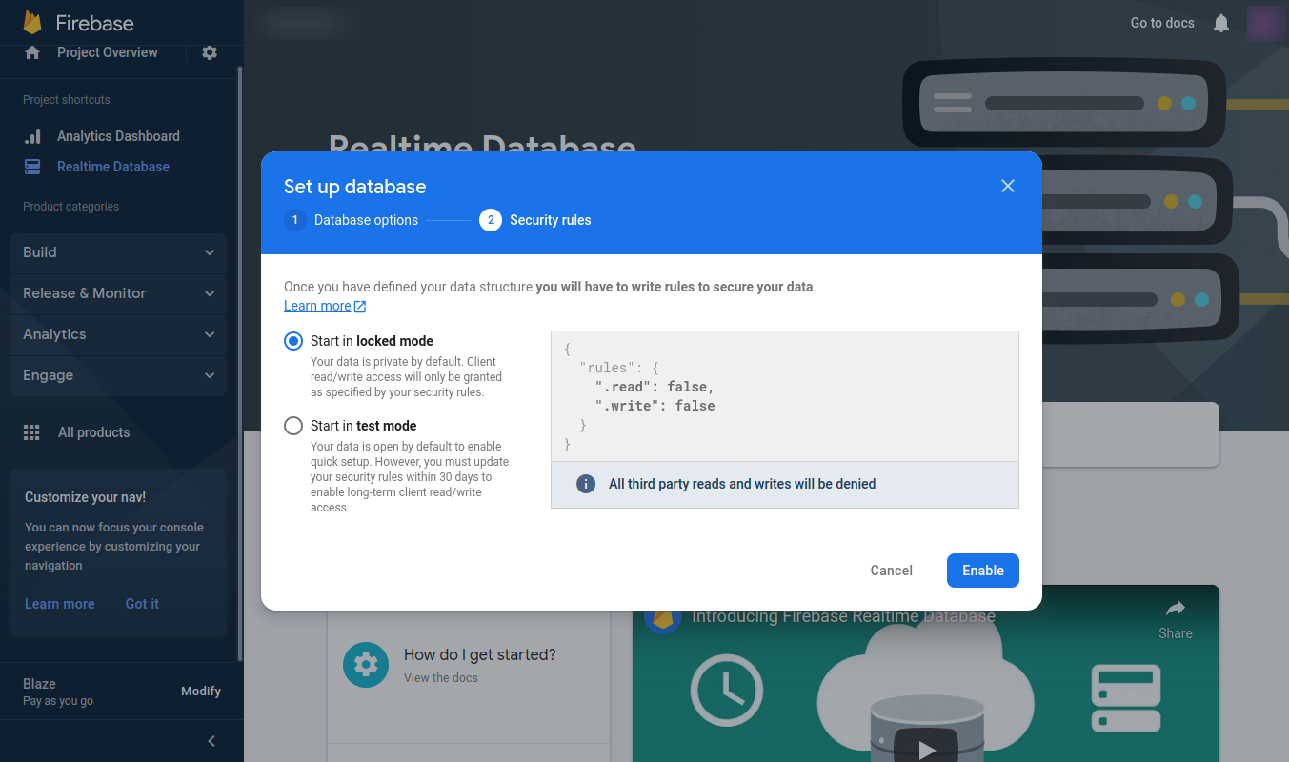

**IMPORTANT NOTE** : After selecting locked mode(false) we have to do manually rules to true and publish.

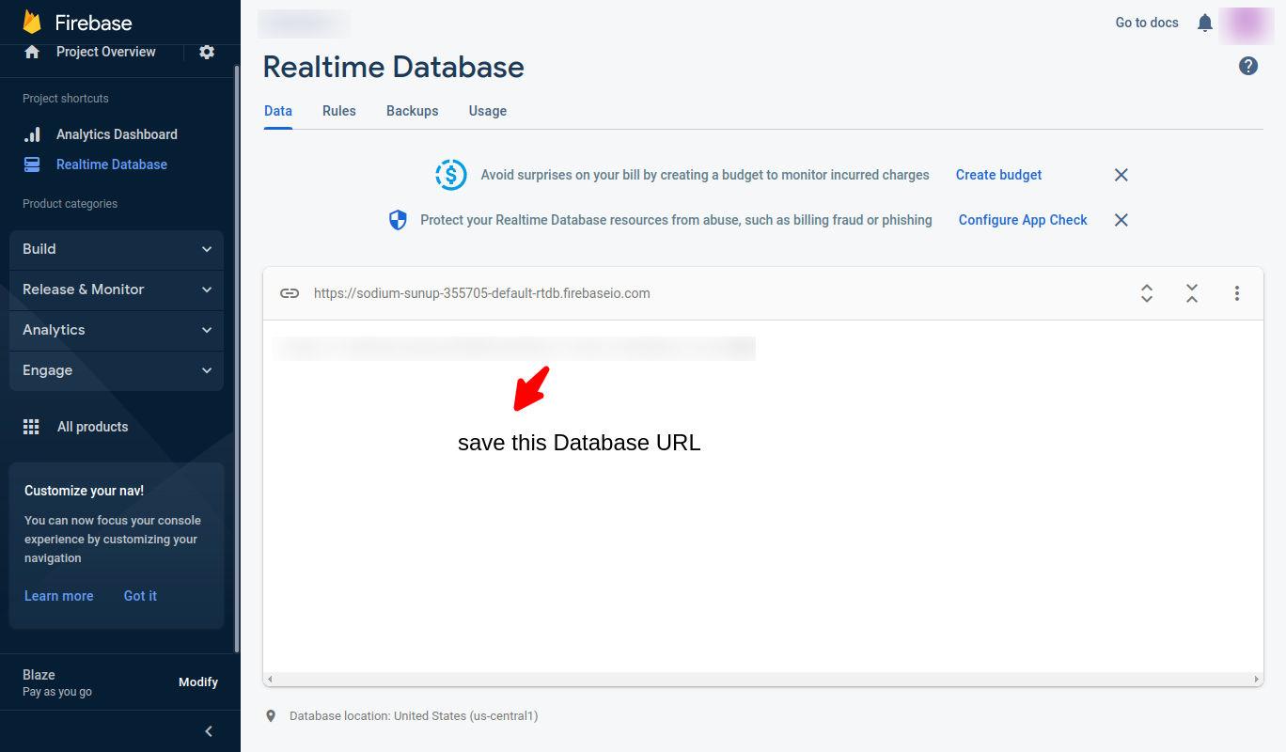

*Note -> Save this url into the database in settings collection.

### 7.6 Add Auth Sign-In Methods.

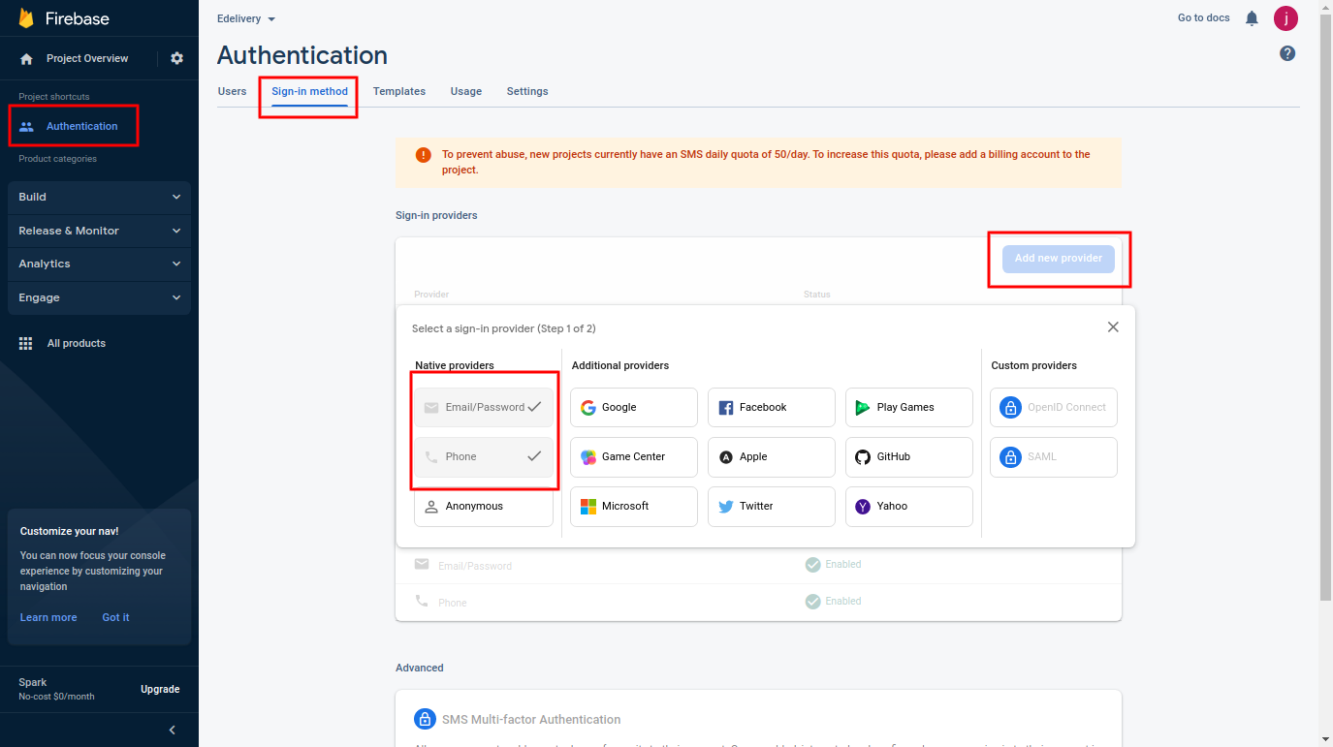

### 7.7 Add this firebase config in your project in all panels And service account json file in database.

src/environments/environment.ts

src/environments/environment.prod.ts

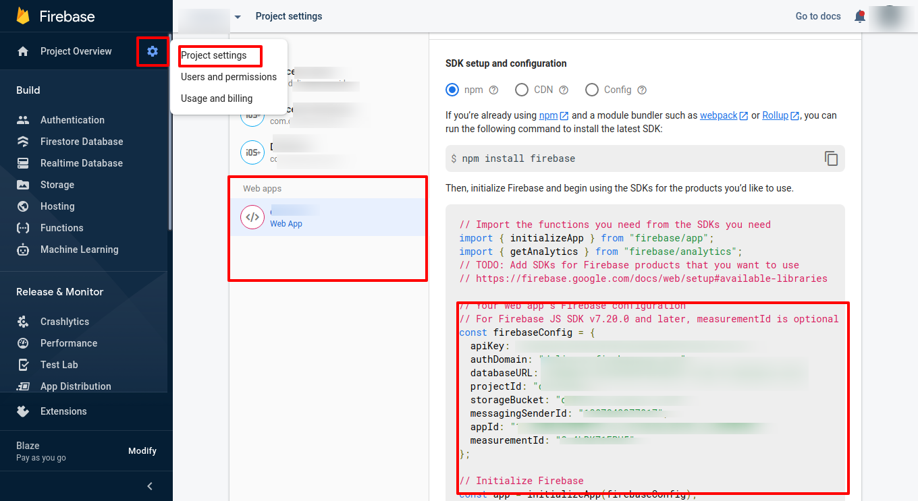

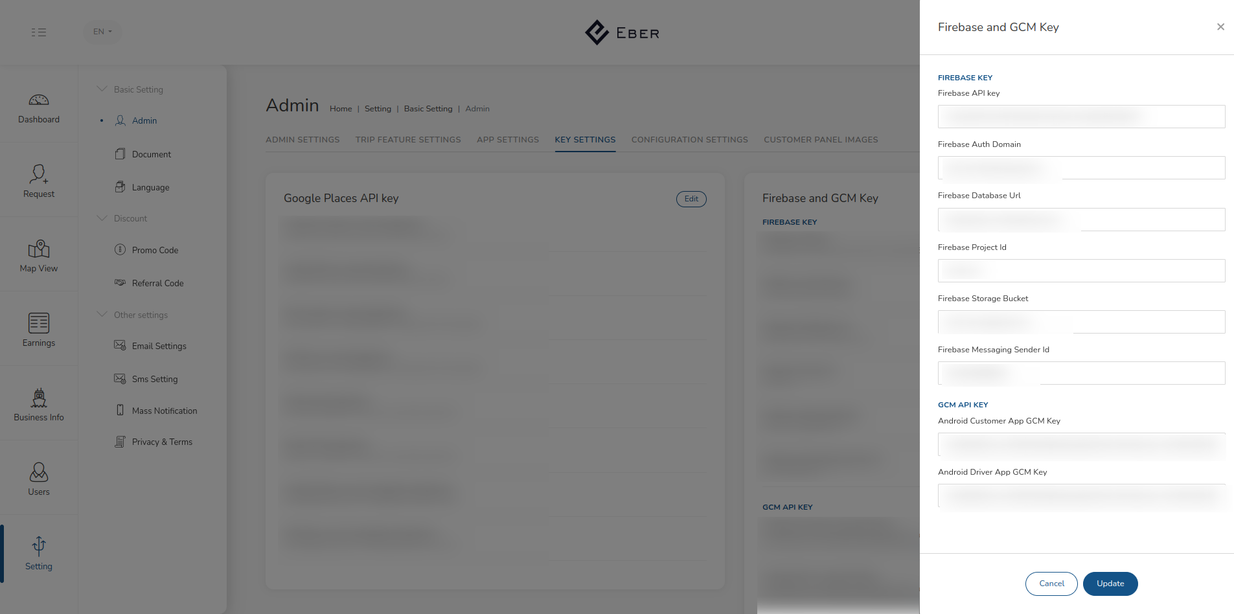

# 8). Basic setup on admin panel for making application fully functional.

Now our applications are live so now we need to do some configurations to make our application fully functional. We need to set Google API keys to make maps work.

As shown in the image head to app settings and press the edit button to set your to google API keys

### 8.1 Set up Google api keys

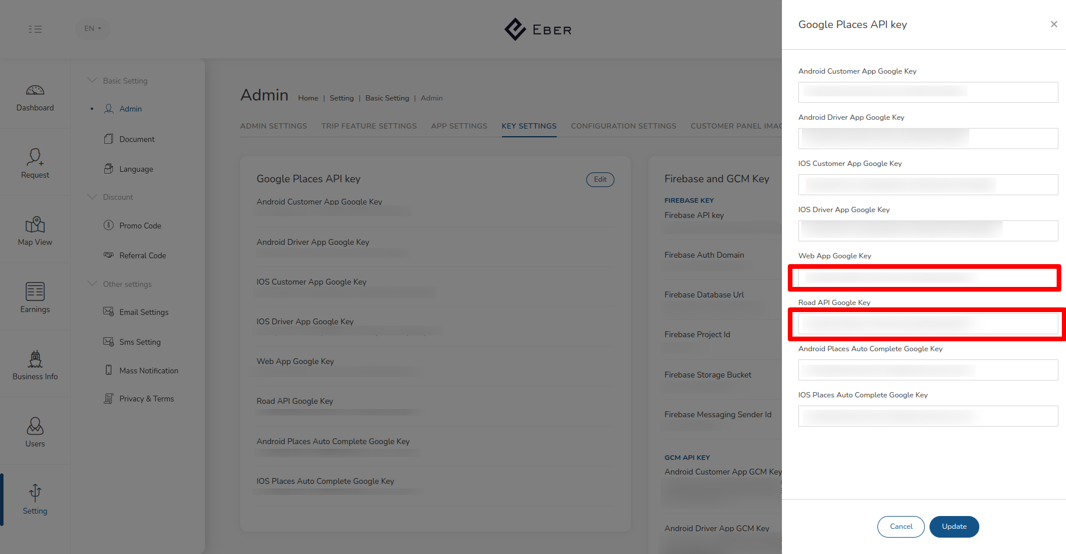

● In the admin panel, navigate to settings, admin, and then key settings.

● Press the edit button located at the top-right corner in User App settings

● Place your google API keys in appropriate fields.

### 8.2 Set up Notification Firebase Keys

● In the admin panel, navigate to settings, admin, and then Key settings.

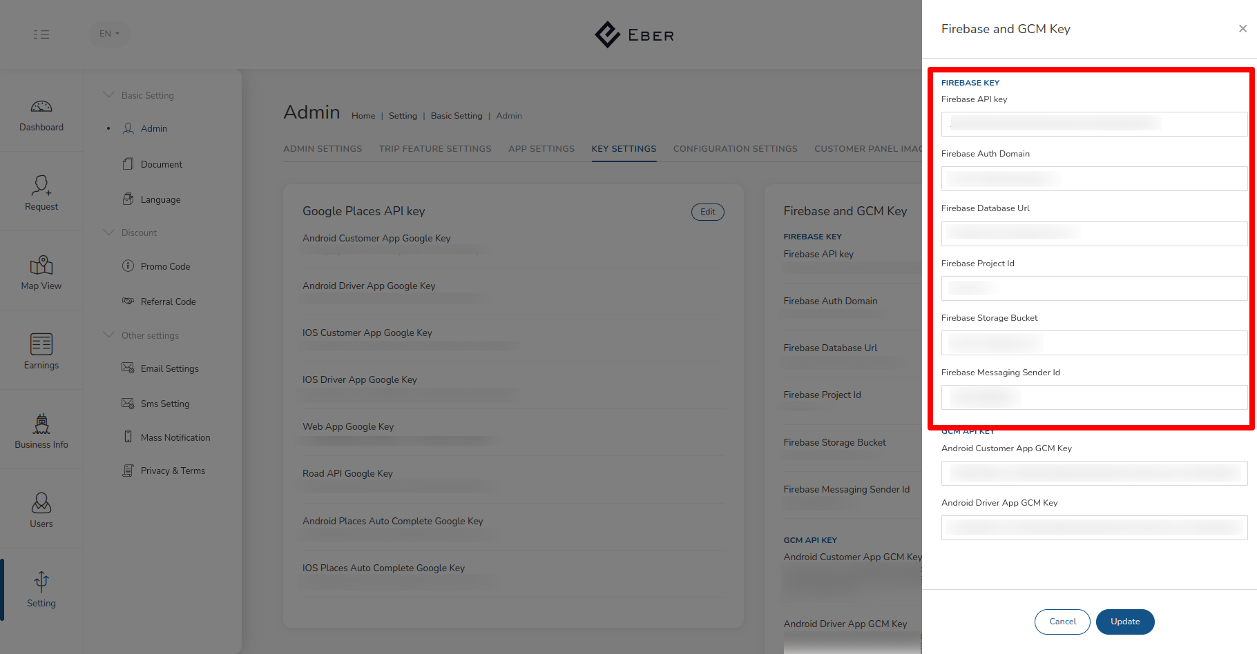

● Now enter your firebase keys in appropriate fields.

## 

# 9). Chat Push Firebase in Backend Instance

### 9.1 Open putty with Backend instance of your project

sudo npm install -g firebase-tools --unsafe-perm

cd /var/www/html OR cd /root

sudo mkdir functions-firebase

sudo firebase login –no-localhost

=>you will get a link

open that link to your browser and log in to your Gmail then you will get

Success in terminal

cd functions-firebase

sudo firebase init

select cloud function

use an existing project

select project

select javascript

Deny ESlint

install dependencies with npm Y

cd functions

then edit your index.js file (this index file you have to make as your DB structure i

am giving here my demo file)

sudo nano index.js

Add the code in index.js

// Code Start

const functions = require('firebase-functions');

const admin = require('firebase-admin');

admin.initializeApp(functions.config().firebase);

exports.sendAdminNotification =

functions.database.ref('/{Topic}/{UniqueId}/{OrderId}/').onWrite(event => {

var topic = event.after._path.split('/');

event.after._data.chat_type = String(event.after._data.chat_type);

const payload = {

notification: {

'chat_type': String(event.after._data.chat_type),

'id': event.after._data.id,

'is_read': String(event.after._data.is_read),

'body': event.after._data.message,

'sender_type': String(event.after._data.sender_type),

'time': event.after._data.time,

'order_id': topic[1]

}

};

if(!event.after._data.is_read)

{

return admin.messaging().sendToTopic(event.after._data.receiver_id, payload)

.then(function(response) {

return console.log('Notification sent successfully:', response);

})

.catch(function(error) {

return console.log('Notification sent failed:', error);

});

}

});

// Code End

cd ..

sudo firebase deploy

# 10). Google API key

### 10.1 Open Google cloud console.

### 10.2 Copy that API key and save it in a text file and use it in Your project

### 10.3 Set this API Key in the given files.

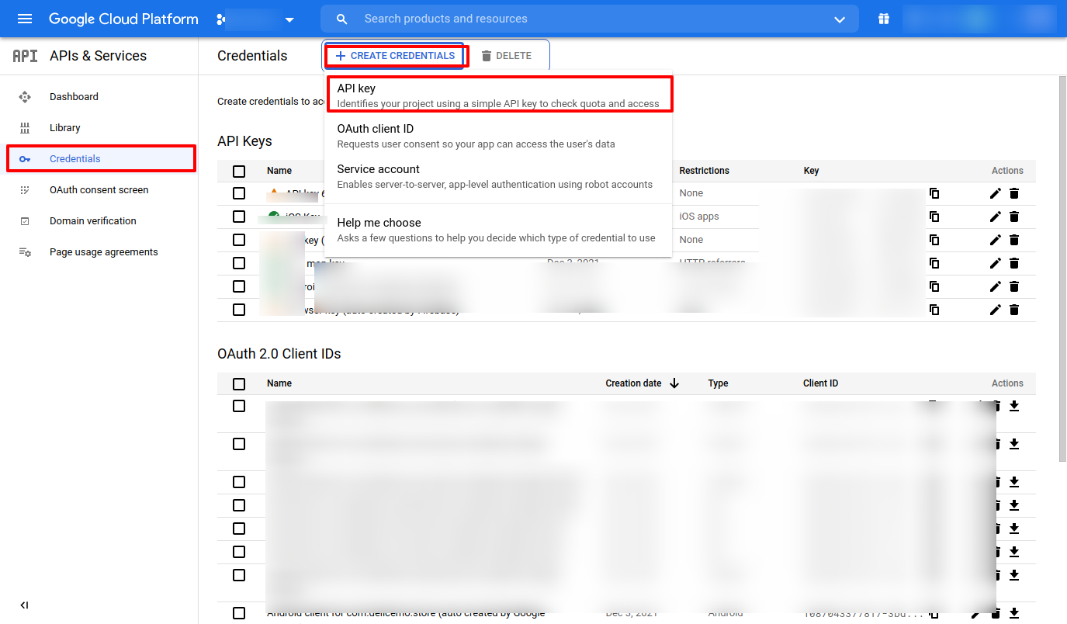

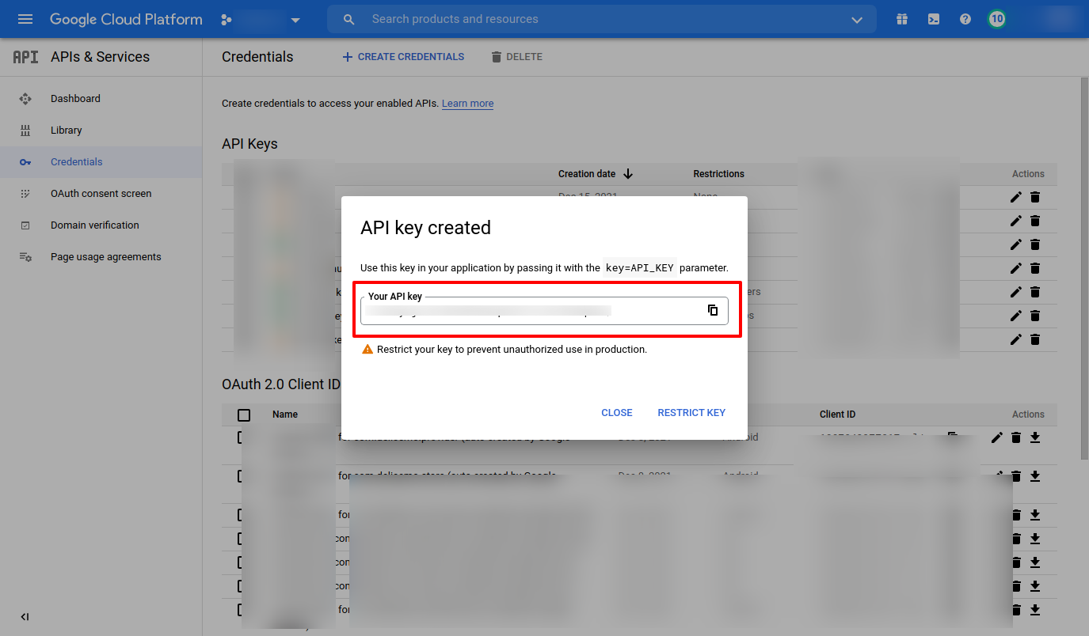

### 10.4 Google API Keys

Directions API

Distance Matrix API

Geocoding API

Geolocation API

Maps JavaScript API

Maps SDK for Android

Maps SDK for iOS

Maps Static API

Places API

Roads API

### 10.5 Configure Auth consent screen if not

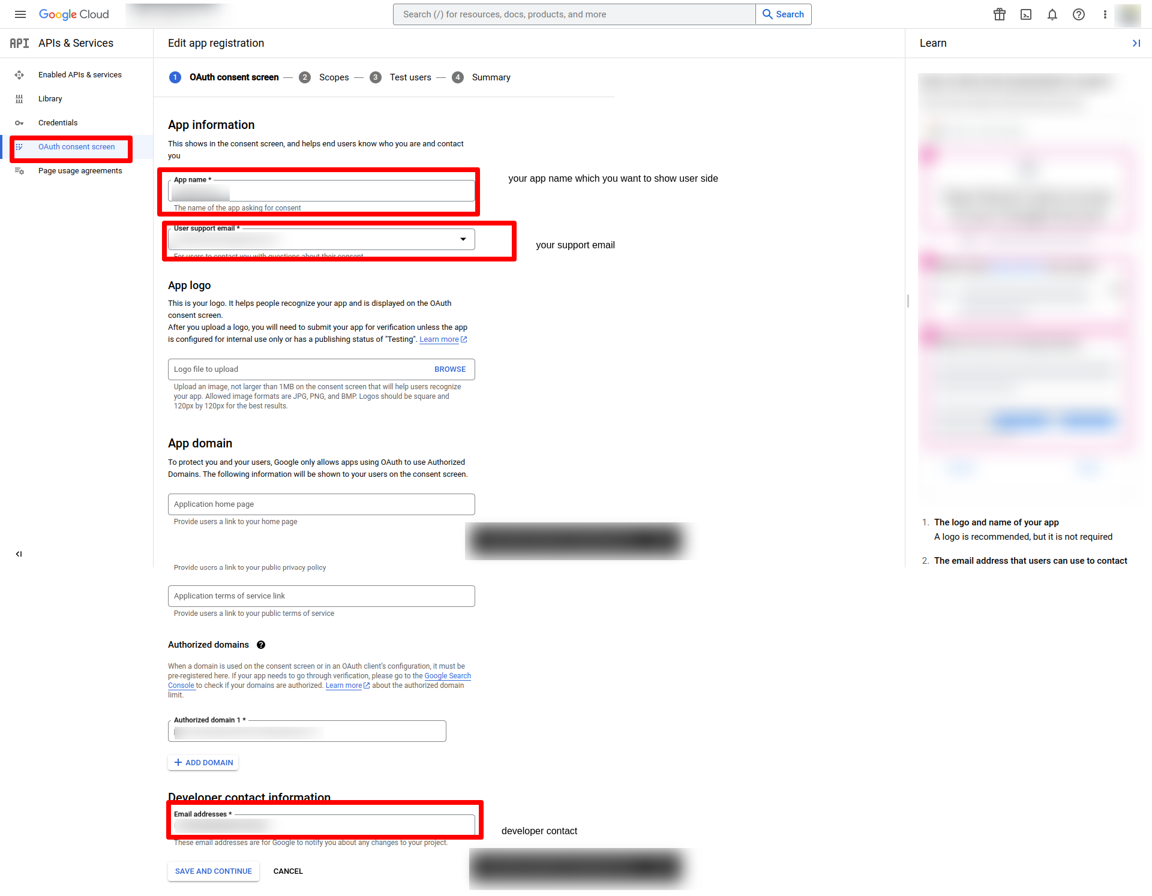

2nd step -> press button save and continue

3rd step -> test user save and continue

4th step -> review summary and back to dashboard

### 10.6 Set up APIs in code

Admin

### -> src/environments/environment.ts

-> src/environments/environment.prod.ts

-> src/index.html

Corporate, Dispatcher, Driver, Partner, User

-> src/environments/environment.ts

-> src/environments/environment.prod.ts

# 11). Social login using Gmail

### 11.1 Open google console and select your project.

### 11.2 Select Web client auto service.

* Note -> Set google app id in the project after generating.

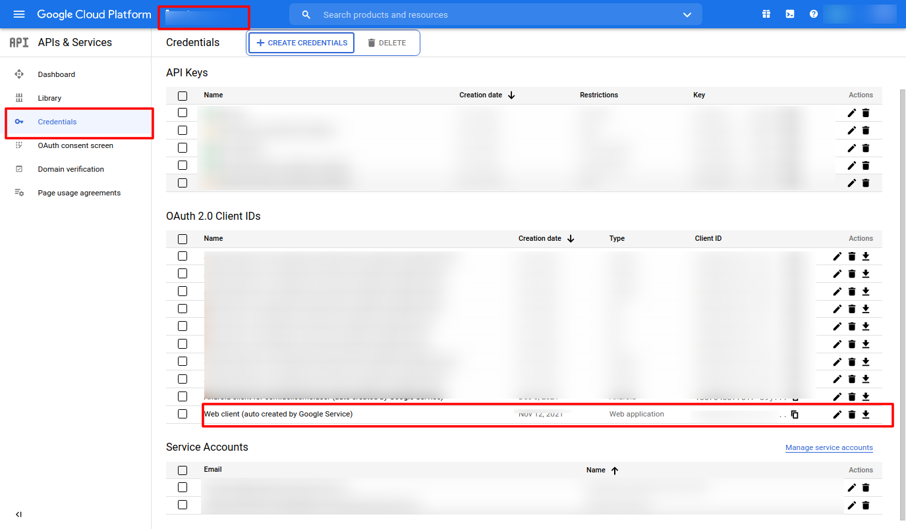

### 11.3 Add your domain name to URI

### 11.4 And use Client Id & Secret in your project Database.

### 11.5 IMPORTANT new panels

* Add client_id in driver panel (/src/app/views/app/auth/auth.component.ts)
* User panel (/src/app/containers/pages/auth-modal/auth-modal.component.ts)

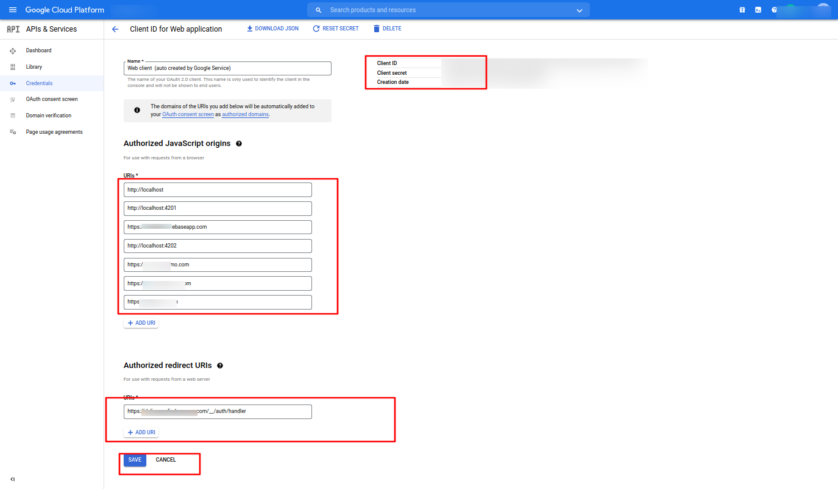

# 12). Facebook Login.

### 12.1 Open Facebook developer console.

### 12.2 Create app

1 -> select consumer, click next

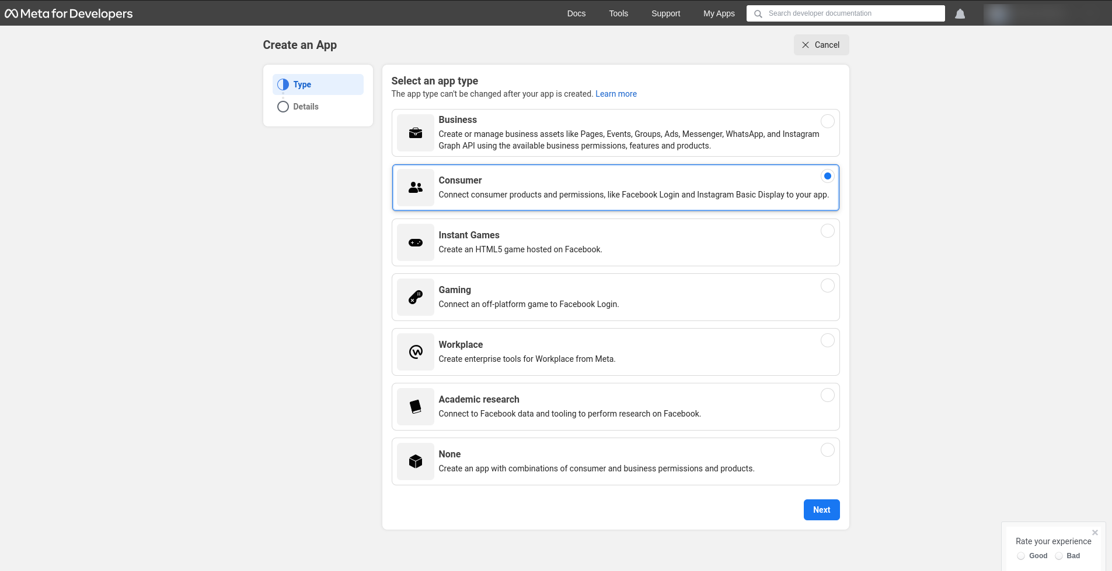

2 -> your app name

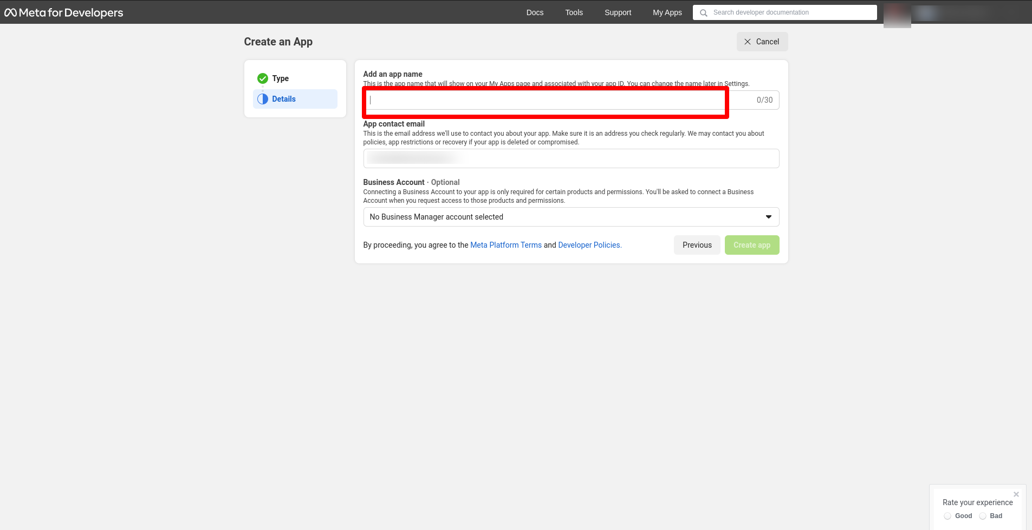

### 12.3 Select your project app.

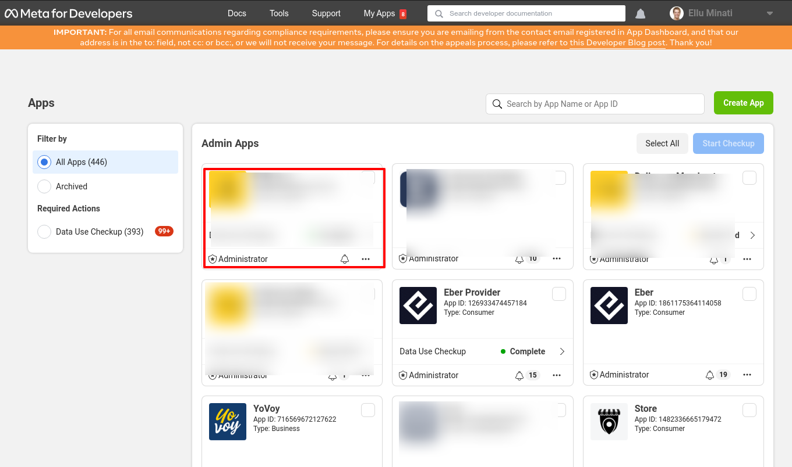

### 12.4 Click on FB Login Setting.

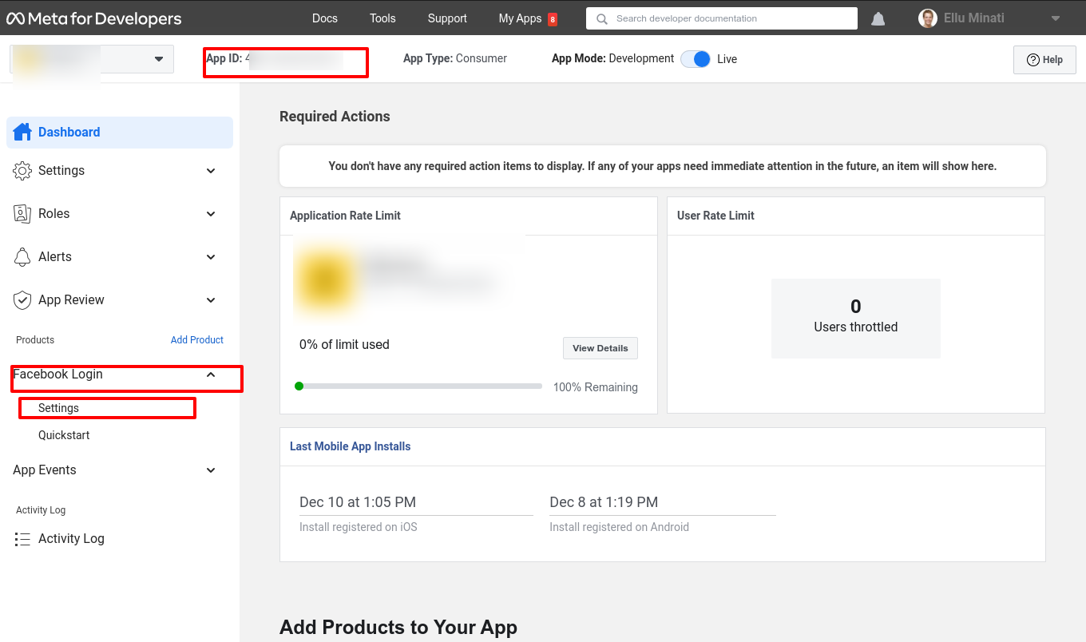

### 12.5 Add Domains of your project

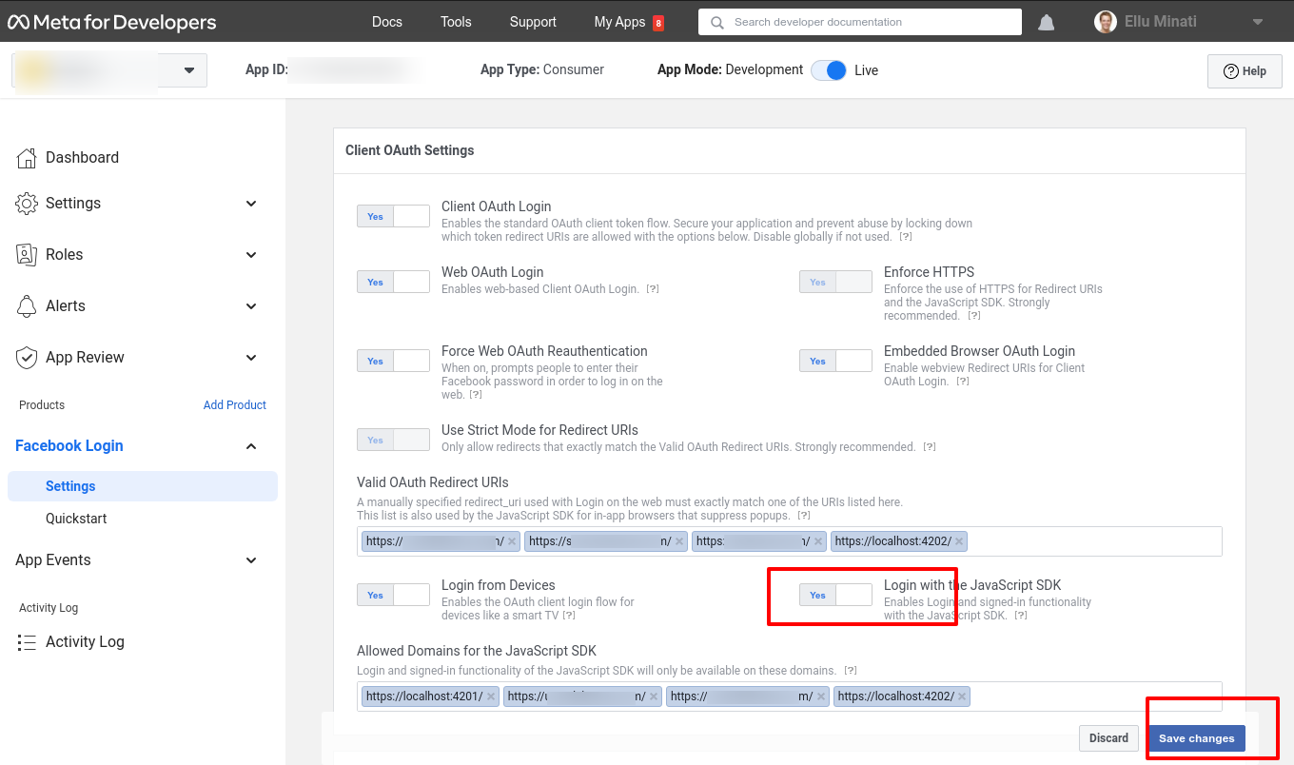

### 12.6 Give advance access

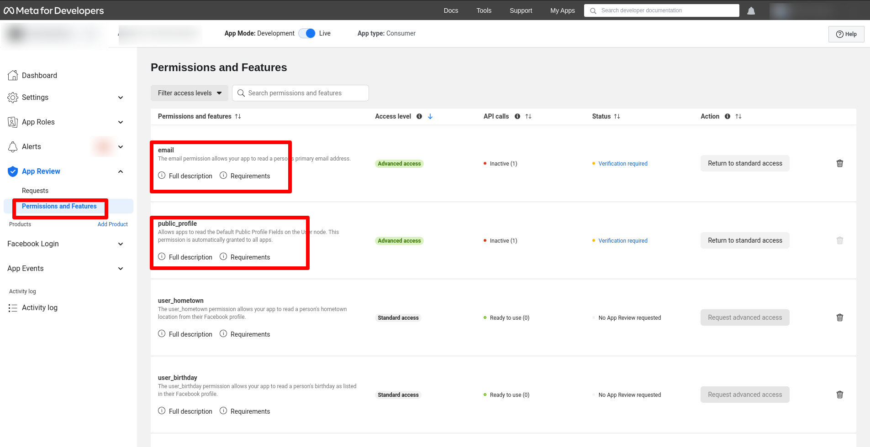

### 12.7 Complete basic settings, privacy-terms condition, data deletion url, logo change if want, category business and pages, add website, app, ios.

### 12.8 data use check up if it already completes its signal as green. If not you have to complete 2 easy setup. Only tap yes this both steps

### 12.9 Save the changes

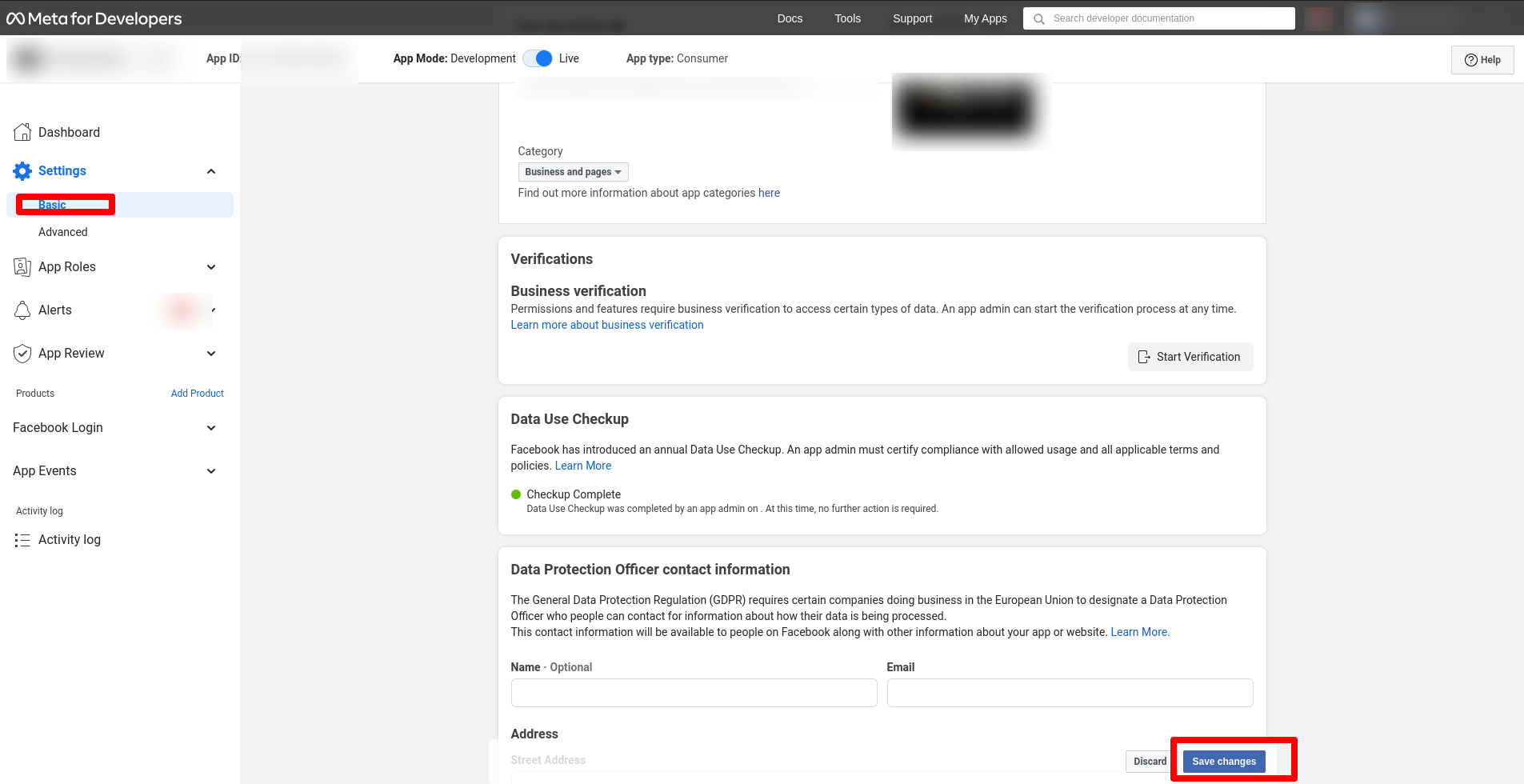

IMPORTANT

### 12.10 Add fb app id in user panel (/src/app/app.module.ts) and driver panel (/src/app/app.module.ts)

# 13). Note For Folder Structure.

In the delivered code you might not get following files/folders because it will be generated or added after installation.

Some of the folders contain dynamic files/folders.

### 13.1 List of empty folders in clone:

* data/partner_document : Uploaded Images For Partner Document
* data/partner_profile : Uploaded Images For Partner Profile
* data/provider_document : Uploaded Images For Driver Document
* data/provider_profile : Uploaded Images For Driver Profile
* data/service_type_images : Uploaded Images For Vehicle Image
* data/service_type_map_pin_images : Uploaded Images For Vehicle Map Pin
* data/user_document : Uploaded Images For User Document
* data/user_profile : Uploaded Images For User Profile

### 13.2 The following file/folder will get auto generated after the installation:

* node_modules : Auto Generate After Installation Of Node Dependencies
* package-lock.json : Auto Generate After Installation Of Node Dependencies
* log_files : Auto Generate Files For Logs
* data/xlsheet : Auto Generate xl sheets
* config/data : Auto Generate For Temporary Image Upload Cache

### 13.3 The following keys/file are removed that need to be configured from client account that needs to be push in the repository:

* app/ios_push/push_file.p8 - Will be added by admin from client account

## 

# 14). Stripe Configuration.

### 14.1 Login Stripe Account

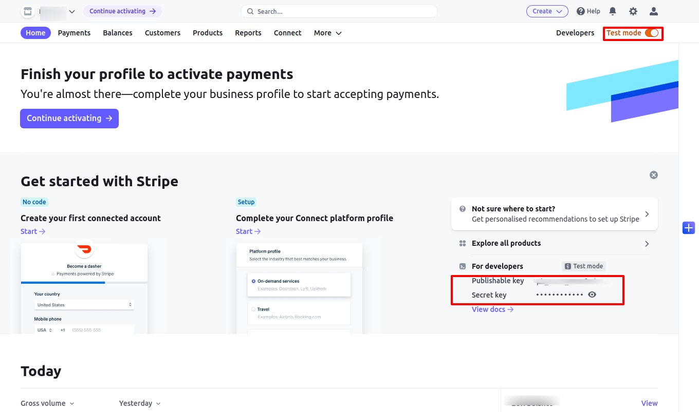

### 14.2 Use this test mode private and public key,and save this key in payment_gateway collection.

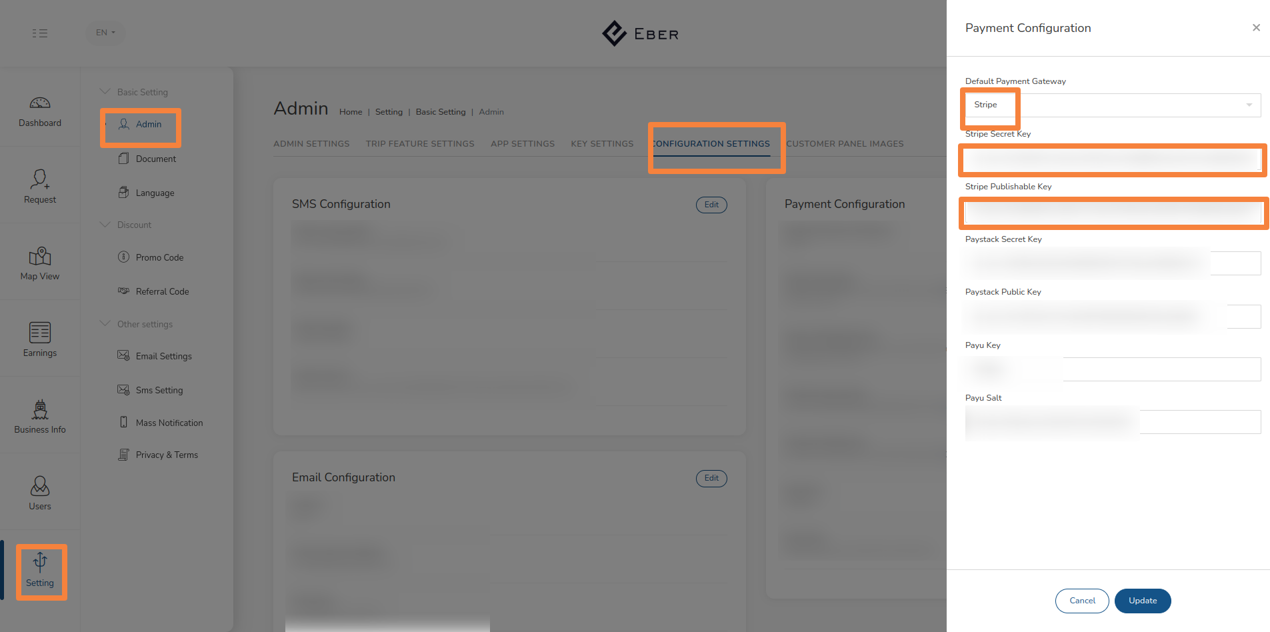

### 14.3 Add stripe publishable key in to user panel, partner panel & driver panel in code

-> src/environments/environment.ts

-> src/environments/environment.prod.ts

### 14.4 And started the Connect Account

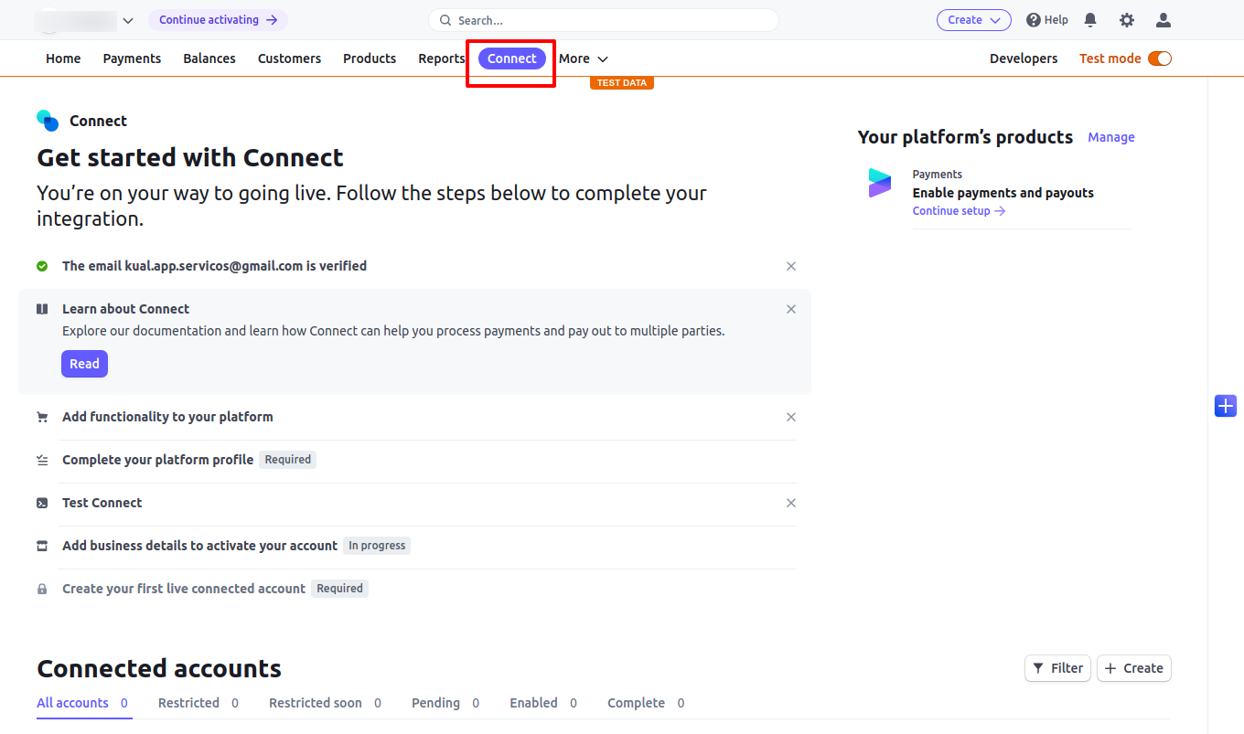

# 15). Twilio Configuration.

### 15.1 Login twilio

### 15.2 Purchase number which have sms and voice capability

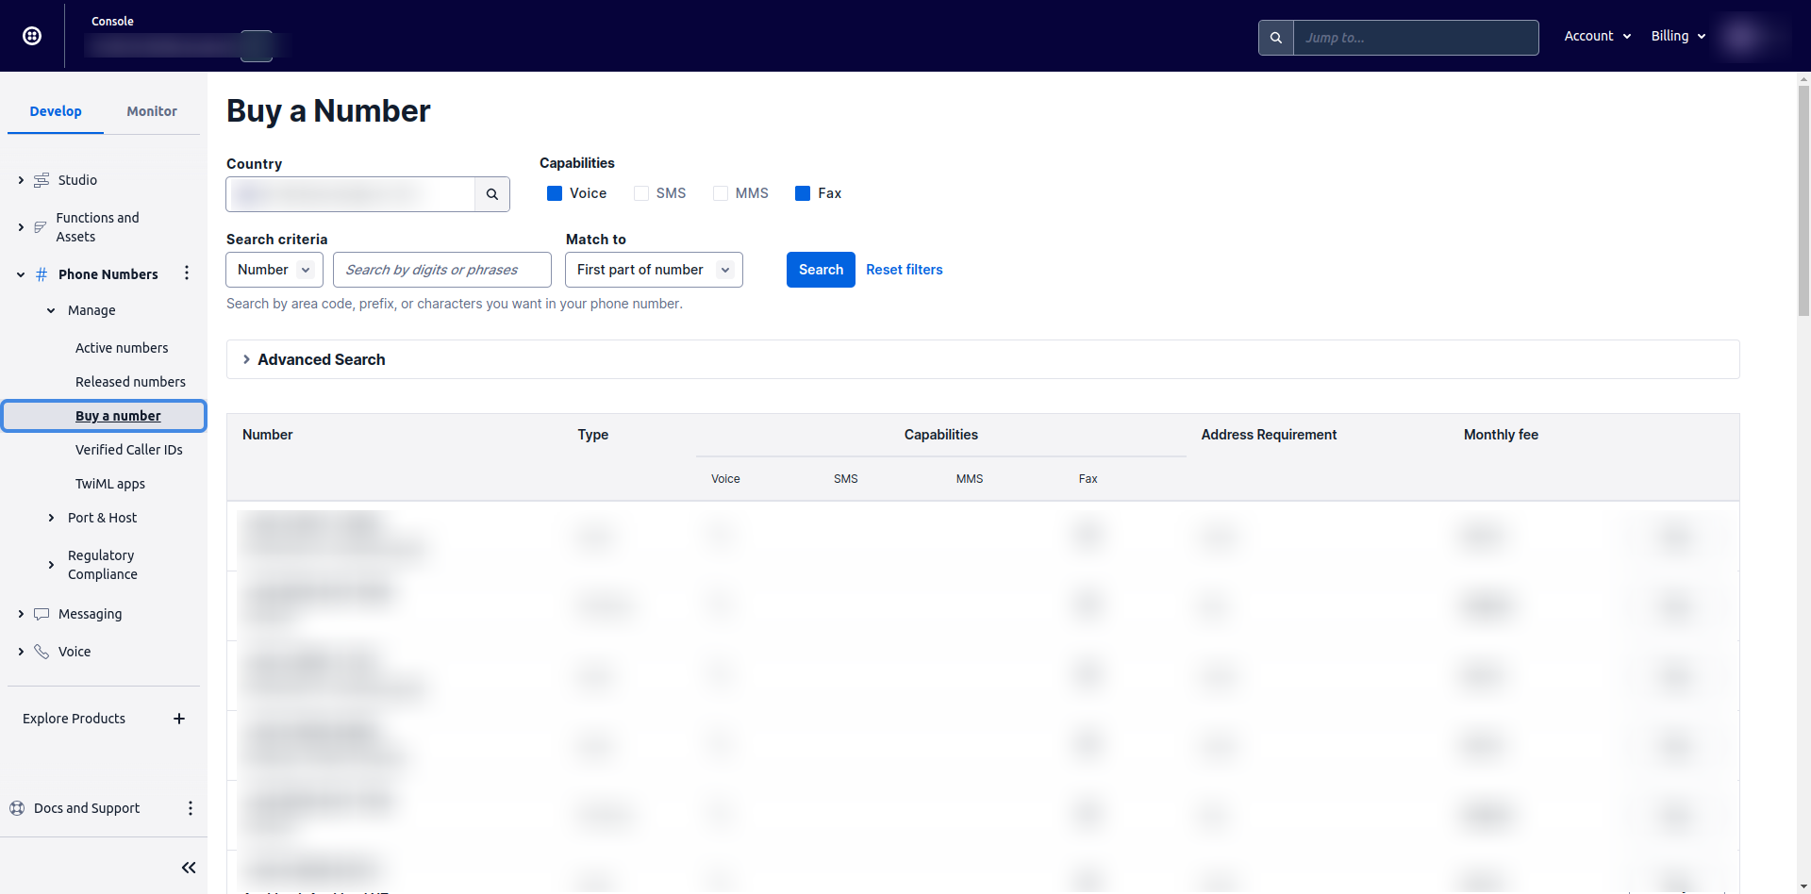

Suggestion number in list purchase number as per your country code.

### 15.3 In trial account you have to verified number for test purpose

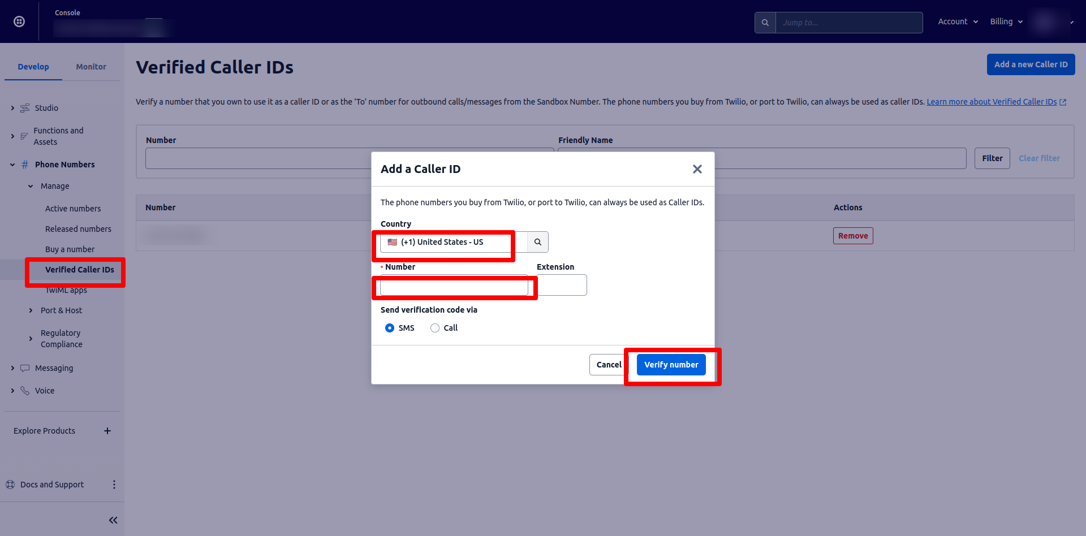

### 15.4 Check your country to have permission to enable service for the number you verified above. Go to messaging -> settings -> geo permissions

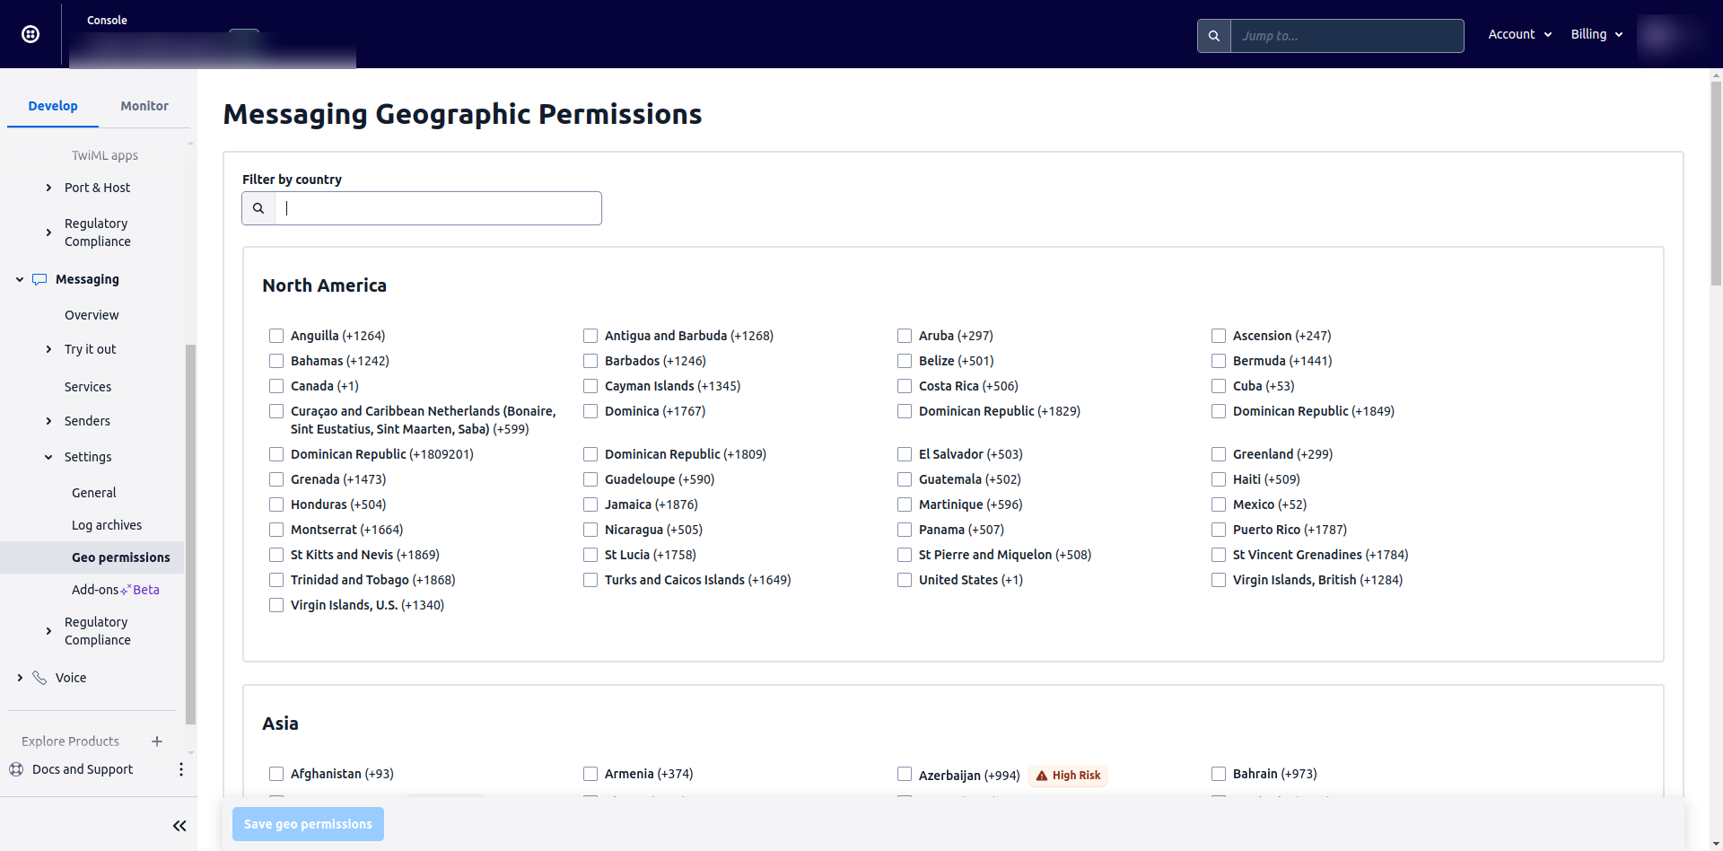

### 15.5 And save this Account SID,Auth Token & Phone number in Admin Panel Settings.

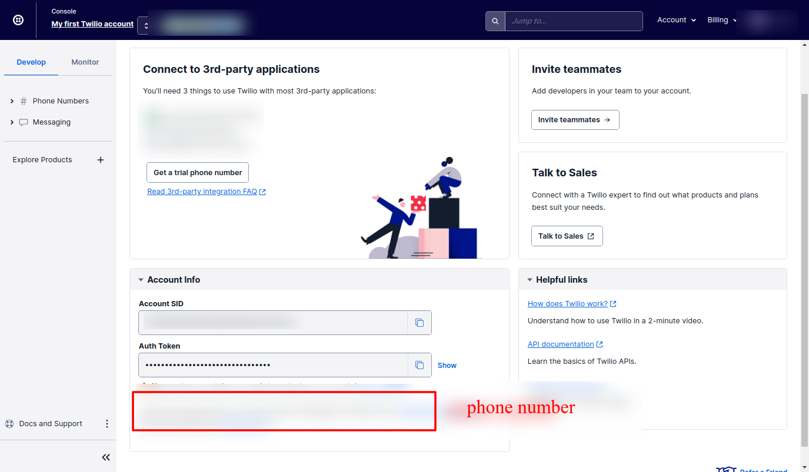

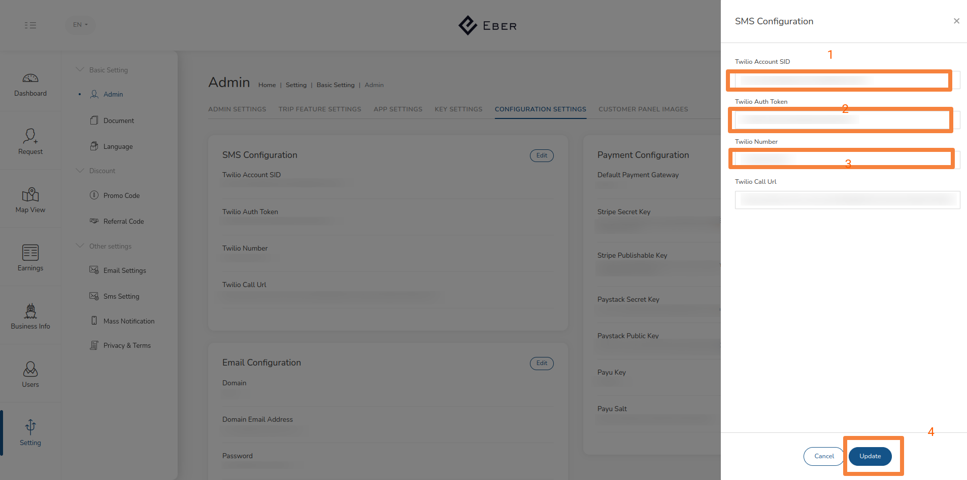

### 15.6 Twilio Call Masking

-> Go to search bar and search create twiml bin

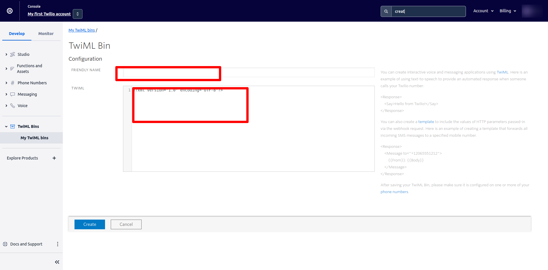

Any friendly name you want. Enter twiml code as below

<Response>

<Say>Hello From Twilio!</Say>

<Dial>

<Number>{{to}}</Number>

</Dial>

</Response>

Then create

> you got twiml url after this copy and paste in our admin panel settings

# 16). Terms & Condition Details.

### 16.1 Given Terms and Privacy Document add in to admin panel.

